**Supporting Information**

**Key factors governing the** **device performance of CIGS solar cells: insights from machine learning**

Chengwan Zhu#a,b, Wu Liu#a,b, Yaoyao Lia,b, Xiaomin Huoa,b, Haotian Lia,b, Kai Guoc, Bo Qiaoa,b, Suling Zhaoa,b, Zheng Xua,b, Honge Zhaoa,b, Dandan Song*a,b

a Key Laboratory of Luminescence and Optical Information, Beijing Jiaotong University, Ministry of Education, Beijing 100044, China

b Institute of Optoelectronics Technology, Beijing Jiaotong University, Beijing 100044, China

c Chongqing Shenhua Thin Film Solar Technology Co., Ltd, Chongqing 400714, China

#These authors contributed equally: Chengwan Zhu, Wu Liu.

Address correspondence to E-mail: [ddsong@bjtu.edu.cn](mailto:ddsong@bjtu.edu.cn)

1. **Datasets and information for machine learning**

The datasets used for machine learning are obtained from literatures. The full records are listed in Table S1.

Table S1 Detailed information of the input features and the photovoltaic performance parameters of CIGS solar cells used in this work (Dataset A)

|  |  |  |  |  |  |  |  |  |  |  |  |  |  |  |  |  |  |  |  |
| --- | --- | --- | --- | --- | --- | --- | --- | --- | --- | --- | --- | --- | --- | --- | --- | --- | --- | --- | --- |
|  | CGI | GGIF | GGIM | GGIB | AD | PDT | BL | CT  (μm) | ES | FS | ST  (℃) | BFL | BFT  (nm) | CBO  (ev) | JSC  (mA/cm2) | VOC  (mV) | FF  (%) | PCE  (%) | Ref. |
| 1 | 0.93 | 0.3 | 0.3 | 0.3 | Y | N | N | 1.2 | evaporation | SLG | NA | CdS | 80 | -0.298 | 33.5 | 505 | 47.1 | 8 | [1] |
| 2 | 0.93 | 0.3 | 0.3 | 0.3 | Y | N | Y | 1.2 | evaporation | SLG | NA | CdS | 80 | -0.298 | 36.6 | 531 | 56.9 | 11.1 |
| 3 | 0.93 | 0.3 | 0.3 | 0.3 | Y | N | Y | 1.2 | evaporation | SLG | NA | CdS | 80 | -0.298 | 35.6 | 464 | 53.8 | 8.9 |
| 4 | 0.93 | 0.3 | 0.3 | 0.3 | Y | N | Y | 1.2 | evaporation | SLG | NA | CdS | 80 | -0.298 | 35.3 | 468 | 53 | 8.8 |
| 5 | 0.875 | 0.5 | 0.5 | 0.5 | Y | N | N | 1.2 | three-stage co-evaporation | SLG | 560 | CdS | 70 | -0.298 | 29.4 | 762 | 65.9 | 14.8 | [2] |
| 6 | 0.875 | 0.5 | 0.5 | 0.5 | Y | N | N | 1.6 | three-stage co-evaporation | SLG | 560 | CdS | 70 | -0.298 | 31.4 | 742 | 70 | 16.3 |
| 7 | 0.875 | 0.5 | 0.5 | 0.5 | Y | N | N | 1.8 | three-stage co-evaporation | SLG | 560 | CdS | 70 | -0.298 | 30 | 734 | 67.8 | 14.9 |
| 8 | NA | NA | NA | NA | Y | N | N | 2 | thermal evaporation | SLG | 560 | CdS | 80 | -0.298 | 28.7 | 539 | 64.9 | 10.1 | [3] |
| 9 | NA | NA | NA | NA | Y | N | N | 2 | thermal evaporation | Glass lift-off | 560 | CdS | 80 | -0.298 | 24.7 | 172 | 35.7 | 1.5 |
| 10 | NA | NA | NA | NA | Y | N | N | 2 | thermal evaporation | SLG | 560 | CdS | 80 | -0.298 | 29.9 | 546 | 63.7 | 10.4 |
| 11 | NA | NA | NA | NA | Y | N | N | 2 | thermal evaporation | Glass lift-off | 560 | CdS | 80 | -0.298 | 25.4 | 513 | 61.7 | 8 |  |
| 12 | NA | NA | NA | NA | Y | N | N | 2 | thermal evaporation | SLG | 560 | CdS | 80 | -0.298 | 31.1 | 513 | 67.2 | 10.7 |
| 13 | NA | NA | NA | NA | Y | N | N | 2 | thermal evaporation | Glass lift-off | 560 | CdS | 80 | -0.298 | 31.4 | 517 | 63.1 | 10.2 |
| 14 | 0.7 | 0.36 | 0.36 | 0.36 | Y | N | N | 2 | e-beam evaporation | SLG | 300 | a-Si | 30 | 0.450 | 31.5 | 406 | 39 | 5 | [4] |
| 15 | 0.7 | 0.41 | 0.41 | 0.41 | Y | N | N | 2 | e-beam evaporation | SLG | 300 | a-Si | 30 | 0.450 | 30.2 | 472 | 46 | 6.6 |
| 16 | 0.7 | 0.47 | 0.47 | 0.47 | Y | N | N | 2 | e-beam evaporation | SLG | 300 | a-Si | 30 | 0.450 | 27.7 | 465 | 48 | 6.2 |
| 17 | 0.91 | 0.31 | 0.31 | 0.31 | N | Y | Y | 2 | sputting/selenization | SLG | NA | CdS | NA | -0.298 | 33.6 | 393 | 64.4 | 8.5 | [5] |
| 18 | 0.89 | 0.3 | 0.3 | 0.3 | N | Y | Y | 2 | sputting/selenization | SLG | 200 | CdS | NA | -0.298 | 38.1 | 400 | 65.5 | 10 |
| 19 | 0.9 | 0.3 | 0.3 | 0.3 | N | Y | Y | 2 | sputting/selenization | SLG | 300 | CdS | NA | -0.298 | 37.7 | 452 | 70 | 11.9 |
| 20 | 0.9 | 0.3 | 0.3 | 0.3 | N | Y | Y | 2 | sputting/selenization | SLG | 400 | CdS | NA | -0.298 | 35.7 | 395 | 64.5 | 9.1 |
| 21 | 0.8 | 0.45 | 0.35 | 0.8 | Y | N | N | 2 | three-stage co-evaporation | SLG | 450 | CdS | 50 | -0.298 | 35.4 | 696 | 75.3 | 18.6 | [6] |
| 22 | 0.8 | 0.58 | 0.25 | 0.5 | N | N | N | 2 | three-stage co-evaporation | PI | 450 | CdS | 50 | -0.298 | 36.5 | 547 | 58 | 11.6 |
| 23 | 0.8 | 0.5 | 0.25 | 0.48 | N | Y | N | 2 | three-stage co-evaporation | PI | 450 | CdS | 50 | -0.298 | 36.2 | 642 | 72.8 | 16.9 |
| 24 | 0.8 | 0.52 | 0.2 | 0.5 | N | Y | N | 2 | three-stage co-evaporation | PI | 450 | CdS | 50 | -0.298 | 35.9 | 697 | 74.8 | 18.7 |
| 25 | 0.72 | 0.2 | 0.45 | 0.7 | Y | N | N | 1.3 | three-stage co-evaporation | Cz-Si | 550 | CdS | 65.5 | -0.298 | 30.53 | 610 | 60.71 | 11.72 | [7] |
| 26 | 0.8 | 0.4 | 0.4 | 0.4 | Y | N | N | 0.55 | one-stage co-evaporation | SLG | 550 | CdS | NA | -0.298 | 22.26 | 500 | 48.78 | 5.43 | [8] |
| 27 | 0.8 | 0.4 | 0.4 | 0.4 | Y | Y | N | 0.55 | one-stage co-evaporation | SLG | 550 | CdS | NA | -0.298 | 23.34 | 640 | 66.94 | 10 |
| 28 | 0.8 | 0.4 | 0.4 | 0.4 | Y | Y | N | 0.55 | one-stage co-evaporation | SLG | 550 | CdS | NA | -0.298 | 21.91 | 570 | 61.86 | 7.73 |
| 29 | NA | 0.42 | 0.02 | 0.7 | N | N | Y | 2.5 | co-evaporation | SUS | 638 | ZnS(O,OH) | NA | 0.250 | 38 | 580 | 72.8 | 16.1 | [9] |
| 30 | NA | 0.4 | 0.08 | 0.7 | N | N | Y | 2.5 | co-evaporation | SUS | 647 | ZnS(O,OH) | NA | 0.250 | 37.6 | 623 | 74.9 | 17.6 |
| 31 | NA | 0.38 | 0.15 | 0.7 | N | N | Y | 2.5 | co-evaporation | SUS | 656 | ZnS(O,OH) | NA | 0.250 | 36.1 | 620 | 73 | 16.4 |
| 32 | 0.85 | 0.27 | 0.27 | 0.27 | Y | N | N | 1.2 | sputtering | SLG | 450 | CdS | 50 | -0.298 | 22.8 | 466 | 72 | 7.7 | [10] |
| 33 | 0.85 | 0.27 | 0.27 | 0.27 | Y | N | N | 1.2 | sputtering | SLG | 525 | CdS | 50 | -0.298 | 30.3 | 494 | 78.2 | 11.8 |
| 34 | 0.84 | 0.3 | 0.3 | 0.3 | Y | N | N | 1.2 | magnetron sputtering | SLG | 540 | CdS | 50 | -0.298 | 26.46 | 367.18 | 71.19 | 7.93 | [11] |
| 35 | 0.84 | 0.3 | 0.3 | 0.3 | Y | N | N | 1.2 | magnetron sputtering | SLG | 540 | CdS | 50 | -0.298 | 39.34 | 453 | 80.49 | 14.35 |
| 36 | 0.84 | 0.3 | 0.3 | 0.3 | Y | N | N | 1.2 | magnetron sputtering | SLG | 540 | CdS | 50 | -0.298 | 39.08 | 415.41 | 68.5 | 11.12 |
| 37 | 0.92 | 0.36 | 0.36 | 0.36 | Y | Y | N | 2.5 | co-evaporation | SLG | NA | CdS | NA | -0.298 | 34.34 | 733 | 77.4 | 19.5 | [12] |
| 38 | 0.92 | 0.35 | 0.35 | 0.35 | Y | Y | N | 2.5 | co-evaporation | SLG | NA | CdS | NA | -0.298 | 34.34 | 731 | 77.7 | 19.6 |
| 39 | 0.91 | 0.32 | 0.32 | 0.32 | Y | N | N | 2.5 | co-evaporation | SLG | NA | CdS | NA | -0.298 | 34.8 | 676 | 77.2 | 18.2 |
| 40 | 0.91 | 0.29 | 0.29 | 0.29 | Y | Y | N | 2.5 | co-evaporation | SLG | NA | CdS | NA | -0.298 | 35.2 | 715 | 80.2 | 20.2 |
| 41 | 0.98 | 0.19 | 0.19 | 0.19 | Y | N | N | 1.2 | one-step sputtering | SLG | 200 | CdS | NA | -0.298 | 23.6 | 275 | 39 | 2.5 | [13] |
| 42 | 0.8 | 0.5 | 0.32 | 0.42 | N | N | Y | 1.4 | evaporation | SUS | 650 | CdS | NA | -0.298 | 34.1 | 570 | 74 | 14.4 | [14] |
| 43 | 0.95 | 0.5 | 0.24 | 0.72 | N | N | Y | 1.4 | evaporation | SUS | 650 | CdS | NA | -0.298 | 36.9 | 623 | 73.5 | 16.9 |
| 44 | 0.92 | 0.6 | 0.19 | 0.75 | N | N | Y | 1.4 | evaporation | SUS | 630 | CdS | NA | -0.298 | 39.7 | 601 | 71 | 17 |
| 45 | 0.9 | 0.6 | 0.18 | 0.74 | N | N | Y | 1.4 | evaporation | SUS | 610 | CdS | NA | -0.298 | 40 | 601 | 72.9 | 17.5 |
| 46 | 0.9 | 0.39 | 0.39 | 0.39 | Y | N | N | 1 | three-stage co-evaporation | SLG | NA | CdS | 50 | -0.298 | 34.8 | 680 | 71.7 | 17 | [15] |
| 47 | 0.93 | 0.39 | 0.39 | 0.39 | Y | Y | N | 1 | three-stage co-evaporation | SLG | NA | CdS | 50 | -0.298 | 35 | 700 | 73.1 | 17.9 |
| 48 | 0.86 | 0.36 | 0.36 | 0.36 | Y | N | N | 2.2 | three-stage co-evaporation | SLG | 600 | CdS | 50 | -0.298 | 33.7 | 667 | 75.9 | 17 | [16] |
| 49 | 0.87 | 0.37 | 0.37 | 0.37 | Y | Y | N | 2.2 | three-stage co-evaporation | SLG | 600 | CdS | 50 | -0.298 | 33.5 | 704 | 75 | 17.7 |
| 50 | 0.86 | 0.33 | 0.22 | 0.35 | Y | N | N | 1.3 | three-stage co-evaporation | SLG | 350 | CdS | 50 | -0.298 | 32.21 | 530 | 63 | 10.81 | [17] |
| 51 | 0.83 | 0.38 | 0.23 | 0.35 | Y | N | N | 1.3 | three-stage co-evaporation | SLG | 350 | CdS | 50 | -0.298 | 30.84 | 480 | 61.8 | 9.16 |
| 52 | 0.82 | 0.31 | 0.25 | 0.45 | Y | N | N | 1.3 | three-stage co-evaporation | SLG | 350 | CdS | 50 | -0.298 | 31.85 | 520 | 68.5 | 11.36 |
| 53 | 0.85 | 0.37 | 0.27 | 0.45 | Y | N | N | 1.3 | three-stage co-evaporation | SLG | 350 | CdS | 50 | -0.298 | 33.91 | 530 | 69.5 | 12.5 |
| 54 | 0.85 | 0.43 | 0.27 | 0.45 | Y | N | N | 1.3 | three-stage co-evaporation | SLG | 350 | CdS | 50 | -0.298 | 29.1 | 550 | 59.5 | 9.54 |
| 55 | 0.9 | 0.35 | 0.45 | 0.55 | Y | N | N | 1.85 | one-stage co-evaporation | SLG | NA | CdS | 50 | -0.298 | 30.62 | 671 | 71.1 | 14.5 | [18] |
| 56 | 0.9 | 0.35 | 0.45 | 0.55 | Y | N | N | 1.85 | one-stage co-evaporation | SLG | NA | ZnSnO | 30 | NA | 31.73 | 666 | 69.3 | 14.7 |
| 57 | NA | NA | NA | NA | Y | N | N | 2.2 | three-stage co-evaporation | SLG | NA | CdS | 30 | -0.298 | 26.96 | 606 | 45.8 | 7.47 | [19] |
| 58 | NA | NA | NA | NA | Y | N | N | 2.2 | three-stage co-evaporation | SLG | NA | CdS | 30 | -0.298 | 34.1 | 606 | 69 | 14.26 |
| 59 | NA | NA | NA | NA | Y | N | N | 2.2 | three-stage co-evaporation | SLG | NA | CdS | 30 | -0.298 | 32.36 | 583 | 68.8 | 13 |
| 60 | NA | NA | NA | NA | Y | N | N | 2 | three-stage co-evaporation | SLG | NA | CdS | 55 | -0.298 | 31.4 | 697 | 75.5 | 16.5 | [20] |
| 61 | NA | NA | NA | NA | Y | N | N | 2 | three-stage co-evaporation | SLG | NA | CdS | 55 | -0.298 | 29.5 | 576 | 50.7 | 8.6 |
| 62 | NA | NA | NA | NA | Y | Y | N | 2 | three-stage co-evaporation | SLG | NA | CdS | 55 | -0.298 | 29.2 | 657 | 70.9 | 13.6 |
| 63 | NA | NA | NA | NA | N | Y | N | 2 | three-stage co-evaporation | Alumina | NA | CdS | 55 | -0.298 | 31.4 | 699 | 73 | 16 |
| 64 | NA | NA | NA | NA | N | Y | N | 2 | three-stage co-evaporation | Alumina | NA | CdS | 55 | -0.298 | 30.2 | 646 | 71.5 | 13.9 |
| 65 | NA | NA | NA | NA | Y | N | N | NA | three-stage co-evaporation | SLG | NA | CdS | 100 | -0.298 | 32.9 | 656 | 75.6 | 16.3 | [21] |
| 66 | NA | NA | NA | NA | Y | N | N | NA | three-stage co-evaporation | SLG | NA | Zn(O,S) | 100 | 0.600 | 32 | 546 | 69.4 | 12.1 |
| 67 | NA | NA | NA | NA | Y | N | N | NA | three-stage co-evaporation | SLG | NA | CdS/Zn(O,S) | 100 | 0.830 | 32.9 | 666 | 74.8 | 16.4 |
| 68 | NA | NA | NA | NA | Y | N | N | NA | three-stage co-evaporation | SLG | NA | CdS/Zn(O,S) | 100 | 0.830 | 32.1 | 585 | 65 | 12.2 |
| 69 | NA | 0.45 | 0.2 | 0.6 | N | N | Y | 1.5 | co-evaporation | SUS | 520 | CdS | 50 | -0.298 | 35.6 | 602 | 72.4 | 15.6 | [22] |
| 70 | NA | 0.48 | 0.05 | 0.8 | N | N | Y | 1.5 | co-evaporation | SUS | 520 | CdS | 50 | -0.298 | 37.9 | 623 | 73.5 | 17.3 |
| 71 | 0.92 | 0.38 | 0.38 | 0.38 | Y | N | N | 2 | three-stage co-evaporation | SLG | NA | CdS | 70.42 | -0.298 | 30.33 | 625 | 61.97 | 11.71 | [23] |
| 72 | 0.92 | 0.38 | 0.38 | 0.38 | Y | N | N | 2 | three-stage co-evaporation | SLG | NA | (Cd,Zn)S | 71.19 | 0.160 | 31.67 | 651 | 59.58 | 12.12 |
| 73 | 0.92 | 0.38 | 0.38 | 0.38 | Y | N | N | 2 | three-stage co-evaporation | SLG | NA | CdS | 71.18 | -0.298 | 30.98 | 633 | 63.55 | 11.88 |
| 74 | 0.92 | 0.38 | 0.38 | 0.38 | Y | N | N | 2 | three-stage co-evaporation | SLG | NA | (Cd,Zn)S | 72.37 | 0.130 | 31.13 | 635 | 65.01 | 12.22 |
| 75 | NA | 0.52 | 0.13 | 0.47 | Y | N | N | 1.3 | co-evaporation | SLG | 450 | CdS | 50 | -0.298 | 33 | 592 | 72.4 | 14.1 | [24] |
| 76 | NA | 0.5 | 0.15 | 0.45 | Y | N | N | 1.3 | co-evaporation | SLG | 450 | CdS | 50 | -0.298 | 32.1 | 640 | 74.7 | 15.3 |
| 77 | NA | 0.45 | 0.25 | 0.45 | Y | N | N | 1.3 | co-evaporation | SLG | 450 | CdS | 50 | -0.298 | 28.9 | 682 | 73.4 | 14.5 |
| 78 | NA | NA | NA | NA | Y | N | N | 2 | three-stage co-evaporation | SLG | 580 | CdS | 90 | -0.298 | 33.2 | 588 | 65.8 | 12.9 | [25] |
| 79 | NA | NA | NA | NA | Y | N | Y | 2 | three-stage co-evaporation | SUS | 580 | CdS | 90 | -0.298 | 31.8 | 499 | 60.6 | 9.6 |
| 80 | NA | NA | NA | NA | N | N | Y | 2 | three-stage co-evaporation | SUS | 580 | CdS | 90 | -0.298 | 34.3 | 609 | 68.5 | 14.3 |
| 81 | 1.05 | 0.27 | 0.27 | 0.27 | N | N | N | 1.6 | sputtering | glass | NA | CdS | 50 | -0.298 | 10.4 | 254.2 | 37.8 | 1.2 | [26] |
| 82 | 0.97 | 0.232 | 0.232 | 0.232 | N | N | N | 1.6 | sputtering | glass | NA | CdS | 50 | -0.298 | 33.9 | 437.9 | 63.8 | 9.5 |
| 83 | 0.88 | 0.48 | 0.27 | 0.55 | Y | N | N | 1.5 | three-stage co-evaporation | SLG | NA | CdS | 50 | -0.298 | 31.2 | 718 | 76.6 | 17.2 | [27] |
| 84 | 0.88 | 0.45 | 0.07 | 0.45 | N | N | N | 1.5 | three-stage co-evaporation | PI | NA | CdS | 50 | -0.298 | 33.7 | 634 | 71.2 | 15.3 |
| 85 | NA | NA | NA | NA | Y | N | N | 2 | three-stage co-evaporation | SLG | NA | CdS | 55 | -0.298 | 28.2 | 440 | 60.6 | 7.55 | [28] |
| 86 | NA | 0.35 | 0.35 | 0.35 | N | Y | Y |  | co-evaporation | mild steel | 450 | CdS | 50 | -0.298 | 34.5 | 692 | 75.5 | 18 | [29] |
| 87 | 0.83 | 0.2 | 0.2 | 0.2 | N | N | N | 1.6 | sputtering | glass | NA | CdS | 50 | -0.298 | 28.6 | 465 | 74.7 | 9.9 | [30] |
| 88 | 0.84 | 0.18 | 0.18 | 0.18 | N | N | N | 1.6 | sputtering | glass | NA | CdS | 50 | -0.298 | 33.1 | 461.9 | 77.3 | 11.8 |
| 89 | 0.88 | 0.22 | 0.1 | 0.3 | N | Y | N | 1.924 | three-stage co-evaporation | SUS | 500 | CdS | 50 | -0.298 | 33.79 | 487.44 | 68.78 | 11.33 | [31] |
| 90 | 0.89 | 0.25 | 0.25 | 0.25 | Y | N | N | 2.4 | three-stage co-evaporation | SLG | 520 | CdS | 60 | -0.298 | 36.8 | 522 | 65 | 12.4 | [32] |
| 91 | 0.89 | 0.25 | 0.25 | 0.25 | Y | Y | N | 2.4 | three-stage co-evaporation | SLG | 520 | CdS | 60 | -0.298 | 36.9 | 611 | 69.9 | 15.8 |
| 92 | 0.86 | 0.37 | 0.37 | 0.37 | Y | N | N | 2.4 | three-stage co-evaporation | SLG | 520 | CdS | 60 | -0.298 | 35.2 | 581 | 66.2 | 13.6 |
| 93 | 0.86 | 0.37 | 0.37 | 0.37 | Y | Y | N | 2.4 | three-stage co-evaporation | SLG | 520 | CdS | 60 | -0.298 | 35.2 | 694 | 73.6 | 18 |
| 94 | 0.9 | 0.4 | 0.4 | 0.4 | Y | N | N | 2.4 | three-stage co-evaporation | SLG | 520 | CdS | 60 | -0.298 | 33.6 | 650 | 73.3 | 16 |
| 95 | 0.9 | 0.4 | 0.4 | 0.4 | Y | Y | N | 2.4 | three-stage co-evaporation | SLG | 520 | CdS | 60 | -0.298 | 33.5 | 722 | 74.4 | 18 |
| 96 | 0.78 | 0.57 | 0.57 | 0.57 | Y | N | N | 2.4 | three-stage co-evaporation | SLG | 520 | CdS | 60 | -0.298 | 30.9 | 717 | 75.7 | 16.7 |
| 97 | 0.78 | 0.57 | 0.57 | 0.57 | Y | Y | N | 2.4 | three-stage co-evaporation | SLG | 520 | CdS | 60 | -0.298 | 31.2 | 760 | 75.5 | 18 |
| 98 | 0.9 | 0.41 | 0.28 | 0.52 | Y | N | N | 2.3 | three-stage co-evaporation | SLG | 550 | CdS | 50 | -0.298 | 32.3 | 706 | 72.4 | 16.5 | [33] |
| 99 | 0.9 | 0.49 | 0.37 | 0.5 | Y | N | N | 2.3 | three-stage co-evaporation | SLG | 550 | CdS | 50 | -0.298 | 29.8 | 691 | 76.5 | 15.7 |
| 100 | 0.9 | 0.3 | 0.4 | 0.48 | Y | N | N | 2.3 | three-stage co-evaporation | SLG | 550 | CdS | 50 | -0.298 | 31.2 | 675 | 75.8 | 16 |
| 101 | 0.9 | 0.35 | 0.3 | 0.5 | Y | N | N | 2.3 | three-stage co-evaporation | SLG | 550 | CdS | 50 | -0.298 | 31.3 | 709 | 75.8 | 16.8 |
| 102 | 0.9 | 0.35 | 0.28 | 0.54 | Y | N | N | 2.3 | three-stage co-evaporation | SLG | 550 | CdS | 50 | -0.298 | 32.4 | 707 | 76.5 | 17.5 |
| 103 | 0.9 | 0.46 | 0.24 | 0.52 | Y | N | N | 2.3 | three-stage co-evaporation | SLG | 550 | CdS | 50 | -0.298 | 33.3 | 716 | 75.9 | 18.1 |
| 104 | 0.9 | 0.48 | 0.22 | 0.52 | Y | N | N | 2.3 | three-stage co-evaporation | SLG | 550 | CdS | 50 | -0.298 | 34.1 | 725 | 74.7 | 18.5 |
| 105 | 0.98 | 0.38 | 0.38 | 0.38 | Y | N | N | 2.5 | three-stage co-evaporation | SLG | NA | CdS | 50 | -0.298 | 36.49 | 635 | 70.6 | 16.35 | [34] |
| 106 | 0.98 | 0.38 | 0.38 | 0.38 | Y | N | N | 2.5 | three-stage co-evaporation | SLG | NA | CdS | 50 | -0.298 | 36.02 | 635 | 69 | 15.81 |
| 107 | 0.93 | 0.23 | 0.23 | 0.23 | Y | N | N | 2 | three-stage co-evaporation | SLG | NA | CdS | 80 | -0.298 | 35 | 606 | 69.3 | 14.7 | [35] |
| 108 | 0.9 | 0.32 | 0.32 | 0.32 | Y | N | N | 2 | three-stage co-evaporation | SLG | NA | CdS | 80 | -0.298 | 30 | 613 | 62.5 | 11.5 |
| 109 | 0.86 | 0.38 | 0.38 | 0.38 | Y | N | N | 2 | three-stage co-evaporation | SLG | NA | CdS | 80 | -0.298 | 26.7 | 652 | 68.4 | 11.9 |
| 110 | 0.95 | 0.5 | 0.5 | 0.5 | Y | N | N | 2 | three-stage co-evaporation | SLG | NA | CdS | 80 | -0.298 | 22.7 | 680 | 58.8 | 9.09 |
| 111 | 0.81 | 0.25 | 0.25 | 0.25 | N | N | N | 1.2 | sputting/selenization | glass | 575 | CdS | 50 | -0.298 | 26 | 474.9 | 65.3 | 8.1 | [36] |
| 112 | 0.81 | 0.32 | 0.32 | 0.32 | N | N | N | 1.2 | sputting/selenization | glass | 575 | CdS | 50 | -0.298 | 30.6 | 500.7 | 67 | 10.3 |
| 113 | 0.83 | 0.46 | 0.46 | 0.46 | N | N | N | 1.2 | sputting/selenization | glass | 575 | CdS | 50 | -0.298 | 27 | 509.2 | 61.5 | 8.5 |
| 114 | 0.83 | 0.54 | 0.54 | 0.54 | N | N | N | 1.2 | sputting/selenization | glass | 575 | CdS | 50 | -0.298 | 22.6 | 551.7 | 58.2 | 7.2 |
| 115 | 0.7 | 0.32 | 0.32 | 0.32 | Y | N | N | 1.5 | RF-magnetron sputtering | SLG | 550 | CdS | 75 | -0.298 | 24.8 | 513 | 60 | 7.7 | [37] |
| 116 | 0.73 | 0.3 | 0.3 | 0.3 | Y | N | N | 1.5 | RF-magnetron sputtering | SLG | 600 | CdS | 75 | -0.298 | 34 | 524 | 60 | 10 |
| 117 | 0.77 | 0.29 | 0.29 | 0.29 | Y | N | N | 1.5 | RF-magnetron sputtering | SLG | 650 | CdS | 75 | -0.298 | 25.6 | 477 | 50 | 6.7 |
| 118 | 0.89 | 0.35 | 0.35 | 0.35 | Y | N | N | 2.2 | three-stage co-evaporation | SLG | 540 | CdS | 50 | -0.298 | 33.6 | 694 | 77.5 | 18.1 | [38] |
| 119 | 0.91 | 0.35 | 0.35 | 0.35 | Y | N | N | 2.2 | three-stage co-evaporation | SLG | 470 | CdS | 50 | -0.298 | 33.8 | 617 | 71.3 | 14.9 |
| 120 | 0.91 | 0.35 | 0.35 | 0.35 | Y | N | N | 2.2 | three-stage co-evaporation | SLG | 470 | CdS | 50 | -0.298 | 34 | 647 | 73.4 | 16.1 |
| 121 | 0.9 | 0.35 | 0.35 | 0.35 | Y | N | N | 2.2 | three-stage co-evaporation | SLG | 470 | CdS | 50 | -0.298 | 34.6 | 658 | 74.3 | 16.9 |
| 122 | 0.89 | 0.35 | 0.35 | 0.35 | Y | N | N | 2.2 | three-stage co-evaporation | SLG | 470 | CdS | 50 | -0.298 | 33.8 | 650 | 75.7 | 16.6 |
| 123 | 0.9 | 0.35 | 0.35 | 0.35 | Y | N | N | 2.2 | three-stage co-evaporation | SLG | 470 | CdS | 50 | -0.298 | 33.4 | 660 | 72.9 | 16.1 |
| 124 | NA | 0.4 | 0.3 | 0.4 | Y | N | N | 2 | three-stage co-evaporation | SLG | 475 | CdS | NA | -0.298 | 33.37 | 574.3 | 70.25 | 13.47 | [39] |
| 125 | NA | 0.45 | 0.18 | 0.57 | Y | N | N | 2 | three-stage co-evaporation | Ti foil | 550 | CdS | NA | -0.298 | 35.08 | 592.4 | 72.3 | 15.02 |
| 126 | 0.93 | 0.29 | 0.29 | 0.29 | N | N | N | 2 | evaporation | glass | 250 | CdS | 60 | -0.298 | 20.3 | 740 | 74 | 11.09 | [40] |
| 127 | 0.93 | 0.29 | 0.29 | 0.29 | N | N | N | 2 | evaporation | glass | 250 | CdS | 70 | -0.298 | 18.04 | 880 | 67 | 10.61 |
| 128 | NA | 0.36 | 0.46 | 0.57 | Y | N | N | 0.49 | three-stage co-evaporation | SLG | 600 | CdS | NA | -0.298 | 26.4 | 733 | 78.2 | 15.2 | [41] |
| 129 | NA | 0.25 | 0.27 | 0.3 | Y | N | N | 0.43 | three-stage co-evaporation | SLG | 600 | CdS | NA | -0.298 | 27.2 | 603 | 72.9 | 12 |
| 130 | NA | 0.32 | 0.43 | 0.55 | Y | N | N | 0.54 | three-stage co-evaporation | SLG | 600 | CdS | NA | -0.298 | 23.6 | 684 | 77.3 | 12.5 |
| 131 | NA | 0.26 | 0.36 | 0.47 | Y | N | N | 0.61 | three-stage co-evaporation | SLG | 600 | CdS | NA | -0.298 | 27.3 | 663 | 76.6 | 13.9 |
| 132 | 0.85 | 0.18 | 0.18 | 0.18 | Y | N | N | 1.3 | sputtering | SLG | 550 | CdS | 60 | -0.298 | 28.76 | 556 | 67 | 10.75 | [42] |
| 133 | 0.87 | 0.16 | 0.16 | 0.16 | Y | N | N | 1.3 | sputtering | SLG | 550 | CdS | 60 | -0.298 | 30.18 | 553 | 68 | 11.28 |
| 134 | 0.93 | 0.29 | 0.29 | 0.29 | Y | N | N | 3 | three-stage co-evaporation | SLG | 540 | CdS | 40 | -0.298 | 37.22 | 658 | 69.1 | 16.93 | [43] |
| 135 | 0.93 | 0.29 | 0.29 | 0.29 | Y | Y | N | 3 | three-stage co-evaporation | SLG | 540 | CdS | 40 | -0.298 | 37.28 | 688 | 72.7 | 18.66 |
| 136 | NA | NA | NA | NA | Y | N | N | 2.25 | three-stage co-evaporation | SLG | NA | Zn(S,O) | 80 | 0.600 | 37.18 | 665 | 47.1 | 11.65 | [44] |
| 137 | NA | NA | NA | NA | Y | N | N | 2.25 | three-stage co-evaporation | SLG | NA | CdS | NA | -0.298 | 28.49 | 626 | 67.79 | 12.09 |
| 138 | NA | 0.6 | 0.35 | 0.5 | Y | Y | N | 2 | three-stage co-evaporation | SLG | 500 | CdS | 50 | -0.298 | 34 | 670 | 74.9 | 17.1 | [45] |
| 139 | NA | 0.6 | 0.35 | 0.5 | Y | N | N | 2 | three-stage co-evaporation | SLG | 500 | CdS | 50 | -0.298 | 32.3 | 630 | 63.5 | 12.9 |
| 140 | 0.85 | 0.35 | 0.35 | 0.35 | Y | N | N | 3.2 | three-stage co-evaporation | SLG | NA | CdS | 50 | -0.298 | 36.2 | 635.4 | 74 | 17.2 | [46] |
| 141 | NA | NA | NA | NA | N | Y | N | 1.8 | two-stage co-evaporation | glass | 25 | CdS | NA | -0.298 | 33 | 532 | 56.2 | 10.1 | [47] |
| 142 | NA | NA | NA | NA | N | Y | N | 1.8 | two-stage co-evaporation | glass | 200 | CdS | NA | -0.298 | 33 | 547 | 53.3 | 10 |
| 143 | NA | NA | NA | NA | N | N | N | 1.8 | two-stage co-evaporation | glass | 200 | CdS | NA | -0.298 | 27 | 517 | 58.8 | 8.41 |
| 144 | 0.85 | 0.3 | 0.3 | 0.3 | Y | N | N | 2 | one-stage co-evaporation | SLG | 550 | CdS | 100 | -0.298 | 25.5 | 406 | 41.3 | 4.3 | [48] |
| 145 | 0.85 | 0.3 | 0.3 | 0.3 | Y | N | N | 2 | one-stage co-evaporation | SLG | 450 | ZnSe | 100 | NA | 19.5 | 446 | 43.5 | 3.8 |
| 146 | 0.85 | 0.3 | 0.3 | 0.3 | Y | N | N | 2 | one-stage co-evaporation | SLG | 550 | ZnO | 100 | -0.160 | 29.5 | 493 | 59.3 | 8.6 |
| 147 | 1 | 0.29 | 0.29 | 0.29 | Y | N | N | 2 | one-step sputtering | glass | 550 | CdS | 80 | -0.298 | 19.44 | 380 | 47 | 3.45 | [49] |
| 148 | 0.99 | 0.28 | 0.28 | 0.28 | Y | N | N | 2 | one-step sputtering | glass | 550 | CdS | 80 | -0.298 | 19.34 | 400 | 57 | 4.43 |
| 149 | 0.9 | 0.31 | 0.31 | 0.31 | Y | N | N | 2 | one-step sputtering | SLG | 550 | CdS | 80 | -0.298 | 19.97 | 420 | 60 | 5.02 |
| 150 | 0.9 | 0.3 | 0.3 | 0.3 | Y | N | N | 2 | one-step sputtering | SLG | 550 | CdS | 80 | -0.298 | 19.81 | 520 | 60 | 6.17 |
| 151 | 0.91 | 0.3 | 0.3 | 0.3 | Y | Y | N | 2 | one-step sputtering | SLG | 550 | CdS | 80 | -0.298 | 21.85 | 580 | 71 | 8.94 |
| 152 | 0.91 | 0.3 | 0.3 | 0.3 | Y | Y | N | 2 | one-step sputtering | SLG | 550 | CdS | 80 | -0.298 | 23.65 | 590 | 72 | 10.04 |
| 153 | 0.95 | 0.35 | 0.43 | 0.52 | Y | N | N | 2.5 | three-stage co-evaporation | SLG | 530 | CdS | 60 | -0.298 | 31.4 | 642 | 74.5 | 15 | [50] |
| 154 | 0.95 | 0.35 | 0.43 | 0.52 | Y | Y | N | 2.5 | three-stage co-evaporation | SLG | 530 | CdS | 60 | -0.298 | 32.9 | 668 | 70.2 | 15.5 |
| 155 | 0.87 | 0.36 | 0.36 | 0.36 | Y | Y | N | 2.5 | three-stage co-evaporation | SLG | 530 | CdS | NA | -0.298 | 34.25 | 695 | 75.6 | 17.98 | [51] |
| 156 | 0.87 | 0.36 | 0.36 | 0.36 | Y | N | N | 2.5 | three-stage co-evaporation | SLG | 530 | CdS | NA | -0.298 | 34.63 | 671 | 73.4 | 17.06 |
| 157 | 0.895 | 0.22 | 0.44 | 0.67 | Y | N | N | 2.75 | three-stage co-evaporation | SLG | NA | CdS | NA | -0.298 | 36.4 | 670 | 71.4 | 17.4 | [52] |
| 158 | 0.895 | 0.22 | 0.44 | 0.67 | Y | Y | N | 2.75 | three-stage co-evaporation | SLG | NA | CdS | NA | -0.298 | 36.2 | 697 | 74 | 18.7 |
| 159 | 0.81 | 0.23 | 0.23 | 0.23 | Y | N | N | 1.4 | three-stage co-evaporation | SLG | 550 | CdS | 90 | -0.298 | 33.3 | 550 | 71.4 | 13.2 | [53] |
| 160 | 0.81 | 0.23 | 0.23 | 0.23 | N | N | Y | 1.4 | three-stage co-evaporation | SUS | 550 | CdS | 90 | -0.298 | 32.4 | 380 | 55.2 | 6.8 |
| 161 | 1 | 0.37 | 0.37 | 0.37 | Y | N | N | 1.8 | three-stage co-evaporation | SLG | 580 | CdS | 50 | -0.298 | 30.1 | 541 | 63.8 | 10.4 | [54] |
| 162 | 1 | 0.37 | 0.37 | 0.37 | Y | N | N | 1.8 | three-stage co-evaporation | SLG | 580 | CdS | 50 | -0.298 | 29.5 | 557 | 62.7 | 10.3 |
| 163 | 1 | 0.37 | 0.37 | 0.37 | Y | N | N | 1.8 | three-stage co-evaporation | SLG | 580 | CdS | 50 | -0.298 | 29.2 | 617 | 65.2 | 11.7 |
| 164 | 1 | 0.37 | 0.37 | 0.37 | Y | N | N | 1.8 | three-stage co-evaporation | SLG | 580 | CdS | 50 | -0.298 | 28.8 | 599 | 64.5 | 11.1 |
| 165 | 1 | 0.37 | 0.37 | 0.37 | Y | N | N | 1.8 | three-stage co-evaporation | SLG | 580 | CdS | 50 | -0.298 | 28.2 | 609 | 64.2 | 11 |
| 166 | 1 | 0.37 | 0.37 | 0.37 | Y | N | N | 1.8 | three-stage co-evaporation | SLG | 500 | CdS | 50 | -0.298 | 31.4 | 617 | 61.9 | 12 |
| 167 | 1 | 0.37 | 0.37 | 0.37 | Y | N | N | 1.8 | three-stage co-evaporation | SLG | 520 | CdS | 50 | -0.298 | 31.1 | 607 | 66.2 | 12.5 |
| 168 | 1 | 0.37 | 0.37 | 0.37 | Y | N | N | 1.8 | three-stage co-evaporation | SLG | 540 | CdS | 50 | -0.298 | 30.5 | 598 | 64.2 | 11.7 |
| 169 | 1 | 0.37 | 0.37 | 0.37 | Y | N | N | 1.8 | three-stage co-evaporation | SLG | 560 | CdS | 50 | -0.298 | 29.3 | 606 | 62.4 | 11.1 |
| 170 | 1 | 0.37 | 0.37 | 0.37 | Y | N | N | 1.8 | three-stage co-evaporation | SLG | 580 | CdS | 50 | -0.298 | 29.2 | 617 | 65.2 | 11.7 |
| 171 | 0.81 | 0.3 | 0.3 | 0.3 | N | N | Y | 2 | evaporation | SLG | 525 | CdS | 50 | -0.298 | 28 | 550 | 57 | 9 | [55] |
| 172 | 0.81 | 0.3 | 0.3 | 0.3 | N | Y | Y | 2 | evaporation | SLG | 525 | CdS | 50 | -0.298 | 24 | 625 | 65 | 10 |
| 173 | 0.81 | 0.3 | 0.3 | 0.3 | Y | N | N | 2 | evaporation | SLG | 525 | CdS | 50 | -0.298 | 27.5 | 580 | 70 | 11 |
| 174 | 0.81 | 0.3 | 0.3 | 0.3 | Y | Y | N | 2 | evaporation | SLG | 525 | CdS | 50 | -0.298 | 27 | 610 | 72 | 12 |
| 175 | 0.81 | 0.3 | 0.3 | 0.3 | Y | N | N | 2 | evaporation | SLG | 525 | CdS | 50 | -0.298 | 29.5 | 650 | 77 | 15 |
| 176 | 0.85 | 0.31 | 0.3 | 0.3 | Y | N | N | 2 | sputtering-evaporation | SLG | 550 | CdS | 70 | -0.298 | 34.5 | 582 | 72 | 14.5 | [56] |
| 177 | 0.85 | 0.31 | 0.3 | 0.3 | Y | N | N | 2 | sputtering-evaporation | SLG | 550 | CdS | 70 | -0.298 | 38.9 | 496 | 68.6 | 13.2 |
| 178 | 0.85 | 0.29 | 0.29 | 0.3 | N | N | N | 2 | sputtering-evaporation | SUS | 550 | CdS | 70 | -0.298 | 37.5 | 534 | 69 | 13.8 |
| 179 | 0.85 | 0.3 | 0.32 | 0.31 | N | N | N | 2 | sputtering-evaporation | SUS | 450 | CdS | 70 | -0.298 | 30.7 | 512 | 64.3 | 10.1 |
| 180 | 0.91 | 0.217 | 0.244 | 0.305 | Y | Y | N | 2 | three-stage co-evaporation | SLG | 450 | CdS | 61 | -0.298 | 33.4 | 620 | 71.2 | 14.8 | [57] |
| 181 | 0.79 | 0.218 | 0.27 | 0.32 | Y | Y | N | 2 | three-stage co-evaporation | SLG | 450 | CdS | 40 | -0.298 | 34 | 617 | 76 | 16 |
| 182 | 0.83 | 0.22 | 0.22 | 0.22 | N | N | N | 2.5 | co-evaporation | SLG | 540 | CdS | NA | -0.298 | 27.1 | 390 | 47 | 5.02 | [58] |
| 183 | 0.95 | 0.55 | 0.55 | 0.55 | N | N | N | 2.5 | co-evaporation | SLG | 540 | CdS | NA | -0.298 | 25.6 | 530 | 52 | 7.08 |
| 184 | 1 | 0.88 | 0.88 | 0.88 | N | N | N | 2.5 | co-evaporation | SLG | 540 | CdS | NA | -0.298 | 4.9 | 580 | 24 | 0.69 |
| 185 | NA | 0.33 | 0.33 | 0.33 | Y | N | N | 2.3 | three-stage co-evaporation | SLG | NA | CdS | NA | -0.298 | 30.9 | 719 | 76.4 | 17 | [59] |
| 186 | NA | 0.33 | 0.33 | 0.33 | Y | N | N | 2.3 | three-stage co-evaporation | SLG | NA | ZnS75 | NA | 0.710 | 31.4 | 652 | 61.9 | 12.7 |
| 187 | NA | 0.33 | 0.33 | 0.33 | Y | N | N | 2.3 | three-stage co-evaporation | SLG | NA | ZnS85 | NA | 0.600 | 31.6 | 676 | 72.9 | 15.6 |
| 188 | NA | 0.33 | 0.33 | 0.33 | Y | N | N | 2.3 | three-stage co-evaporation | SLG | NA | ZnS95 | NA | 0.480 | 32.6 | 692 | 77 | 17.3 |
| 189 | 0.91 | 0.43 | 0.43 | 0.43 | Y | Y | N | 2 | inline co-evaporation | SLG | NA | Zn(O,S) | 33 | 0.300 | 35.2 | 703 | 43.4 | 10.7 | [60] |
| 190 | 0.91 | 0.43 | 0.43 | 0.43 | Y | Y | N | 2 | inline co-evaporation | SLG | NA | CdS | NA | -0.298 | 34.4 | 706 | 74.2 | 18 |
| 191 | 0.97 | 0.27 | 0.27 | 0.27 | Y | N | N | 2 | magnetron sputtering | SLG | 550 | CdS | 80 | -0.298 | 24.52 | 470 | 58 | 6.74 | [61] |
| 192 | 0.96 | 0.27 | 0.27 | 0.27 | Y | N | N | 2 | magnetron sputtering | SLG | 550 | CdS | 80 | -0.298 | 25.81 | 500 | 55 | 7.1 |
| 193 | 0.97 | 0.27 | 0.27 | 0.27 | Y | N | N | 2 | magnetron sputtering | SLG | 550 | CdS | 80 | -0.298 | 27.39 | 610 | 72 | 12.03 |
| 194 | NA | 0.45 | 0.45 | 0.45 | Y | N | N | 2 | co-evaporation | SLG | NA | CdS | 50 | -0.298 | 32.9 | 695 | 77.3 | 17.7 | [62] |
| 195 | NA | 0.45 | 0.45 | 0.45 | Y | N | N | 2 | co-evaporation | SLG | NA | CdS+Zn(O,S) | 50 | 0.250 | 33.3 | 694 | 79.2 | 18.3 |
| 196 | NA | 0.45 | 0.45 | 0.45 | Y | N | N | 2 | co-evaporation | SLG | NA | CdS+Zn(O,S) | 50 | NA | 33.7 | 686 | 78.5 | 18.1 |
| 197 | NA | 0.45 | 0.45 | 0.45 | Y | N | N | 2 | co-evaporation | SLG | NA | Zn(O,S) | 50 | 0.300 | 33.9 | 682 | 67.7 | 15.7 |
| 198 | NA | 0.45 | 0.45 | 0.45 | Y | N | N | 2 | co-evaporation | SLG | NA | CdS | 50 | -0.298 | 33.5 | 694 | 76 | 17.6 |
| 199 | NA | 0.45 | 0.45 | 0.45 | Y | N | N | 2 | co-evaporation | SLG | NA | Zn(O,S)+CdS | 50 | NA | 33.5 | 698 | 78.7 | 18.4 |
| 200 | NA | 0.45 | 0.45 | 0.45 | Y | N | N | 2 | co-evaporation | SLG | NA | Zn(O,S)+CdS | 50 | NA | 33.6 | 698 | 79.3 | 18.6 |
| 201 | NA | 0.45 | 0.45 | 0.45 | Y | N | N | 2 | co-evaporation | SLG | NA | Zn(O,S) | 50 | 0.300 | 33.9 | 633 | 74.7 | 16 |
| 202 | 0.91 | 0.14 | 0.14 | 0.14 | Y | N | N | 1.65 | evaporation | SLG | 525 | CdS | NA | -0.298 | 32.95 | 460 | 35.21 | 4.9 | [63] |
| 203 | 0.95 | 0.31 | 0.31 | 0.31 | Y | N | N | 1.65 | evaporation | SLG | 525 | CdS | NA | -0.298 | 27.56 | 490 | 46.67 | 5.58 |
| 204 | 0.91 | 0.26 | 0.26 | 0.26 | Y | N | N | 1.65 | evaporation | SLG | 525 | CdS | NA | -0.298 | 34.69 | 480 | 48.48 | 6.94 |
| 205 | 0.93 | 0.21 | 0.21 | 0.21 | Y | N | N | 1.65 | evaporation | SLG | 525 | CdS | NA | -0.298 | 33.98 | 530 | 59.96 | 10.03 |
| 206 | 0.95 | 0.08 | 0.08 | 0.08 | Y | N | N | 1.65 | evaporation | SLG | 525 | CdS | NA | -0.298 | 28.48 | 450 | 32.16 | 3.67 |
| 207 | 0.8 | 0.13 | 0.13 | 0.13 | Y | N | N | 1.8 | evaporation | Ti foil | 525 | CdS | NA | -0.298 | 37.5 | 350 | 37.75 | 6.22 | [64] |
| 208 | NA | NA | NA | NA | N | N | N | 2.5 | two-stage coevaporation | ultrathin glass | 520 | CdS | NA | -0.298 | 32.8 | 390 | 45 | 5.8 | [65] |
| 209 | NA | NA | NA | NA | N | Y | N | 2.5 | two-stage coevaporation | ultrathin glass | 520 | CdS | NA | -0.298 | 32.9 | 428 | 51 | 7.2 |
| 210 | NA | NA | NA | NA | N | Y | N | 2.5 | two-stage coevaporation | ultrathin glass | 520 | CdS | NA | -0.298 | 35 | 455 | 52 | 8.3 |
| 211 | NA | NA | NA | NA | N | Y | N | 2.5 | two-stage coevaporation | ultrathin glass | 520 | CdS | NA | -0.298 | 31.9 | 434 | 48 | 6.6 |
| 212 | NA | 0.28 | 0.4 | 0.53 | Y | Y | N | 1 | three-stage co-evaporation | BSG | 550 | CdS | NA | -0.298 | 27.5 | 611 | 63.7 | 10.7 | [66] |
| 213 | NA | 0.28 | 0.4 | 0.53 | Y | N | N | 1 | three-stage co-evaporation | SLG | 550 | CdS | NA | -0.298 | 29 | 517 | 60.1 | 9 |
| 214 | NA | 0.28 | 0.4 | 0.53 | Y | Y | N | 1 | three-stage co-evaporation | SLG | 550 | CdS | NA | -0.298 | 27.1 | 615 | 65.5 | 10.9 |
| 215 | 0.85 | 0.33 | 0.33 | 0.33 | Y | N | N | 2.5 | three-stage co-evaporation | SLG | NA | CdS | 50 | -0.298 | 30.3 | 704 | 74.9 | 16 | [67] |
| 216 | 0.85 | 0.33 | 0.33 | 0.33 | Y | Y | N | 2.5 | three-stage co-evaporation | SLG | NA | CdS | 50 | -0.298 | 27.9 | 721 | 78.7 | 15.8 |
| 217 | 0.85 | 0.33 | 0.33 | 0.33 | Y | N | N | 2.5 | three-stage co-evaporation | BSG | NA | CdS | 50 | -0.298 | 31.6 | 653 | 74.1 | 15.3 |
| 218 | 0.76 | 0.41 | 0.41 | 0.41 | N | N | N | 1.2 | sputting/selenization | SUS | NA | CdS+ZnS | 73.2 | 0.380 | 25.59 | 533 | 56.07 | 7.65 | [68] |
| 219 | 0.85 | 0.36 | 0.36 | 0.36 | N | N | N | 1.2 | sputting/selenization | SUS | NA | CdS+ZnS | 44.1 | 0.360 | 25.69 | 516 | 66 | 8.74 |
| 220 | 0.73 | 0.42 | 0.42 | 0.42 | N | N | N | 1.2 | sputting/selenization | SUS | NA | CdS+ZnS | 107.5 | 0.330 | 25.11 | 524 | 54.17 | 7.12 |
| 221 | 0.89 | 0.25 | 0.25 | 0.25 | N | N | N | 1.2 | sputting/selenization | SUS | NA | CdS | 66 | -0.298 | 24.61 | 531 | 62.4 | 8.15 |
| 222 | 0.76 | 0.41 | 0.41 | 0.41 | N | N | N | 1.2 | sputting/selenization | SUS | NA | CdS+ZnS | 73.2 | 0.380 | 26.15 | 504 | 62.61 | 8.26 |
| 223 | 0.85 | 0.36 | 0.36 | 0.36 | N | N | N | 1.2 | sputting/selenization | SUS | NA | CdS+ZnS | 44.1 | 0.360 | 26.72 | 515 | 67.16 | 9.23 |
| 224 | 0.73 | 0.42 | 0.42 | 0.42 | N | N | N | 1.2 | sputting/selenization | SUS | NA | CdS+ZnS | 107.5 | 0.330 | 26.02 | 520 | 68.02 | 9.21 |
| 225 | 0.89 | 0.25 | 0.25 | 0.25 | N | N | N | 1.2 | sputting/selenization | SUS | NA | CdS | 66 | -0.298 | 20.74 | 527 | 67.49 | 7.38 |
| 226 | 0.85 | 0.39 | 0.39 | 0.39 | Y | N | N | 0.55 | co-evaporation | SLG | 500 | CdS | 50 | -0.298 | 25.6 | 549 | 67.5 | 9.5 | [69] |
| 227 | 0.85 | 0.39 | 0.39 | 0.39 | Y | N | N | 0.55 | co-evaporation | SLG | 500 | CdS | 50 | -0.298 | 28.5 | 644 | 52.3 | 9.6 |
| 228 | 0.85 | 0.39 | 0.39 | 0.39 | Y | N | N | 0.55 | co-evaporation | SLG | 500 | CdS | 50 | -0.298 | 27.8 | 622 | 65.1 | 11.3 |
| 229 | 0.76 | 0.1 | 0.1 | 0.1 | Y | N | N | 1.8 | sputtering | SLG | NA | CdS | 60 | -0.298 | 32.02 | 532 | 60.5 | 10.29 | [70] |
| 230 | 0.46 | 0.36 | 0.36 | 0.36 | Y | N | N | 3 | sputtering | SLG | 530 | CdS | 60 | -0.298 | 22.1 | 585 | 52 | 6.7 | [71] |
| 231 | 0.45 | 0.36 | 0.36 | 0.36 | Y | Y | N | 3 | sputtering | SLG | 530 | CdS | 60 | -0.298 | 15 | 443 | 48.3 | 3.2 |
| 232 | 0.61 | 0.36 | 0.36 | 0.36 | Y | N | N | 3 | sputtering | SLG | 530 | CdS | 60 | -0.298 | 32.9 | 630 | 70 | 14.5 |
| 233 | 0.63 | 0.35 | 0.35 | 0.35 | Y | Y | N | 3 | sputtering | SLG | 530 | CdS | 60 | -0.298 | 32.9 | 570 | 66.9 | 12.5 |
| 234 | 0.81 | 0.31 | 0.31 | 0.31 | Y | N | N | 3 | sputtering | SLG | 530 | CdS | 60 | -0.298 | 34.6 | 650 | 71.6 | 16.1 |
| 235 | 0.79 | 0.34 | 0.34 | 0.34 | Y | Y | N | 3 | sputtering | SLG | 530 | CdS | 60 | -0.298 | 33.9 | 676 | 68.6 | 15.7 |
| 236 | 0.9 | 0.24 | 0.24 | 0.24 | Y | N | N | 3 | sputtering | SLG | 530 | CdS | 60 | -0.298 | 34.9 | 647 | 72.6 | 16.4 |
| 237 | 0.87 | 0.27 | 0.27 | 0.27 | Y | Y | N | 3 | sputtering | SLG | 530 | CdS | 60 | -0.298 | 35.1 | 675 | 71.5 | 17 |
| 238 | 0.94 | 0.24 | 0.24 | 0.24 | Y | N | N | 3 | sputtering | SLG | 530 | CdS | 60 | -0.298 | 34.3 | 656 | 72.8 | 16.4 |
| 239 | 0.95 | 0.24 | 0.24 | 0.24 | Y | Y | N | 3 | sputtering | SLG | 530 | CdS | 60 | -0.298 | 34.2 | 684 | 74.5 | 17.5 |
| 240 | 0.8 | 0.21 | 0.21 | 0.21 | Y | N | N | 2 | co-evaporation | SLG | 520 | CdS | 50 | -0.298 | 37.7 | 486 | 66.4 | 12.21 | [72] |
| 241 | 0.8 | 0.29 | 0.29 | 0.29 | Y | N | N | 2 | co-evaporation | SLG | 520 | CdS | 50 | -0.298 | 35.35 | 583 | 73.95 | 15.28 |
| 242 | 0.8 | 0.31 | 0.31 | 0.31 | Y | N | N | 2 | co-evaporation | SLG | 520 | CdS | 50 | -0.298 | 34.98 | 590 | 73.56 | 15.18 |
| 243 | 0.8 | 0.4 | 0.4 | 0.4 | Y | N | N | 2 | co-evaporation | SLG | 520 | CdS | 50 | -0.298 | 32.55 | 620 | 76.55 | 15.44 |
| 244 | 0.8 | 0.46 | 0.46 | 0.46 | Y | N | N | 2 | co-evaporation | SLG | 520 | CdS | 50 | -0.298 | 24.76 | 691 | 70.29 | 12.03 |
| 245 | 0.95 | 0.4 | 0.4 | 0.4 | Y | Y | N | 2 | three-stage co-evaporation | SLG | 550 | CdS | 30 | -0.298 | 34.17 | 763 | 77.7 | 20.26 | [73] |
| 246 | 0.95 | 0.4 | 0.4 | 0.4 | Y | Y | N | 2 | three-stage co-evaporation | SLG | 550 | CdS | 30 | -0.298 | 34.2 | 739 | 75.8 | 19.14 |
| 247 | 0.9 | 0.4 | 0.4 | 0.4 | Y | N | Y | 1.5 | co-evaporation | K-rich glass | 550 | CdS | 40 | -0.298 | 32.69 | 506 | 70.59 | 11.67 | [74] |
| 248 | 0.9 | 0.3 | 0.4 | 0.75 | Y | N | N | 1.5 | co-evaporation | K-rich glass | 550 | CdS | 40 | -0.298 | 32.16 | 700 | 75.62 | 17.03 |
| 249 | 0.9 | 0.3 | 0.4 | 0.75 | Y | Y | N | 1.5 | co-evaporation | K-rich glass | 550 | CdS | 30 | -0.298 | 33.43 | 717 | 75.83 | 18.18 |
| 250 | 0.9 | 0.3 | 0.4 | 0.75 | Y | Y | N | 1.5 | co-evaporation | K-rich glass | 600 | CdS | 30 | -0.298 | 33.19 | 713 | 77.92 | 18.44 |
| 251 | 0.955 | 0.42 | 0.42 | 0.42 | Y | Y | Y | 3 | evaporation | SLG | NA | CdS | 30 | -0.298 | 37.7 | 726 | 76.2 | 20.8 | [75] |
| 252 | 0.955 | 0.42 | 0.42 | 0.42 | Y | Y | Y | 3 | evaporation | SLG | NA | CdS | 10 | -0.298 | 36.7 | 727 | 77.7 | 20.7 |
| 253 | 0.95 | 0.4 | 0.4 | 0.4 | Y | Y | N | 2 | three-stage co-evaporation | SLG | 550 | CdS | 35 | -0.298 | 34.39 | 729 | 78.2 | 19.6 | [76] |
| 254 | 0.95 | 0.4 | 0.4 | 0.4 | Y | Y | N | 2 | three-stage co-evaporation | SLG | 550 | CdS | 35 | -0.298 | 35.23 | 727 | 77.5 | 19.86 |
| 255 | 0.95 | 0.4 | 0.4 | 0.4 | Y | Y | N | 2 | three-stage co-evaporation | SLG | 550 | CdS | 35 | -0.298 | 34.79 | 756 | 78.9 | 20.76 |
| 256 | 0.95 | 0.4 | 0.4 | 0.4 | Y | Y | N | 2 | three-stage co-evaporation | SLG | 550 | CdS | 35 | -0.298 | 33.51 | 757 | 79.8 | 20.23 |
| 257 | 0.84 | 0.44 | 0.44 | 0.44 | Y | N | N | 0.65 | three-stage co-evaporation | SLG | 550 | CdS | 60 | -0.298 | 25.3 | 689 | 73.3 | 12.8 | [77] |
| 258 | 0.84 | 0.44 | 0.44 | 0.44 | Y | N | N | 0.65 | three-stage co-evaporation | SLG | 550 | CdS | 60 | -0.298 | 24.6 | 693 | 75 | 12.8 |
| 259 | 0.84 | 0.44 | 0.44 | 0.44 | Y | N | Y | 0.65 | three-stage co-evaporation | SLG | 550 | CdS | 60 | -0.298 | 24 | 630 | 61.9 | 9.4 |
| 260 | 0.85 | 0.35 | 0.35 | 0.35 | Y | N | N | 1.79 | three-stage co-evaporation | SLG | NA | CdS | 50 | -0.298 | 37.47 | 636 | 69.81 | 16.64 | [78] |
| 261 | 0.85 | 0.33 | 0.33 | 0.33 | Y | Y | N | 1.79 | three-stage co-evaporation | SLG | NA | CdS | 50 | -0.298 | 38.36 | 676 | 74.12 | 19.21 |
| 262 | 0.62 | 0.25 | 0.25 | 0.25 | Y | N | N | 2.5 | e-beam evaporation | SLG | 300 | CdS | 40 | -0.298 | 26.4 | 469 | 57 | 7.1 | [79] |
| 263 | 0.99 | 0.46 | 0.46 | 0.46 | Y | N | N | 2.5 | e-beam evaporation | SLG | 300 | CdS | 40 | -0.298 | 28.9 | 440 | 40 | 5.1 |
| 264 | 0.99 | 0.46 | 0.46 | 0.46 | Y | N | N | 2.5 | e-beam evaporation | SLG | 300 | CdS | 40 | -0.298 | 30.4 | 520 | 57 | 9 |
| 265 | 0.96 | 0.3 | 0.3 | 0.3 | Y | N | N | 2.2 | sputtering | SLG | NA | Zn(O,S) | 70 | -0.298 | 31.68 | 580 | 69.9 | 12.86 | [80] |
| 266 | NA | NA | NA | NA | Y | Y | N | 1.2 | three-stage co-evaporation | SLG | NA | CdS | 50 | -0.298 | 29.7 | 565 | 69.2 | 11.6 | [81] |
| 267 | NA | NA | NA | NA | Y | Y | N | 1.2 | three-stage co-evaporation | SLG | NA | CdS | 50 | -0.298 | 31.9 | 586 | 72.7 | 13.6 |
| 268 | 1 | 0.13 | 0.13 | 0.13 | Y | Y | N | 2.25 | three-stage co-evaporation | SLG | 450 | CdS | 50 | -0.298 | 34.3 | 673 | 66.6 | 15.4 | [82] |
| 269 | NA | 0.3 | 0.26 | 0.3 | Y | N | N | 0.9 | three-stage co-evaporation | SLG | 550 | CdS | 50 | -0.298 | 29.16 | 667.69 | 66.71 | 12.99 | [83] |
| 270 | NA | 0.53 | 0.19 | 0.22 | Y | N | N | 0.9 | three-stage co-evaporation | SLG | 550 | CdS | 50 | -0.298 | 26.65 | 677.47 | 62.48 | 11.28 |
| 271 | NA | 0.12 | 0.33 | 0.42 | Y | N | N | 0.9 | three-stage co-evaporation | SLG | 550 | CdS | 50 | -0.298 | 31.78 | 635.55 | 69.78 | 14.09 |
| 272 | NA | 0.25 | 0.24 | 0.48 | Y | N | N | 0.9 | three-stage co-evaporation | SLG | 550 | CdS | 50 | -0.298 | 27.5 | 701.48 | 72.89 | 14.06 |
| 273 | NA | 0.35 | 0.2 | 0.55 | Y | N | N | 0.9 | three-stage co-evaporation | SLG | 550 | CdS | 50 | -0.298 | 29.05 | 714 | 73.5 | 15.24 |
| 274 | 0.9 | 0.35 | 0.35 | 0.35 | Y | Y | N | 2.5 | three-stage co-evaporation | SLG | NA | CdS | 30 | -0.298 | 33.6 | 696 | 76.3 | 17.9 | [84] |
| 275 | 0.9 | 0.35 | 0.35 | 0.35 | Y | Y | N | 2.5 | three-stage co-evaporation | SLG | NA | CdS | 30 | -0.298 | 35.9 | 718 | 76.8 | 19.9 |
| 276 | 0.9 | 0.35 | 0.35 | 0.35 | Y | Y | N | 2.5 | three-stage co-evaporation | SLG | NA | CdS | 30 | -0.298 | 35.7 | 716 | 77.3 | 19.7 |
| 277 | 1 | 0.3 | 0.22 | 0.39 | N | N | N | 2.4 | three-stage co-evaporation | PI | 400 | CdS | 60 | -0.298 | 34.8 | 560 | 62.61 | 12.1 | [85] |
| 278 | 1 | 0.15 | 0.17 | 0.22 | N | N | N | 2.4 | three-stage co-evaporation | PI | 440 | CdS | 60 | -0.298 | 32.75 | 620 | 67.23 | 13.6 |
| 279 | 0.95 | 0.25 | 0.4 | 0.4 | Y | Y | N | 2 | three-stage co-evaporation | SLG | 550 | CdS | 35 | -0.298 | 34.6 | 746 | 79.4 | 20.5 | [86] |
| 280 | NA | NA | NA | NA | N | N | N | 2.25 | sputtering | glass | NA | Zn(O,S)+ZnMgO | 114 | NA | 38 | 686 | 73.7 | 19.2 | [87] |
| 281 | NA | NA | NA | NA | N | Y | N | 2.25 | sputtering | glass | NA | Zn(O,S)+ZnMgO | 114 | NA | 37.1 | 724 | 73.6 | 19.8 |
| 282 | NA | 0.17 | 0.17 | 0.17 | N | N | N | 2.25 | sputtering | glass | NA | CdS | 14 | -0.298 | 39.3 | 666 | 73.4 | 19.2 |
| 283 | NA | 0.21 | 0.21 | 0.21 | N | Y | N | 2.25 | sputtering | glass | NA | CdS | 14 | -0.298 | 39.4 | 696 | 75.8 | 20.8 |
| 284 | 0.93 | 0.3 | 0.3 | 0.3 | N | Y | N | 1 | DC-magnetron sputtering | glass | NA | Zn(O,S,OH)/Zn0.8Mg0.2O | 50 | 0.350 | 39.6 | 734 | 80.4 | 23.35 | [88] |
| 285 | NA | NA | NA | NA | Y | N | N | NA | RF-magnetron sputtering | SLG | NA | CdS | 60 | -0.298 | 23.09 | 380 | 56.5 | 4.97 | [89] |
| 286 | NA | NA | NA | NA | Y | N | N | 2 | co-evaporation | SLG | 550 | CdS | 50 | -0.298 | 38.4 | 640 | 63.8 | 11.7 | [90] |
| 287 | NA | NA | NA | NA | Y | N | N | 2 | co-evaporation | SLG | 550 | CdS | 50 | -0.298 | 39.9 | 650 | 68.4 | 12.4 |
| 288 | 0.89 | 0.29 | 0.29 | 0.29 | Y | N | N | 3 | three-stage co-evaporation | SLG | 550 | CdS | 50 | -0.298 | 37.5 | 640 | 72.4 | 17.4 | [91] |
| 289 | 0.9 | 0.35 | 0.35 | 0.35 | N | N | N | 2 | co-evaporation | glass | 550 | CdS | NA | -0.298 | 33.7 | 640 | 62 | 13.5 | [92] |
| 290 | 0.85 | 0.15 | 0.15 | 0.15 | Y | N | N | 0.73 | one-stage evaporation | SLG | 500 | CdS | 50 | -0.298 | 25.4 | 514 | 72 | 9.4 | [93] |
| 291 | 0.85 | 0.3 | 0.3 | 0.3 | Y | N | N | 0.68 | one-stage evaporation | SLG | 500 | CdS | 50 | -0.298 | 22.7 | 612 | 73.6 | 10.3 |
| 292 | 0.85 | 0.4 | 0.4 | 0.4 | Y | N | N | 0.6 | one-stage evaporation | SLG | 500 | CdS | 50 | -0.298 | 19.6 | 677 | 75.2 | 10 |
| 293 | 0.85 | 0.6 | 0.6 | 0.6 | Y | N | N | 0.61 | one-stage evaporation | SLG | 500 | CdS | 50 | -0.298 | 13.5 | 732 | 69.8 | 6.7 |
| 294 | NA | NA | NA | NA | Y | N | N | 0.4 | sputtering | SLG | 610 | CdS | 70 | -0.298 | 18.06 | 490 | 61 | 5.33 | [94] |
| 295 | NA | NA | NA | NA | Y | N | N | 2 | co-evaporation | SLG | NA | Zn(O，S) | 35 | 0.450 | 33.26 | 510 | 66.3 | 11.25 | [95] |
| 296 | NA | NA | NA | NA | Y | N | N | 2 | co-evaporation | SLG | NA | Zn(O，S) | 50 | 0.450 | 33.78 | 528 | 65.7 | 11.73 |
| 297 | NA | NA | NA | NA | Y | N | N | 2 | co-evaporation | SLG | NA | Zn(O，S) | 65 | 0.450 | 32.78 | 475 | 65 | 10.1 |
| 298 | NA | NA | NA | NA | N | N | N | 2 | co-evaporation | glass | NA | CdS | 50 | -0.298 | 31.1 | 625 | 76 | 14.7 | [96] |
| 299 | NA | NA | NA | NA | N | N | N | 2 | co-evaporation | glass | NA | CdS | 50 | -0.298 | 28.8 | 708 | 78.5 | 16 |
| 300 | NA | NA | NA | NA | N | N | N | NA | co-evaporation | glass | NA | Zn(O，S) | 20 | NA | 29.9 | 636 | 74 | 13.9 | [97] |
| 301 | NA | NA | NA | NA | N | N | N | NA | co-evaporation | glass | NA | CdS | NA | -0.298 | 29 | 640 | 72 | 13.5 |
| 302 | NA | NA | NA | NA | Y | N | N | 2.25 | co-evaporation | SLG | NA | CdS | 40 | -0.298 | 31.3 | 550 | 61.2 | 13.2 | [98] |
| 303 | 0.97 | 0.28 | 0.28 | 0.28 | N | N | N | 2.25 | three-stage co-evaporation | glass | 530 | CdS | 50 | -0.298 | 26.99 | 434 | 62.81 | 7.35 | [99] |
| 304 | 1.02 | 0.28 | 0.28 | 0.28 | N | N | N | 2.25 | three-stage co-evaporation | glass | 530 | CdS | 50 | -0.298 | 30.62 | 436 | 58.04 | 7.75 |
| 305 | 1.03 | 0.28 | 0.28 | 0.28 | N | N | N | 2.25 | three-stage co-evaporation | glass | 530 | CdS | 50 | -0.298 | 33.22 | 627 | 68.87 | 14.35 |
| 306 | NA | 0.13 | 0.45 | 0.94 | Y | N | N | 1.9 | RF sputtering | SLG | NA | CdS | 50 | -0.298 | 35.97 | 389 | 54.49 | 7.63 | [100] |
| 307 | NA | 0.13 | 0.13 | 0.8 | Y | N | N | 2.1 | RF sputtering | SLG | NA | CdS | 50 | -0.298 | 35.54 | 378 | 58.09 | 7.81 |
| 308 | NA | NA | NA | NA | N | N | Y | 1.2 | sputtering/selenization | SUS | NA | CdS | 70 | -0.298 | 28.54 | 350 | 59.2 | 6.04 | [101] |
| 309 | NA | NA | NA | NA | N | N | Y | 1.2 | sputtering/selenization | SUS | NA | CdS | 70 | -0.298 | 26.46 | 360 | 46.8 | 4.46 |
| 310 | NA | NA | NA | NA | N | N | Y | 1.2 | sputtering/selenization | SUS | NA | CdS | 70 | -0.298 | 30.28 | 380 | 60.3 | 6.89 |
| 311 | 0.7 | 0.25 | 0.25 | 0.25 | Y | Y | N | 0.46 | one-stage co-evaporation | SLG | 550 | CdS | 60 | -0.298 | 28 | 480 | 53 | 7.1 | [102] |
| 312 | 0.7 | 0.25 | 0.25 | 0.25 | Y | N | N | 0.46 | two-stage co-evaporation | SLG | 550 | CdS | 60 | -0.298 | 20 | 280 | 27 | 1.5 |
| 313 | 0.89 | 0.42 | 0.42 | 0.42 | Y | Y | N | NA | co-evaporation | SLG | 530 | CdS | 30 | -0.298 | 34.6 | 695 | 70 | 17 | [103] |
| 314 | 0.89 | 0.42 | 0.42 | 0.42 | Y | Y | N | NA | co-evaporation | SLG | 530 | CdS | 30 | -0.298 | 36.2 | 681 | 64 | 16 |
| 315 | 0.89 | 0.42 | 0.42 | 0.42 | Y | Y | N | NA | co-evaporation | SLG | 530 | CdS | 30 | -0.298 | 34.8 | 599 | 51.5 | 10.8 |
| 316 | 0.89 | 0.42 | 0.42 | 0.42 | Y | N | N | NA | co-evaporation | SLG | 530 | CdS | 55 | -0.298 | 33.2 | 722 | 75 | 18.2 |
| 317 | 0.89 | 0.42 | 0.42 | 0.42 | Y | N | N | NA | co-evaporation | SLG | 530 | CdS | 55 | -0.298 | 34.8 | 710 | 73 | 18.3 |
| 318 | 0.89 | 0.42 | 0.42 | 0.42 | Y | N | N | NA | co-evaporation | SLG | 530 | CdS | 55 | -0.298 | 34 | 600 | 68 | 15.2 |
| 319 | 0.89 | 0.23 | 0.23 | 0.23 | Y | N | N | 2.1 | three-stage co-evaporation | SLG | NA | CdS | 50 | -0.298 | 35.7 | 611 | 70.9 | 15.5 | [104] |
| 320 | 0.89 | 0.23 | 0.23 | 0.23 | Y | N | N | 2.1 | three-stage co-evaporation | SLG | NA | CdS | 50 | -0.298 | 38.9 | 542 | 66.7 | 14.1 |
| 321 | 0.89 | 0.23 | 0.23 | 0.23 | Y | Y | N | 2.1 | three-stage co-evaporation | SLG | NA | CdS | 50 | -0.298 | 36.7 | 579 | 67.4 | 14.3 |
| 322 | 0.89 | 0.23 | 0.23 | 0.23 | Y | Y | N | 2.1 | three-stage co-evaporation | SLG | NA | CdS | 50 | -0.298 | 37.3 | 574 | 69.3 | 14.8 |
| 323 | 0.89 | 0.23 | 0.23 | 0.23 | Y | Y | N | 2.1 | three-stage co-evaporation | SLG | NA | CdS | 50 | -0.298 | 38.3 | 661 | 73.5 | 18.6 |
| 324 | 0.85 | 0.31 | 0.31 | 0.31 | Y | N | N | 2.5 | co-evaporation | SLG | 550 | ZnSnO | 10 | NA | 32.5 | 635 | 75.5 | 15.6 | [105] |
| 325 | 0.85 | 0.31 | 0.31 | 0.31 | Y | N | N | 2.5 | co-evaporation | SLG | 550 | CdS | 50 | -0.298 | 31.2 | 645 | 74 | 14.9 |
| 326 | 0.85 | 0.46 | 0.46 | 0.46 | Y | N | N | 2.5 | co-evaporation | SLG | 550 | ZnSnO | 10 | NA | 29.3 | 679 | 72.2 | 14.3 |
| 327 | 0.85 | 0.46 | 0.46 | 0.46 | Y | N | N | 2.5 | co-evaporation | SLG | 550 | CdS | 50 | -0.298 | 21.8 | 686 | 74.1 | 10.9 |
| 328 | 0.85 | 0.67 | 0.67 | 0.67 | Y | N | N | 2.5 | co-evaporation | SLG | 550 | ZnSnO | 10 | NA | 20.4 | 735 | 65.9 | 9.8 |
| 329 | 0.85 | 0.67 | 0.67 | 0.67 | Y | N | N | 2.5 | co-evaporation | SLG | 550 | CdS | 50 | -0.298 | 14.9 | 766 | 70 | 7.84 |
| 330 | 0.85 | 1 | 1 | 1 | Y | N | N | 2.5 | co-evaporation | SLG | 550 | ZnSnO | 10 | NA | 14 | 917 | 61.9 | 7.8 |
| 331 | 0.85 | 1 | 1 | 1 | Y | N | N | 2.5 | co-evaporation | SLG | 550 | CdS | 50 | -0.298 | 13.8 | 732 | 56.5 | 5.64 |
| 332 | 0.904 | 0.155 | 0.155 | 0.155 | Y | N | N | 1 | sputtering/selenization | SLG | 550 | CdS | 65 | -0.298 | 37.5 | 450 | 61.3 | 10.335 | [106] |
| 333 | 0.87 | 0.28 | 0.28 | 0.28 | Y | N | N | 1.2 | magnetron sputtering | SLG | 550 | CdS | 50 | -0.298 | 36.3 | 407 | 62.4 | 9.2 | [107] |
| 334 | 0.49 | 0.3 | 0.3 | 0.3 | Y | N | N | 1 | three-stage co-evaporation | SLG | 550 | CdS | 50 | -0.298 | 23.97 | 460 | 42.6 | 4.7 | [108] |
| 335 | 0.98 | 0.3 | 0.3 | 0.3 | Y | N | N | 1.17 | three-stage co-evaporation | SLG | 550 | CdS | 50 | -0.298 | 37.33 | 400 | 49.3 | 7.37 |
| 336 | 0.99 | 0.3 | 0.3 | 0.3 | Y | N | N | 1.421 | three-stage co-evaporation | SLG | 550 | CdS | 50 | -0.298 | 35.35 | 510 | 60.8 | 10.97 |
| 337 | 0.92 | 0.31 | 0.31 | 0.31 | Y | N | N | 1.53 | three-stage co-evaporation | SLG | 550 | CdS | 50 | -0.298 | 34.85 | 500 | 52.2 | 9.1 |
| 338 | 0.86 | 0.31 | 0.31 | 0.31 | Y | N | N | 1.654 | three-stage co-evaporation | SLG | 550 | CdS | 50 | -0.298 | 33.72 | 480 | 48.5 | 7.86 |
| 339 | NA | NA | NA | NA | Y | N | N | 2 | co-evaporation | SLG | 550 | ZnS(O,OH) | 20 | NA | 29.6 | 480 | 61.15 | 8.69 | [109] |
| 340 | NA | NA | NA | NA | Y | N | N | 2 | co-evaporation | SLG | 550 | ZnS | 20 | NA | 32.68 | 610 | 73 | 14.4 |
| 341 | 0.9 | 0.325 | 0.325 | 0.325 | N | Y | N | 2.25 | three-stage co-evaporation | glass | NA | CdS | 50 | -0.298 | 37.1 | 717 | 79.3 | 21.1 | [110] |
| 342 | 0.9 | 0.325 | 0.325 | 0.325 | N | Y | N | 2.25 | three-stage co-evaporation | glass | NA | Zn(O,S) | 25 | 0.150 | 37.3 | 711 | 78.8 | 20.9 |
| 343 | 0.9 | 0.325 | 0.325 | 0.325 | N | Y | N | 2.25 | three-stage co-evaporation | glass | NA | Zn(O,S) | 25 | 0.150 | 37.2 | 717 | 78.6 | 21 |
| 344 | NA | NA | NA | NA | Y | N | N | NA | co-evaporation | SLG | NA | Zn(O，S) | 31.5 | 0.150 | 37.3 | 453 | 39.2 | 6.89 | [111] |
| 345 | NA | NA | NA | NA | Y | N | N | NA | co-evaporation | SLG | NA | CdS | NA | -0.298 | 36.1 | 607 | 66.6 | 14.45 |
| 346 | 0.8 | 0.3 | 0.2 | 0.3 | N | Y | N | 1 | three-stage co-evaporation | PI | 400 | CdS | 40 | -0.298 | 35.4 | 700 | 73.5 | 18.1 | [112] |
| 347 | 0.8 | 0.3 | 0.2 | 0.3 | N | Y | N | 1 | three-stage co-evaporation | PI | 400 | CdS | 40 | -0.298 | 34.5 | 675 | 76 | 17.1 |
| 348 | 0.95 | 0.25 | 0.4 | 0.4 | Y | N | N | 2 | three-stage co-evaporation | SLG | 550 | CdS | 50 | -0.298 | 31.9 | 718 | 79 | 18.1 | [113] |
| 349 | 0.95 | 0.25 | 0.4 | 0.4 | Y | Y | N | 2 | three-stage co-evaporation | SLG | 550 | CdS | 50 | -0.298 | 32.2 | 710 | 79 | 18 |
| 350 | 0.95 | 0.25 | 0.4 | 0.4 | Y | Y | N | 2 | three-stage co-evaporation | SLG | 550 | CdS | 50 | -0.298 | 32.3 | 718 | 78 | 18 |
| 351 | 0.95 | 0.25 | 0.4 | 0.4 | Y | Y | N | 2 | three-stage co-evaporation | SLG | 550 | CdS | 50 | -0.298 | 33 | 727 | 78 | 18.7 |
| 352 | 0.95 | 0.25 | 0.4 | 0.4 | N | N | N | 2 | three-stage co-evaporation | Sapphire | 550 | CdS | 50 | -0.298 | 30.3 | 522 | 59 | 9.4 |
| 353 | 0.95 | 0.25 | 0.4 | 0.4 | N | Y | N | 2 | three-stage co-evaporation | Sapphire | 550 | CdS | 50 | -0.298 | 30.1 | 619 | 70 | 13 |
| 354 | 0.95 | 0.25 | 0.4 | 0.4 | N | Y | N | 2 | three-stage co-evaporation | Sapphire | 550 | CdS | 50 | -0.298 | 30.8 | 615 | 70 | 13.1 |
| 355 | 0.95 | 0.25 | 0.4 | 0.4 | N | Y | N | 2 | three-stage co-evaporation | Sapphire | 550 | CdS | 50 | -0.298 | 31.1 | 620 | 70 | 13.4 |
| 356 | 0.85 | 0.31 | 0.31 | 0.31 | Y | N | Y | 0.48 | one-stage evaporation | SLG | 550 | without | NA | NA | 26 | 540 | 59.5 | 8.4 | [114] |
| 357 | 0.85 | 0.31 | 0.31 | 0.31 | Y | Y | Y | 0.48 | one-stage evaporation | SLG | 550 | without | NA | NA | 29.5 | 640 | 64.9 | 12.3 |
| 358 | 0.85 | 0.36 | 0.17 | 0.5 | Y | N | N | 2 | three-stage co-evaporation | SLG | 550 | CdS | NA | -0.298 | 38.6 | 672 | 76.2 | 19.8 | [115] |
| 359 | 0.87 | 0.27 | 0.27 | 0.27 | Y | N | Y | 1.6 | DC-magnetron sputtering | SLG | 580 | Zn(O,S) | 60 | 0.150 | 39.5 | 566 | 69.2 | 15.5 | [116] |
| 360 | NA | NA | NA | NA | Y | N | N | 2.6 | three-stage co-evaporation | SLG | 580 | CdS | 50 | -0.298 | 32.3 | 604 | 72.1 | 14 | [117] |
| 361 | NA | 0.37 | 0.1 | 0.55 | Y | N | N | 2 | three-stage co-evaporation | SLG | 550 | CdS | 50 | -0.298 | 35.3 | 622 | 69.3 | 15.2 | [118] |
| 362 | NA | 0.4 | 0.15 | 0.42 | Y | N | N | 2 | three-stage co-evaporation | SLG | 550 | CdS | 50 | -0.298 | 35.6 | 640 | 72.1 | 16.4 |
| 363 | 0.885 | 0.25 | 0.25 | 0.25 | Y | N | N | 1.85 | sputtering | SLG | 550 | CdS | 70 | -0.298 | 33 | 370 | 44.3 | 5.4 | [119] |
| 364 | 0.885 | 0.25 | 0.25 | 0.25 | Y | N | N | 1.85 | sputtering | SLG | 550 | CdS | 70 | -0.298 | 37.2 | 419 | 55.5 | 8.66 |
| 365 | 0.885 | 0.25 | 0.25 | 0.25 | Y | N | N | 1.85 | sputtering | SLG | 550 | CdS | 70 | -0.298 | 37.95 | 516 | 70.1 | 13.7 |
| 366 | 0.8 | 0.35 | 0.35 | 0.35 | Y | Y | N | NA | three-stage co-evaporation | SLG | 580 | CdS | NA | -0.298 | 30.4 | 745 | 68.5 | 15.9 | [120] |
| 367 | 0.8 | 0.35 | 0.35 | 0.35 | Y | Y | N | NA | three-stage co-evaporation | SLG | 580 | CdS | NA | -0.298 | 31.5 | 705 | 77 | 17.1 |
| 368 | 0.8 | 0.35 | 0.35 | 0.35 | Y | N | N | NA | three-stage co-evaporation | SLG | 580 | CdS | NA | -0.298 | 31.6 | 660 | 72.5 | 15.7 |
| 369 | NA | NA | NA | NA | Y | Y | N | 1.5 | three-stage co-evaporation | SLG | 450 | CdS | NA | -0.298 | 33.5 | 653 | 66.7 | 14.6 | [121] |
| 370 | NA | NA | NA | NA | Y | N | N | 1.5 | three-stage co-evaporation | SLG | 450 | CdS | NA | -0.298 | 32.1 | 540 | 43.1 | 7.5 |
| 371 | NA | NA | NA | NA | Y | N | N | 1.5 | three-stage co-evaporation | SLG | 450 | CdS | NA | -0.298 | 31.4 | 532 | 51.1 | 8.5 |
| 372 | 0.85 | 0.25 | 0.25 | 0.25 | Y | N | N | 2 | three-stage co-evaporation | SLG | 550 | CdS | 30 | -0.298 | 32.7 | 607 | 62 | 12.3 | [122] |
| 373 | 0.85 | 0.25 | 0.25 | 0.25 | Y | Y | N | 2 | three-stage co-evaporation | SLG | 550 | CdS | 30 | -0.298 | 33.4 | 729 | 77.2 | 18.8 |
| 374 | 0.85 | 0.25 | 0.25 | 0.25 | Y | Y | N | 2 | three-stage co-evaporation | SLG | 550 | CdS | 30 | -0.298 | 33 | 734 | 78.6 | 19.1 |
| 375 | 0.79 | 0.34 | 0.34 | 0.34 | Y | Y | Y | 2 | co-evaporation | SLG | 450 | CdS | 30 | -0.298 | 34.7 | 719 | 76 | 19 | [123] |
| 376 | 0.85 | 0.32 | 0.32 | 0.32 | Y | Y | Y | 2 | co-evaporation | SLG | 450 | CdS | 30 | -0.298 | 35.8 | 706 | 75.1 | 19 |
| 377 | 0.9 | 0.31 | 0.31 | 0.31 | Y | Y | Y | 2 | co-evaporation | SLG | 450 | CdS | 30 | -0.298 | 35.2 | 701 | 74.6 | 18.4 |
| 378 | 0.93 | 0.31 | 0.31 | 0.31 | Y | Y | Y | 2 | co-evaporation | SLG | 450 | CdS | 30 | -0.298 | 35 | 701 | 72.9 | 17.9 |
| 379 | 0.89 | 0.34 | 0.34 | 0.34 | Y | Y | Y | 2 | co-evaporation | SLG | 450 | CdS | 30 | -0.298 | 35.9 | 718 | 76.8 | 19.9 |
| 380 | 0.9 | 0.3 | 0.3 | 0.3 | Y | Y | N | 2.5 | three-stage co-evaporation | SLG | 600 | CdS | 50 | -0.298 | 34.9 | 730 | 80 | 19.3 | [124] |

CGI, GGIF, GGIM, GGIB, AD,PDT,BL,CT, ES,FS,ST,BFL,BFT,CBO,ST,JSC, VOC, FF and PCE represent for [Cu]/([Ga]+[In]) ratio (CGI), [Ga]/([Ga]+[In]) ratio (GGI), GGI at the front side (close to n-type layer interface, GGIF), GGI inner the CIGS layer (GGIM), GGI at the back side (close to Mo contact, GGIB), the alkali doping enabled by the substrate or pre-deposited alkali-containing layer (AD), post deposition treatment by alkali ions (PDT), the barrier layer for Na diffusion (with or without, BL), thickness of CIGS layer (CT), fabrication method (co-evaporation or others, ES), substrate type (flexible substrates or glass, FS), the highest substrate temperature during fabrication (ST), n-type buffer layer (material type (BFL), buffer layer thickness (BFT), conduction band offset (CBO, CBO=ECB-CIGS - ECB-BFL), the short circuit current density (JSC), the open circuit voltage (VOC), and the fill factor (FF), the photoelectric conversion efficiency (PCE), respectively.

The data information of the numerical variables and the device performance parameters are analyzed, and the detailed information are listed in Table S2 and Fig. S1. The reported PCE values and other photovoltaic parameters present large deviations. Hence, to avoid poorly performed devices, it is important to get a rule for designing device fabrication procedures and device architectures.

Table S2 Summary of dataset A

|  |  |  |  |  |  |  |  |  |  |  |
| --- | --- | --- | --- | --- | --- | --- | --- | --- | --- | --- |
|  | **CGI** | **GGIF** | **GGIM** | **GGIB** | **CT**  **(μm)** | **ST**  **(℃)** | **JSC (mA/cm2)** | **VOC**  **(mV)** | **FF**  **(%)** | **PCE**  **(%)** |
| **Min.** | 0.45 | 0.08 | 0.02 | 0.08 | 0.4 | 25 | 4.9 | 172 | 24 | 0.69 |
| **Mean** | 0.88 | 0.35 | 0.33 | 0.38 | 1.87 | 517 | 31.33 | 598 | 66.67 | 12.88 |
| **Max.** | 1.05 | 1 | 1 | 1 | 3.2 | 656 | 40 | 917 | 80.49 | 23.35 |

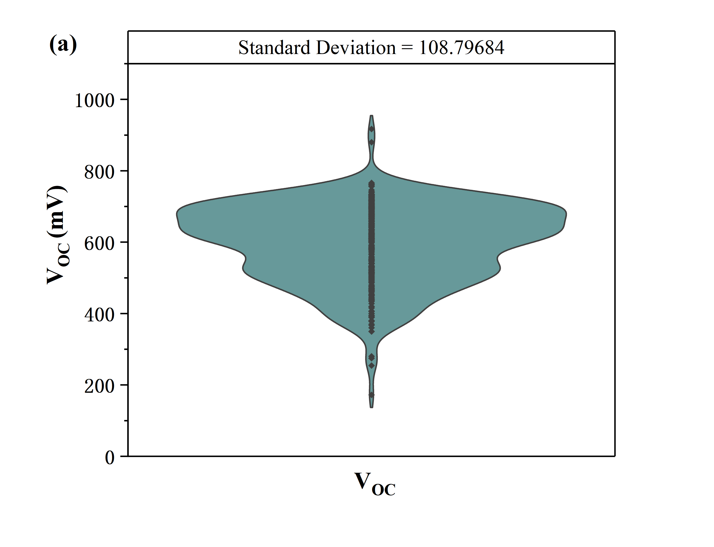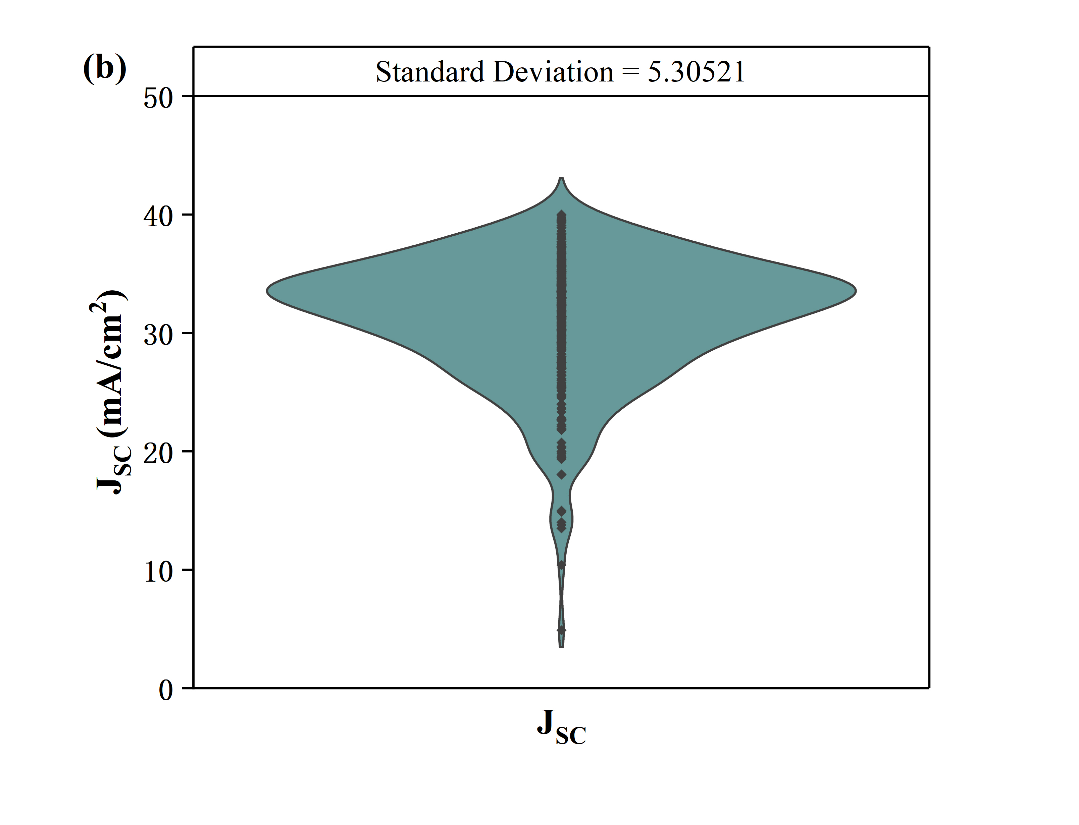

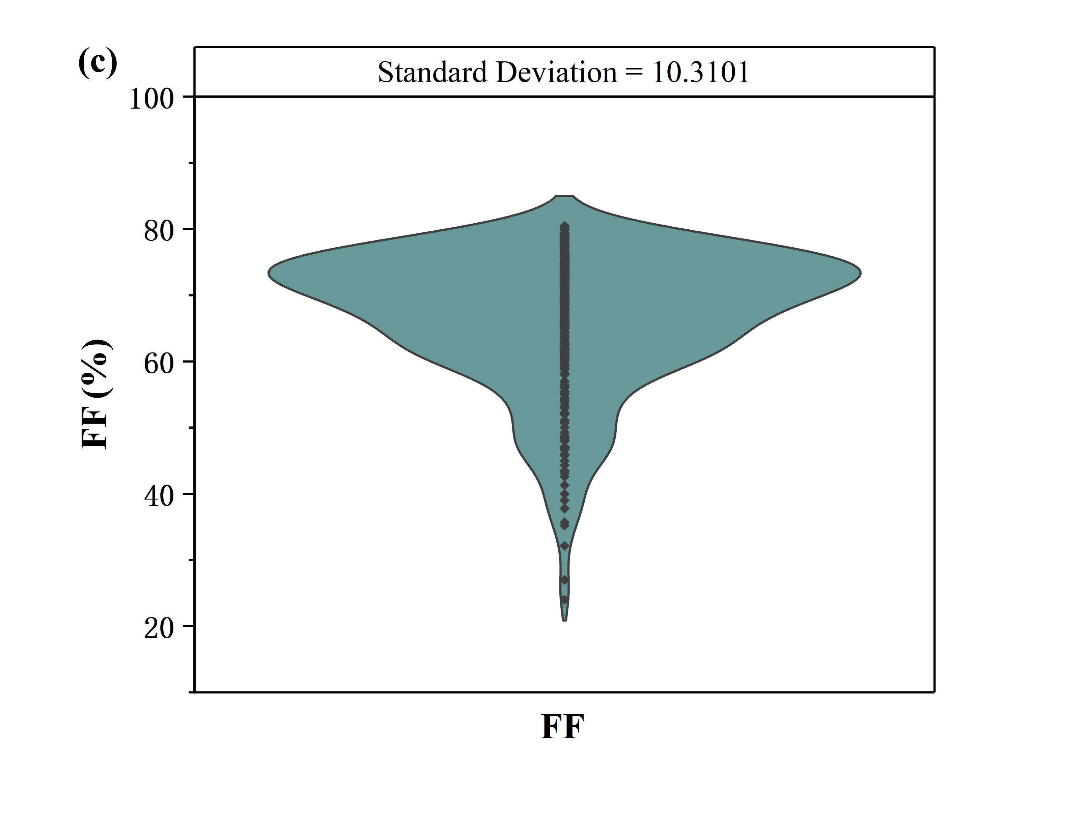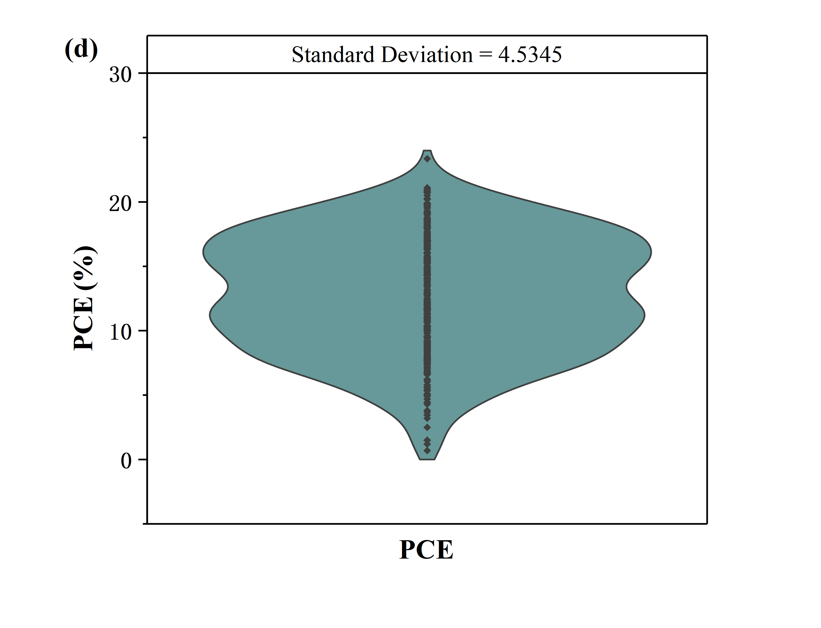

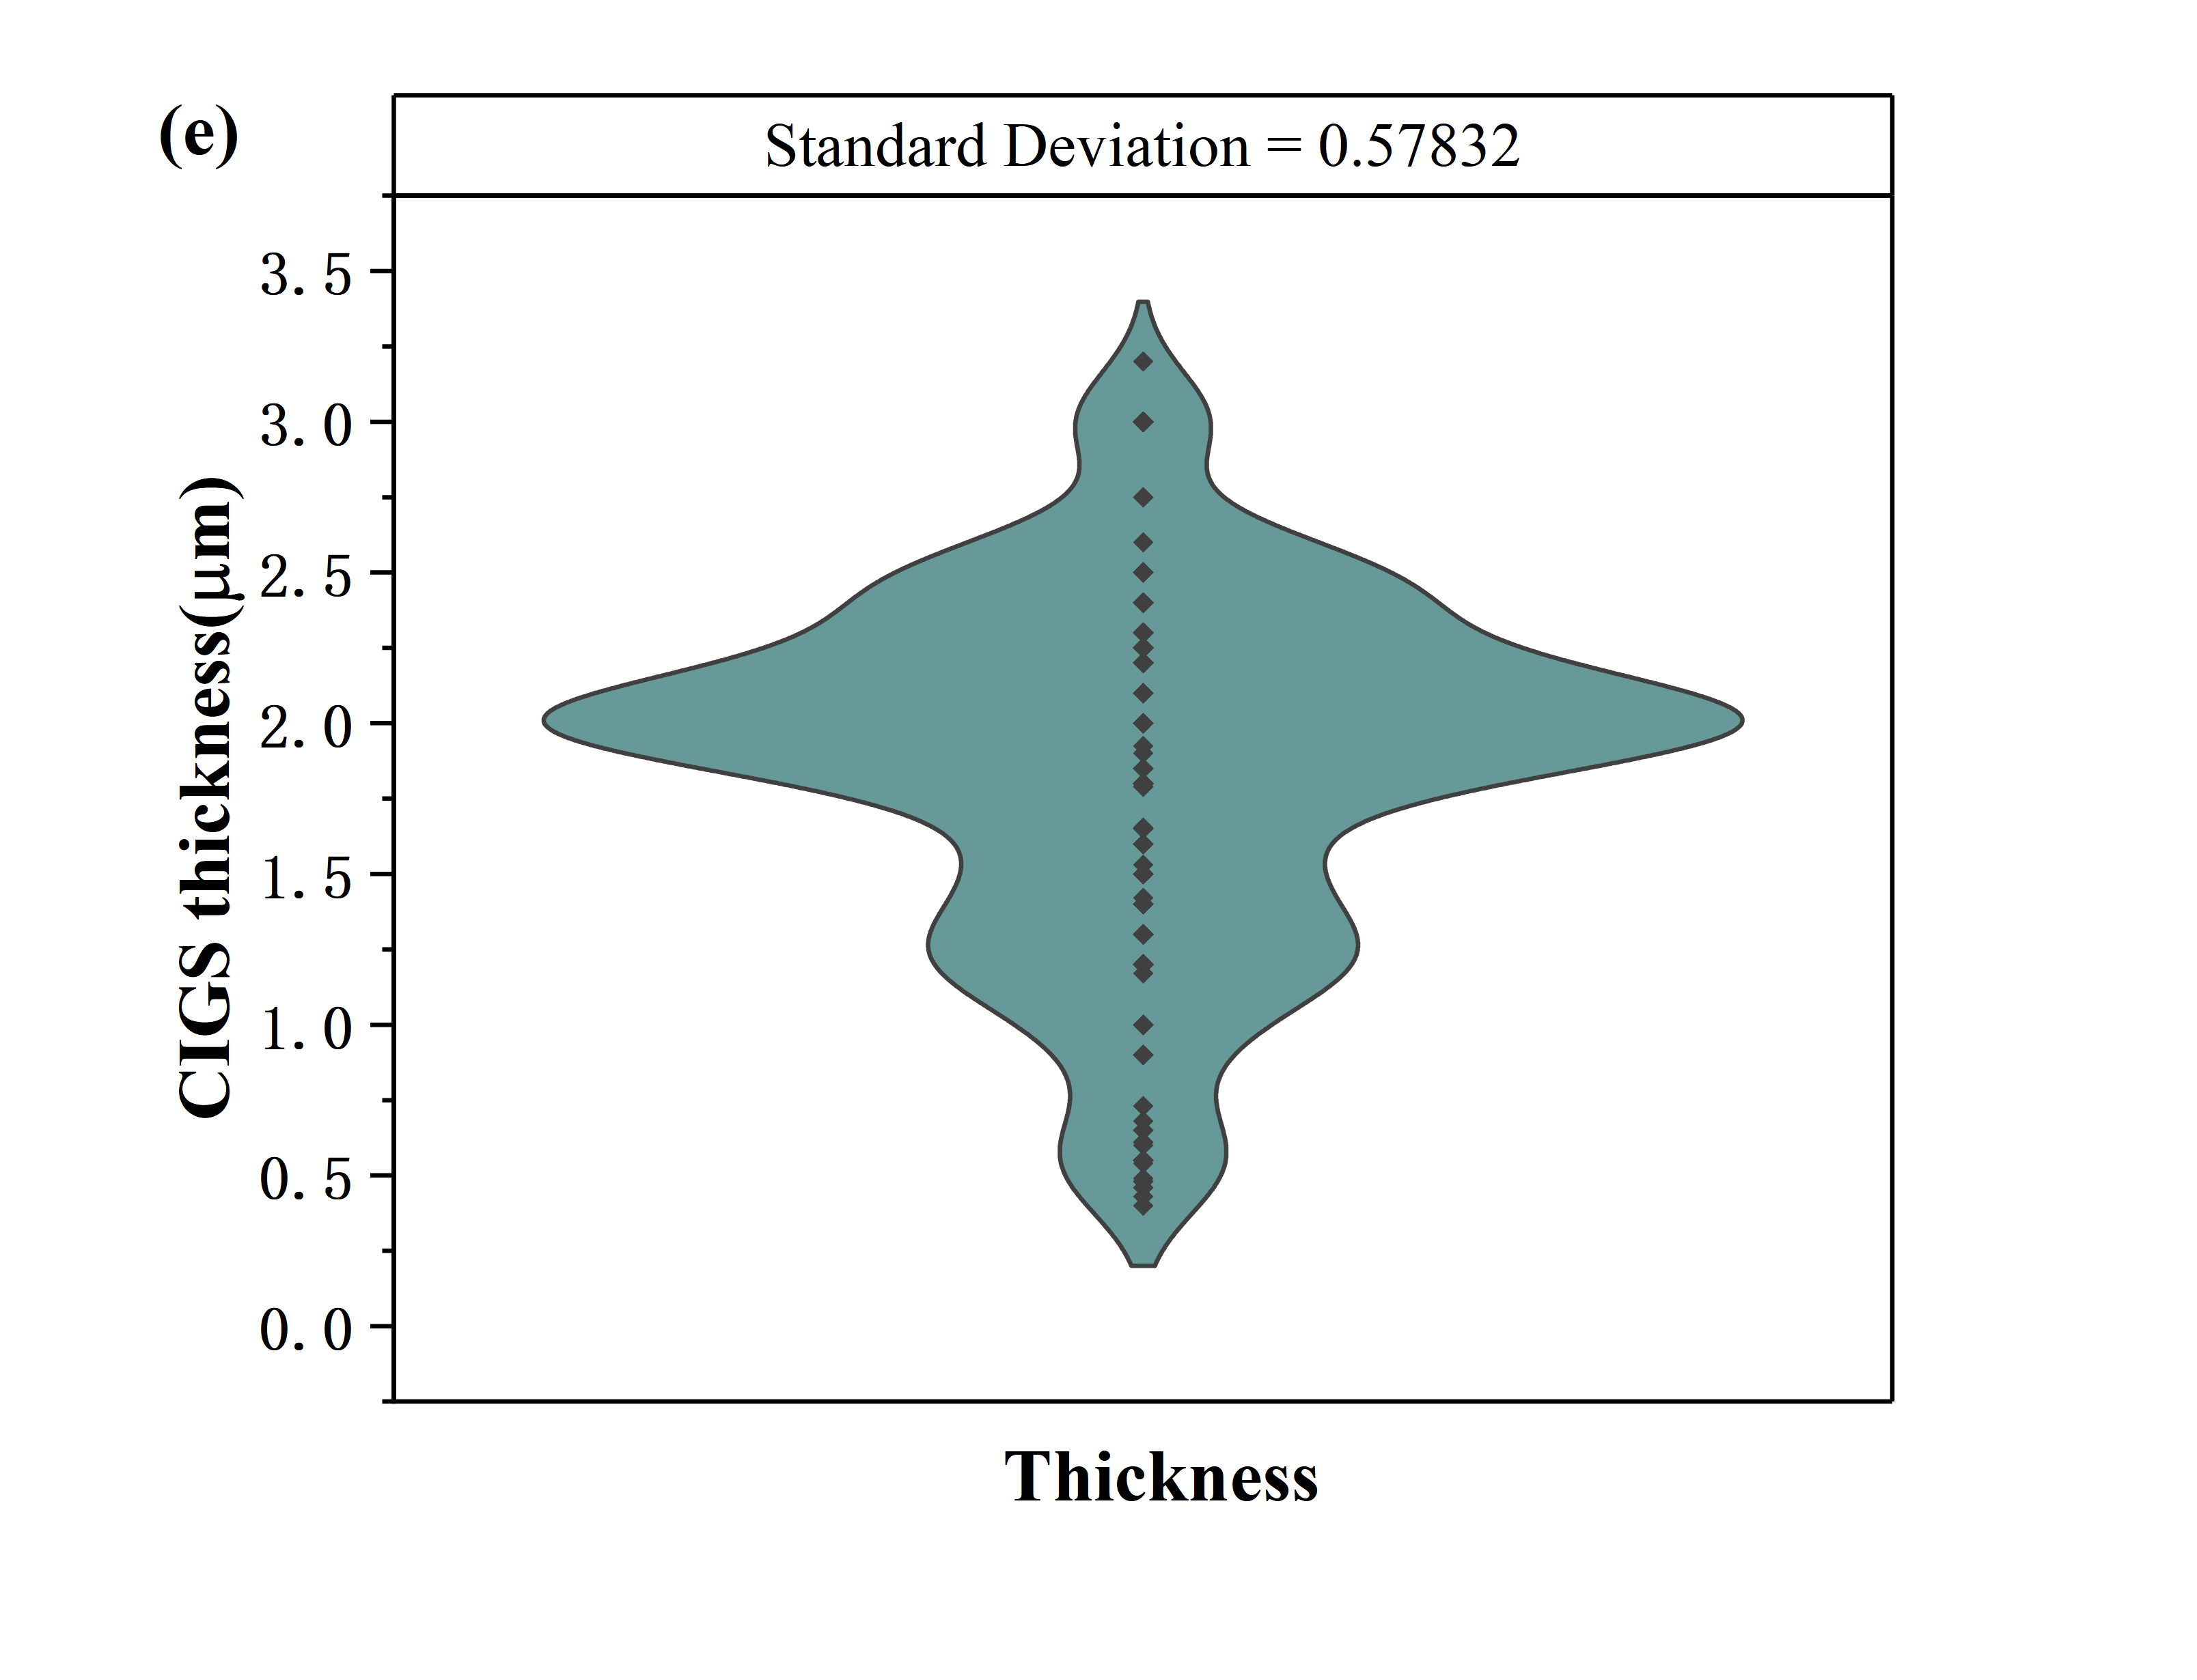

Fig. S1 Violin plots and the standard deviations of the photovoltaic parameters and the CIGS layer thickness. Outliners with extreme low values present in VOC, JSC and FF, which are probably not caused by the considered factors but due to the poor experimental methods and/or other factors out of the consideration. These outliners may induce inaccuracy in ML and need to be concerned.

Table S3 Correlation matrix between the fabrication procedures/the device configuration factors of CIGS solar cells

|  |  |  |  |  |  |  |  |  |  |  |  |  |  |
| --- | --- | --- | --- | --- | --- | --- | --- | --- | --- | --- | --- | --- | --- |
|  | **CGI** | **GGIF** | **GGIM** | **GGIB** | **ES** | **AD** | **PDT** | **BL** | **FS** | **CT** | **BFT** | **CBO** | **ST** |
| **CGI** | 1 | -0.05 | 0 | 0 | 0.03 | -0.06 | 0.03 | 0.03 | -0.12 | 0.12 | -0.07 | -0.17 | 0.07 |
| **GGIF** | -0.05 | 1 | 0.63 | 0.66 | 0.26 | -0.01 | -0.1 | 0.07 | 0.11 | 0.07 | -0.17 | 0.11 | 0.05 |
| **GGIM** | 0 | 0.63 | 1 | 0.5 | 0.17 | 0.19 | 0.03 | -0.15 | -0.28 | 0.1 | -0.16 | 0.06 | 0.07 |
| **GGIB** | 0 | 0.66 | 0.5 | 1 | 0.24 | -0.01 | -0.08 | 0.1 | 0.15 | 0.03 | -0.21 | 0.07 | 0.17 |
| **ES** | 0.03 | 0.26 | 0.17 | 0.24 | 1 | 0.29 | 0.11 | 0.01 | -0.09 | 0.23 | -0.27 | -0.07 | -0.03 |
| **AD** | -0.06 | -0.01 | 0.19 | -0.01 | 0.29 | 1 | -0.07 | -0.27 | -0.55 | 0.03 | -0.08 | -0.07 | 0.17 |
| **PDT** | 0.03 | -0.1 | 0.03 | -0.08 | 0.11 | -0.07 | 1 | 0.09 | -0.05 | 0.17 | -0.28 | -0.12 | -0.12 |
| **BL** | 0.03 | 0.07 | -0.15 | 0.1 | 0.01 | -0.27 | 0.09 | 1 | 0.32 | -0.13 | -0.01 | -0.06 | 0.07 |
| **FS** | -0.12 | 0.11 | -0.28 | 0.15 | -0.09 | -0.55 | -0.05 | 0.32 | 1 | -0.08 | 0.22 | 0.12 | 0.06 |
| **CT** | 0.12 | 0.07 | 0.1 | 0.03 | 0.23 | 0.03 | 0.17 | -0.13 | -0.08 | 1 | -0.16 | 0.02 | -0.04 |
| **BFT** | -0.07 | -0.17 | -0.16 | -0.21 | -0.27 | -0.08 | -0.28 | -0.01 | 0.22 | -0.16 | 1 | 0.15 | 0.2 |
| **CBO** | -0.17 | 0.11 | 0.06 | 0.07 | -0.07 | -0.07 | -0.12 | -0.06 | 0.12 | 0.02 | 0.15 | 1 | -0.11 |
| **ST** | 0.07 | 0.05 | 0.07 | 0.17 | -0.03 | 0.17 | -0.12 | 0.07 | 0.06 | -0.04 | 0.2 | -0.11 | 1 |

Table S4 Data supplementing rules to create dataset C and E. We supplemented the missing data using the commonly used values for the data points.

|  |  |  |  |  |  |  |  |
| --- | --- | --- | --- | --- | --- | --- | --- |
|  | **CGI** | **GGIF** | **GGIM** | **GGIB** | **CT (μm)** | **ST (℃)** | **BFT (nm)** |
| **Supplementary value** | 0.89 | 0.30 | 0.30 | 0.30 | 2 | 550 | 50 |

Table S5 Performances of different ML algorithms in VOC prediction of the CIGS solar cells.

|  |  |  |  |  |  |  |  |
| --- | --- | --- | --- | --- | --- | --- | --- |
| **Datasets** | **ML algorithms** | **Training set** | | **Validation set** | | **Test set** | |
| RMSE (mV) | *r* value | RMSE (mV) | *r* value | RMSE (mV) | *r* value |
| B | *LR* | 80 | 0.72 | 75 | 0.72 | 61 | 0.78 |
| *RF* | 39 | 0.95 | 35 | 0.93 | 57 | 0.86 |
| *NN* | 40 | 0.90 | 48 | 0.86 | 79 | 0.81 |
| *XG* | 12 | 0.99 | 59 | 0.86 | 66 | 0.75 |
| C | *LR* | 79 | 0.64 | 77 | 0.76 | 71 | 0.72 |
| *RF* | 38 | 0.94 | 33 | 0.92 | 66 | 0.82 |
| *NN* | 45 | 0.90 | 31 | 0.96 | 96 | 0.62 |
| *XG* | 17 | 0.99 | 66 | 0.81 | 68 | 0.74 |
| D | *LR* | 57 | 0.71 | 44 | 0.89 | 58 | 0.61 |
| *RF* | 33 | 0.94 | 34 | 0.84 | 50 | 0.80 |
| *NN* | 26 | 0.94 | 28 | 0.93 | 67 | 0.71 |
| *XG* | 7 | 1.00 | 37 | 0.89 | 59 | 0.76 |
| E | *LR* | 55 | 0.71 | 51 | 0.55 | 64 | 0.43 |
| *RF* | 32 | 0.93 | 23 | 0.95 | 47 | 0.80 |
| *NN* | 41 | 0.84 | 41 | 0.80 | 61 | 0.74 |
| *XG* | 11 | 0.99 | 43 | 0.81 | 51 | 0.70 |

Table S6 Performances of different ML algorithms in FF prediction of the CIGS solar cells.

|  |  |  |  |  |  |  |  |
| --- | --- | --- | --- | --- | --- | --- | --- |
| **Datasets** | **ML algorithms** | **Training set** | | **Validation set** | | **Test set** | |
| RMSE (%) | *r* value | RMSE (%) | *r* value | RMSE (%) | *r* value |
| B | *LR* | 7.6 | 0.56 | 5.5 | 0.67 | 9.6 | 0.37 |
| *RF* | 4.5 | 0.90 | 5.4 | 0.55 | 6.5 | 0.81 |
| *NN* | 4.0 | 0.87 | 4.8 | 0.86 | 10.4 | 0.44 |
| *XG* | 2.6 | 0.96 | 5.8 | 0.63 | 8.5 | 0.57 |
| C | *LR* | 9.2 | 0.42 | 7.7 | 0.44 | 10.0 | 0.28 |
| *RF* | 4.9 | 0.91 | 3.8 | 0.90 | 6.4 | 0.73 |
| *NN* | 4.3 | 0.88 | 6.5 | 0.52 | 13.1 | 0.23 |
| *XG* | 2.2 | 0.98 | 8.5 | 0.68 | 8.3 | 0.55 |
| D | *LR* | 4.1 | 0.61 | 3.6 | 0.48 | 5.2 | 0.29 |
| *RF* | 2.0 | 0.93 | 1.4 | 0.95 | 3.5 | 0.81 |
| *NN* | 2.4 | 0.87 | 2.3 | 0.86 | 4.4 | 0.57 |
| *XG* | 0.4 | 1.00 | 3.2 | 0.77 | 4.6 | 0.58 |
| E | *LR* | 6.0 | 0.40 | 4.9 | 0.39 | 4.8 | 0.36 |
| *RF* | 2.5 | 0.92 | 2.1 | 0.93 | 4.3 | 0.67 |
| *NN* | 2.5 | 0.90 | 2.7 | 0.86 | 8.5 | 0.27 |
| *XG* | 1.2 | 0.98 | 4.4 | 0.75 | 5.8 | 0.30 |

Table S7 Performances of different ML algorithms in JSC prediction of the CIGS solar cells.

|  |  |  |  |  |  |  |  |
| --- | --- | --- | --- | --- | --- | --- | --- |
| **Datasets** | **ML algorithms** | **Training set** | | **Validation set** | | **Test set** | |
| RMSE (mA/cm2) | *r* value | RMSE (mA/cm2) | *r* value | RMSE (mA/cm2) | *r* value |
| B | *LR* | 3.8 | 0.67 | 4.0 | 0.66 | 5.0 | 0.63 |
| *RF* | 2.0 | 0.96 | 1.8 | 0.97 | 3.1 | 0.83 |
| *NN* | 1.8 | 0.95 | 3.2 | 0.73 | 6.0 | 0.52 |
| *XG* | 1.0 | 0.98 | 3.4 | 0.75 | 3.7 | 0.79 |
| C | *LR* | 4.4 | 0.62 | 4.0 | 0.66 | 3.9 | 0.50 |
| *RF* | 1.9 | 0.95 | 1.9 | 0.94 | 4.2 | 0.76 |
| *NN* | 2.4 | 0.87 | 2.8 | 0.76 | 4.1 | 0.75 |
| *XG* | 0.9 | 0.98 | 2.9 | 0.84 | 4.8 | 0.56 |
| D | *LR* | 3.4 | 0.63 | 3.1 | 0.44 | 3.1 | 0.60 |
| *RF* | 1.8 | 0.95 | 1.0 | 0.95 | 2.5 | 0.82 |
| *NN* | 2.3 | 0.84 | 3.2 | 0.40 | 3.6 | 0.50 |
| *XG* | 0.4 | 0.99 | 2.1 | 0.56 | 3.1 | 0.81 |
| E | *LR* | 3.2 | 0.60 | 2.9 | 0.54 | 3.0 | 0.37 |
| *RF* | 1.6 | 0.93 | 1.4 | 0.91 | 2.4 | 0.82 |
| *NN* | 1.9 | 0.86 | 1.9 | 0.79 | 4.3 | 0.38 |
| *XG* | 0.3 | 1.00 | 2.5 | 0.82 | 2.9 | 0.66 |

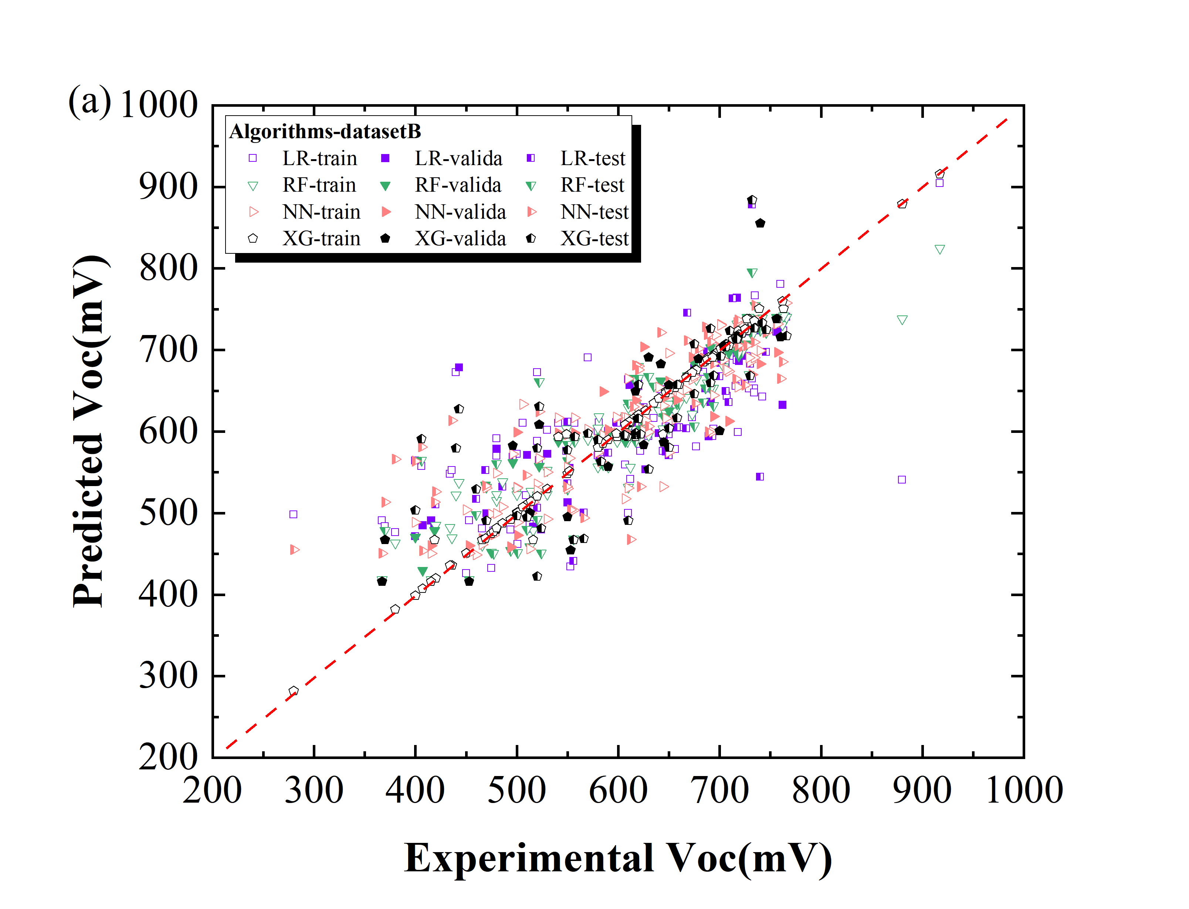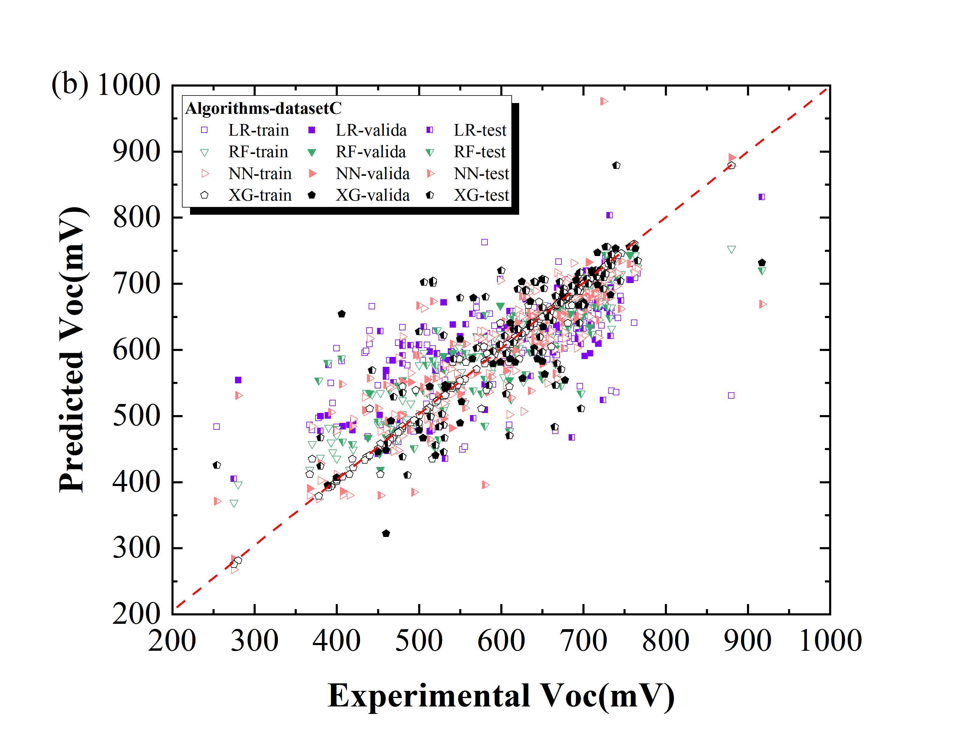

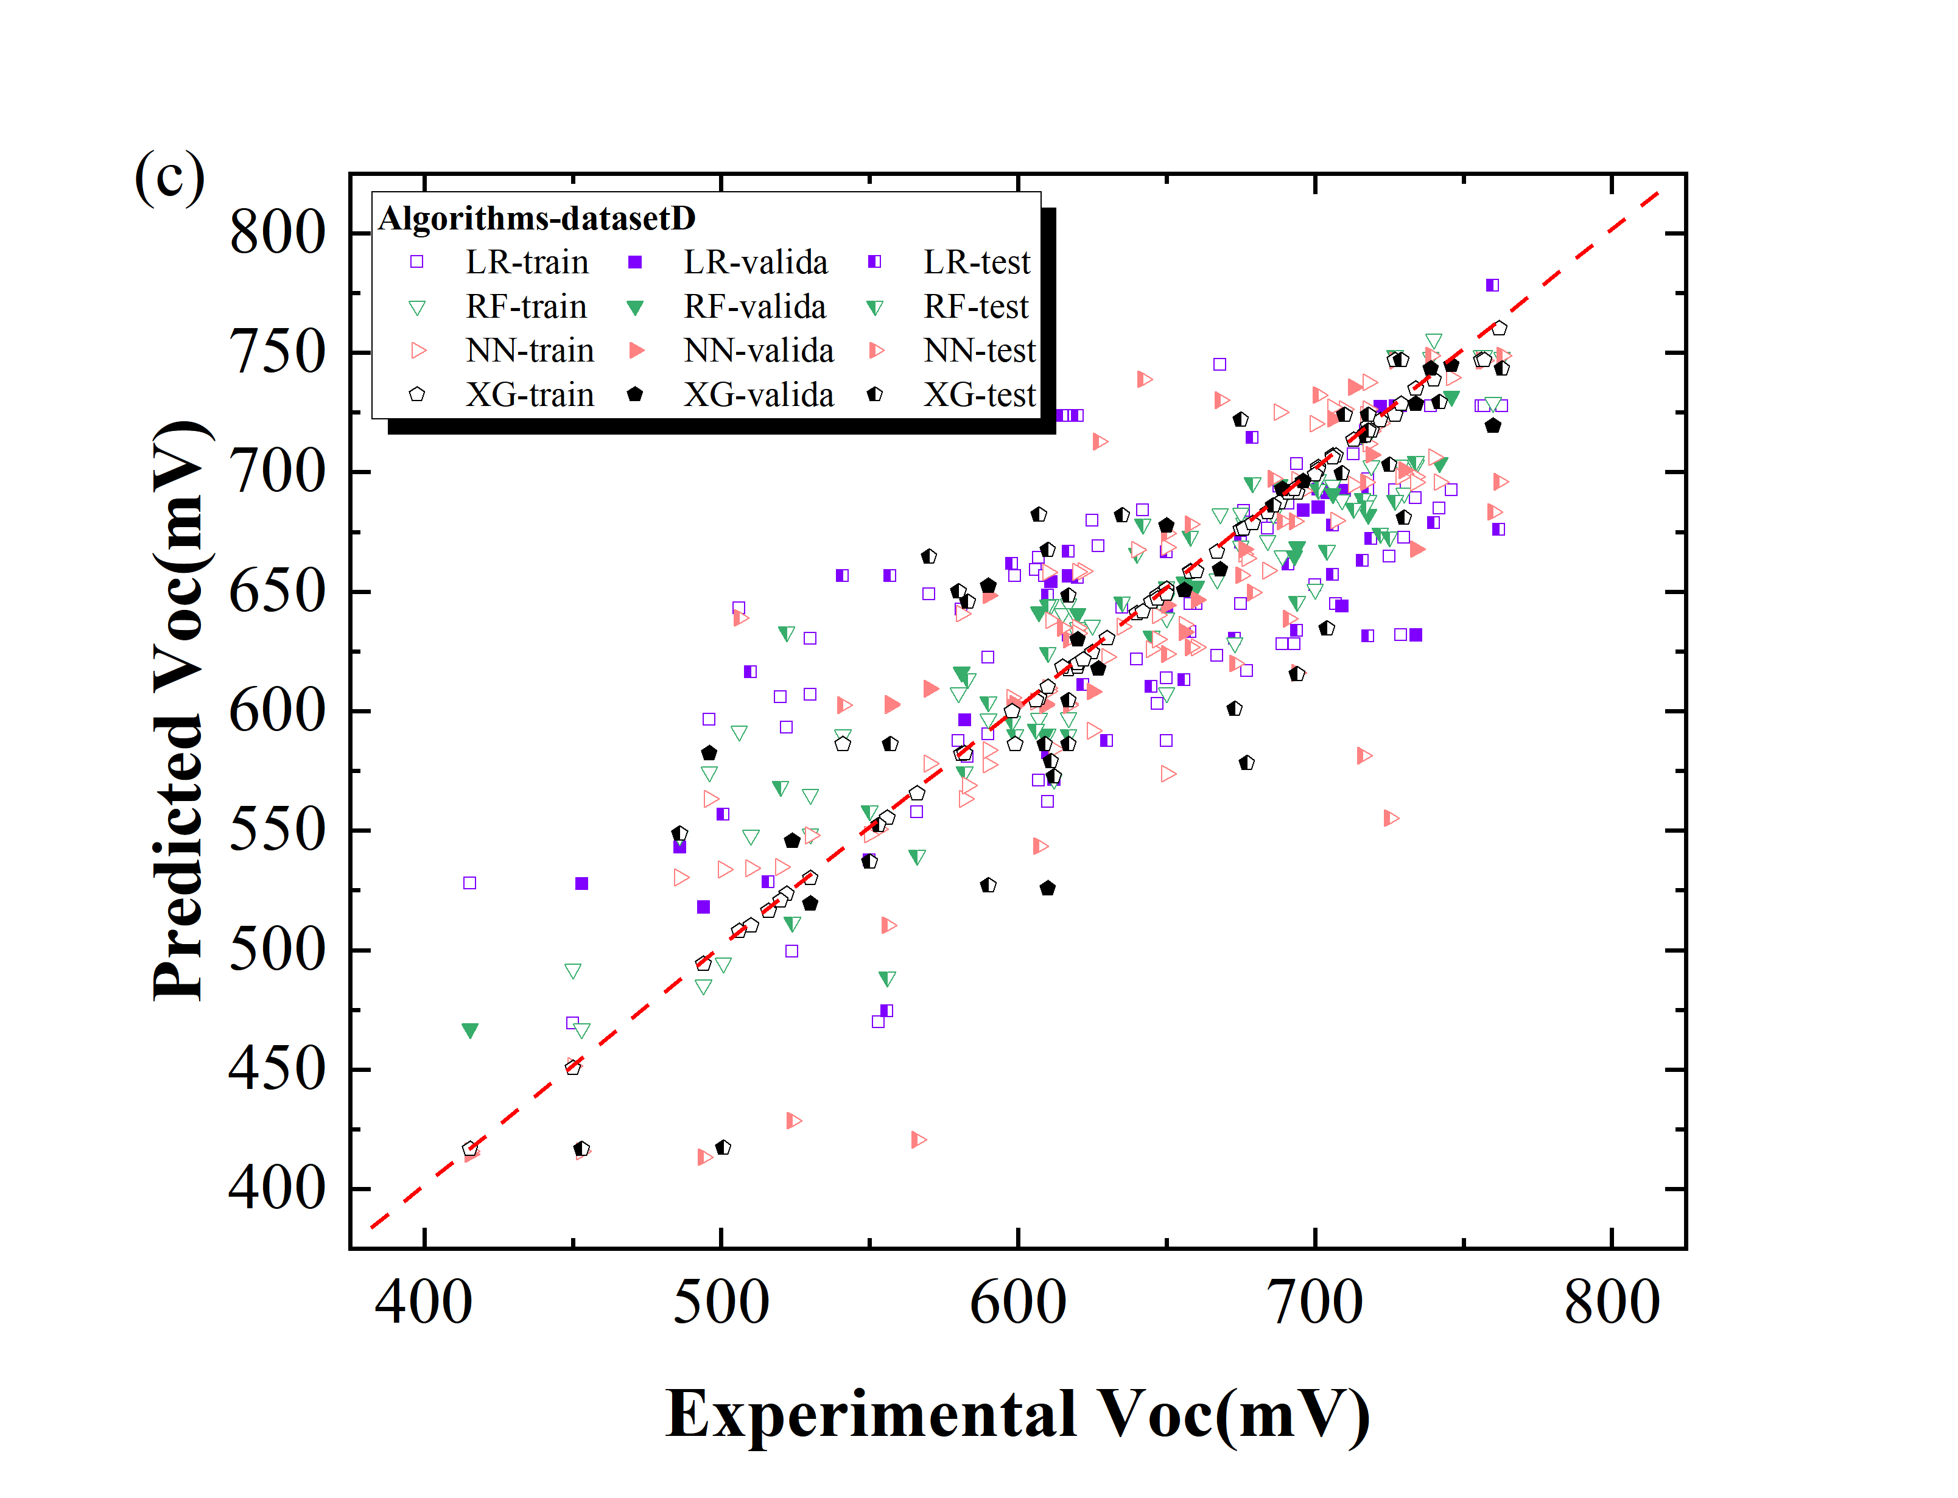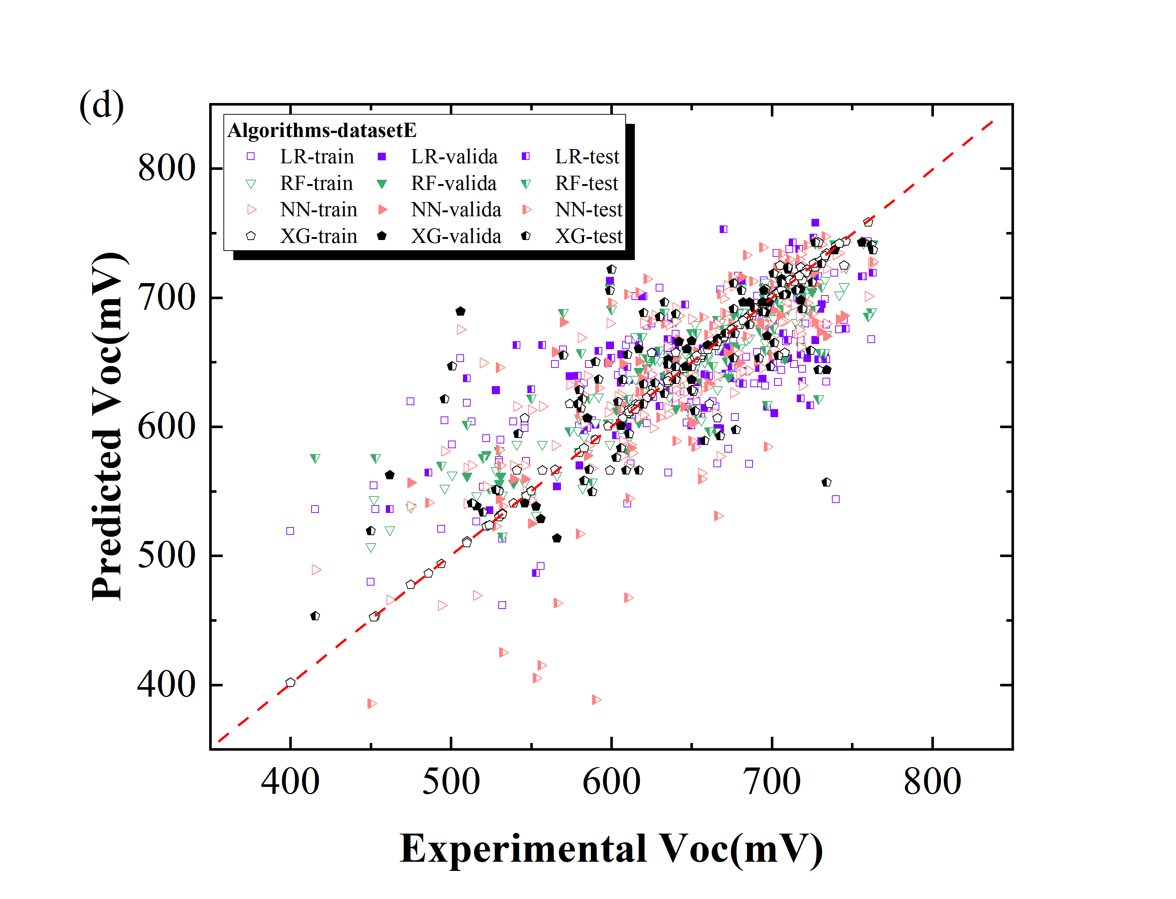

Fig. S2 Comparison of the experimental VOC values and the predicted values by different algorithms. The red dash line presents the condition in which the predicted value equals to the experimental value.

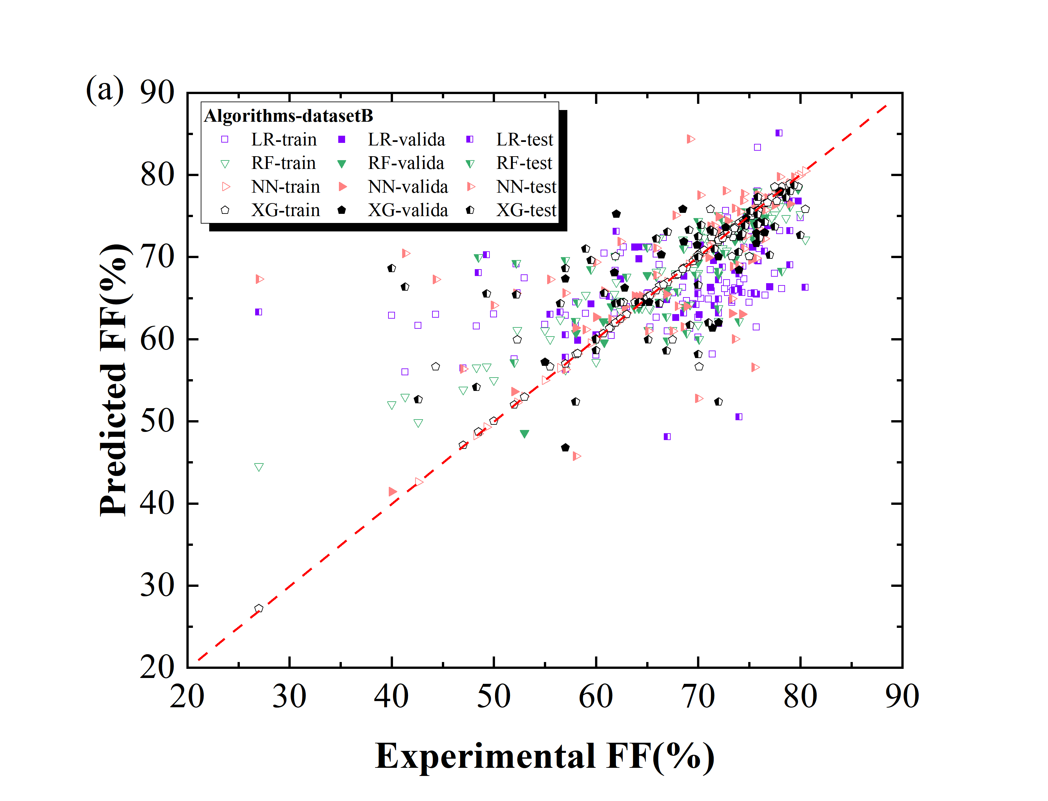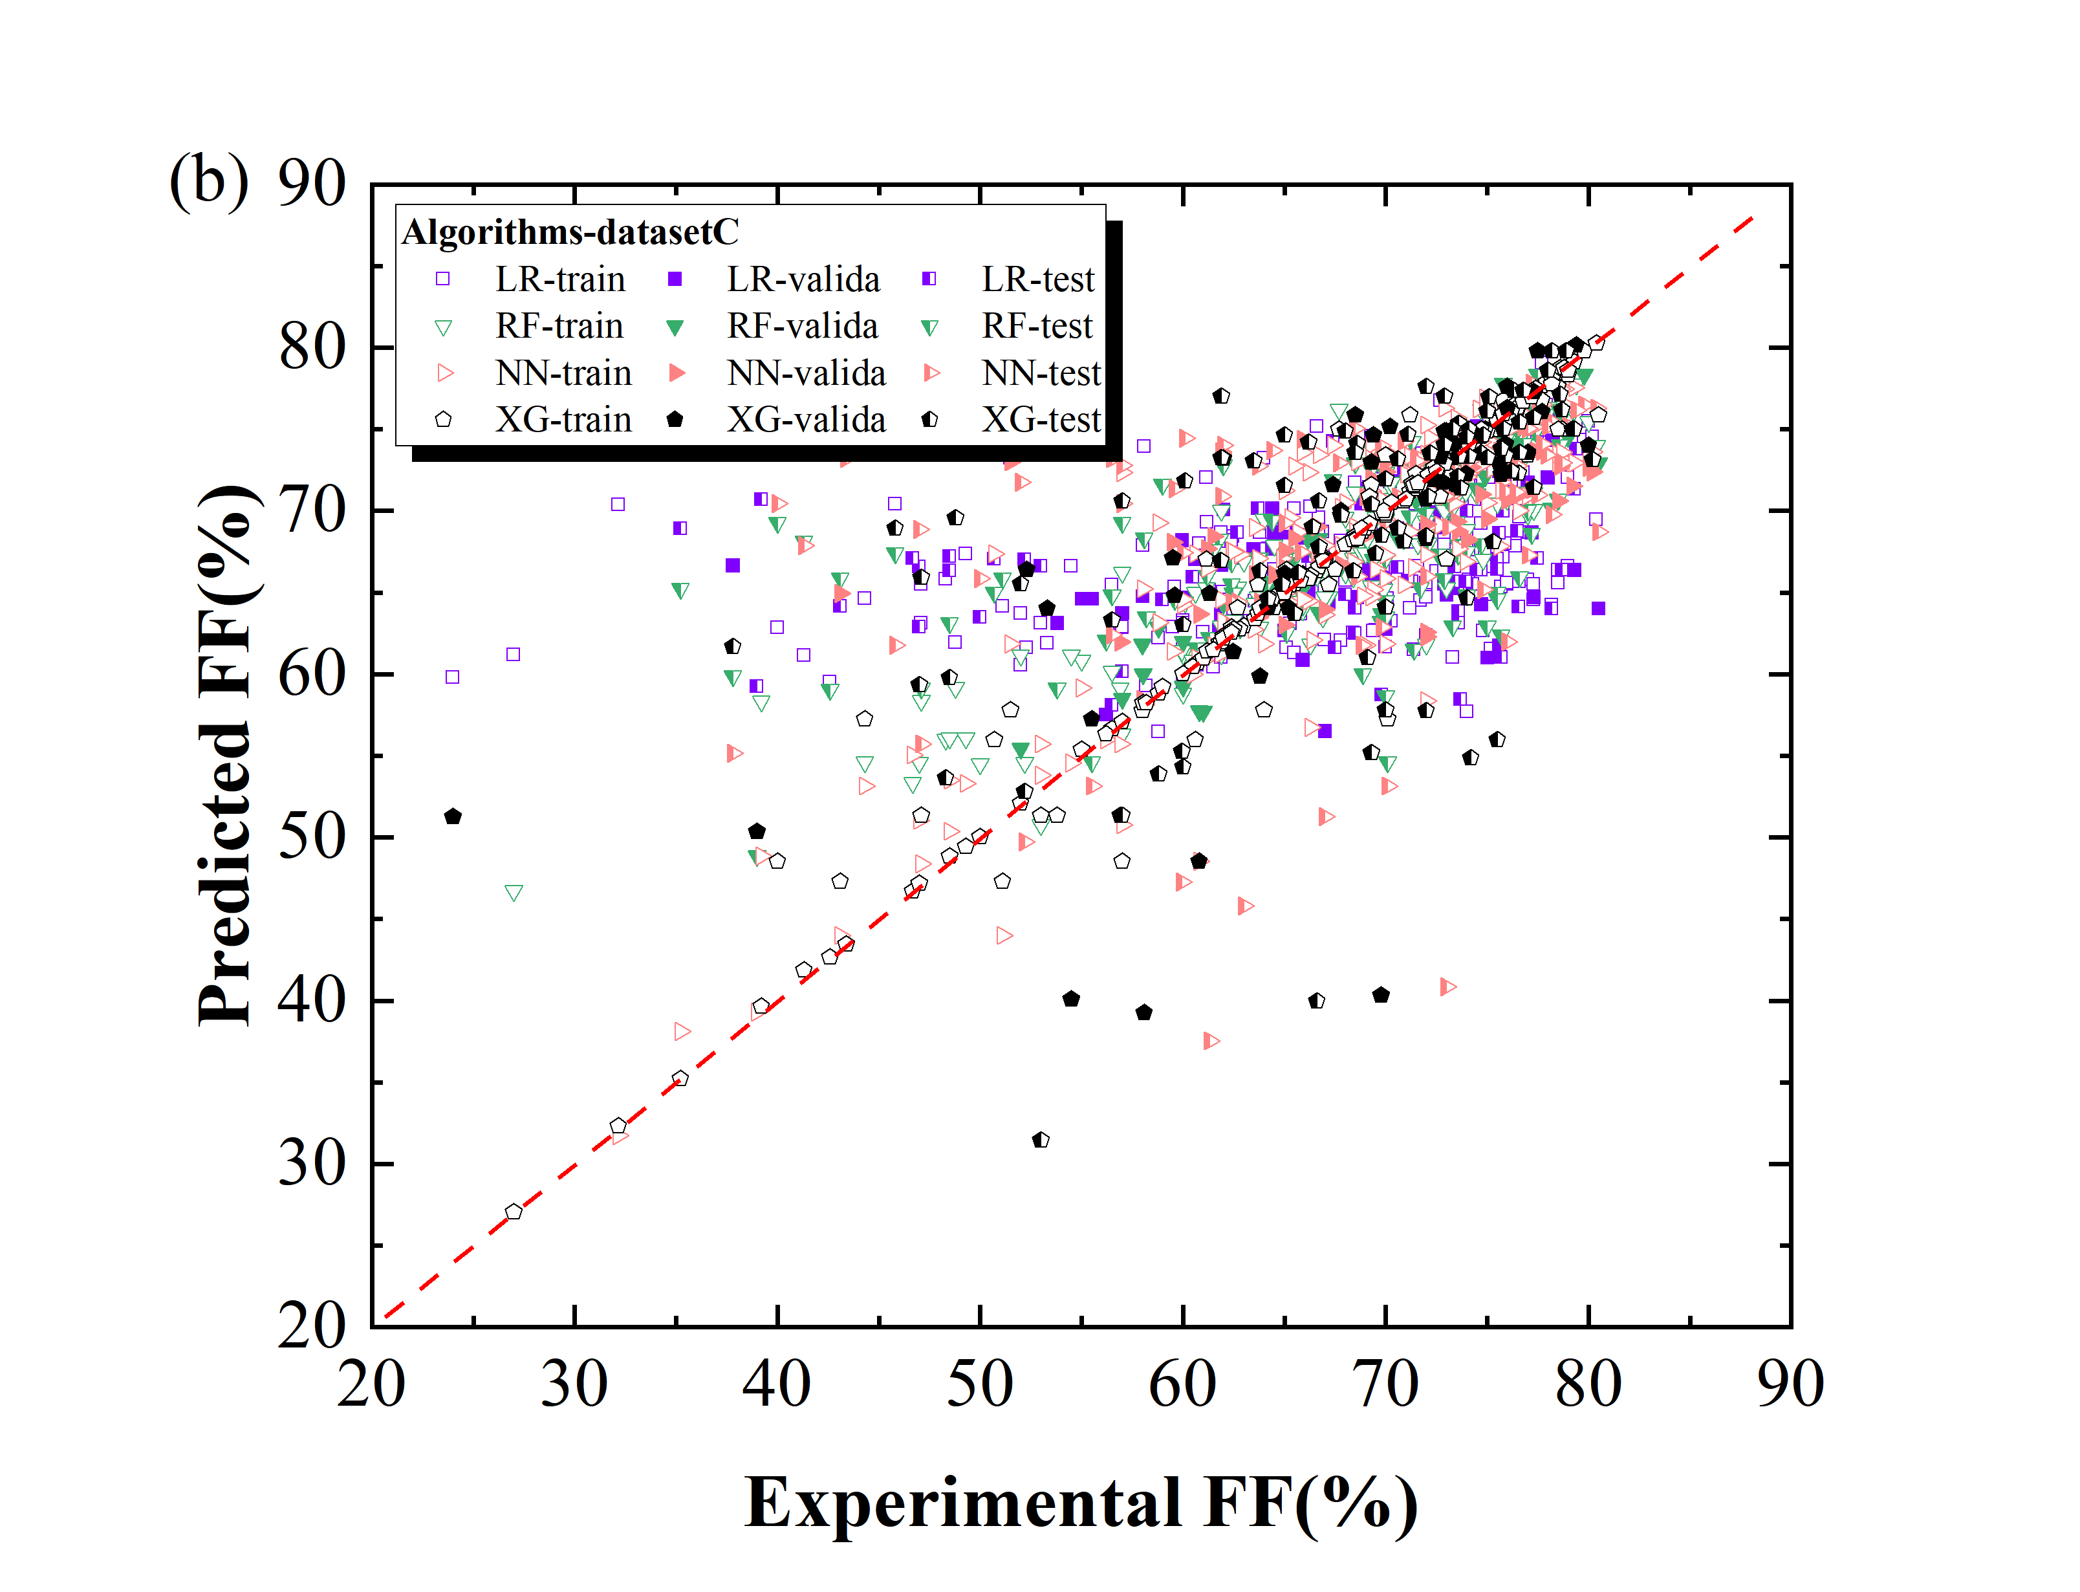

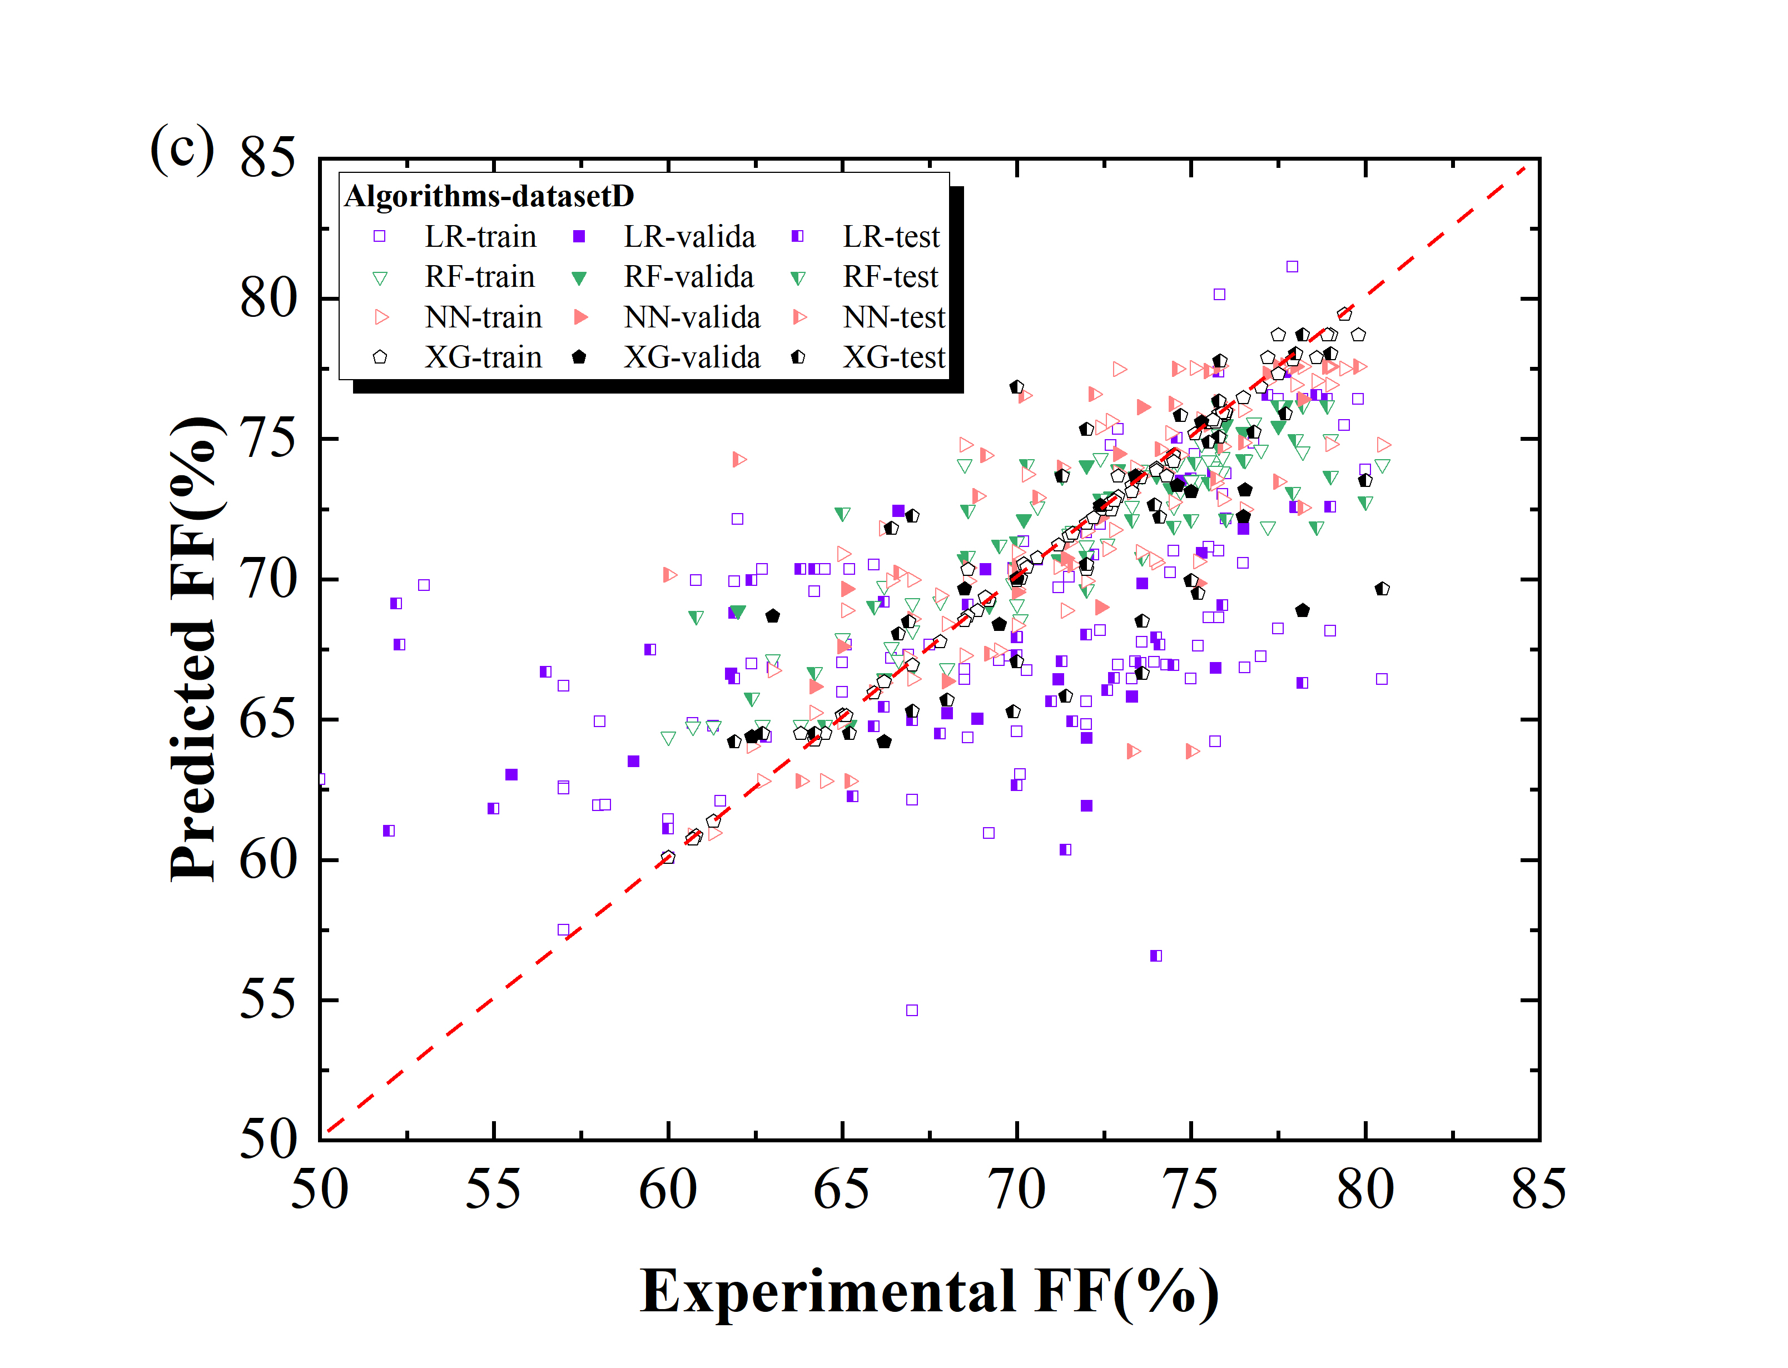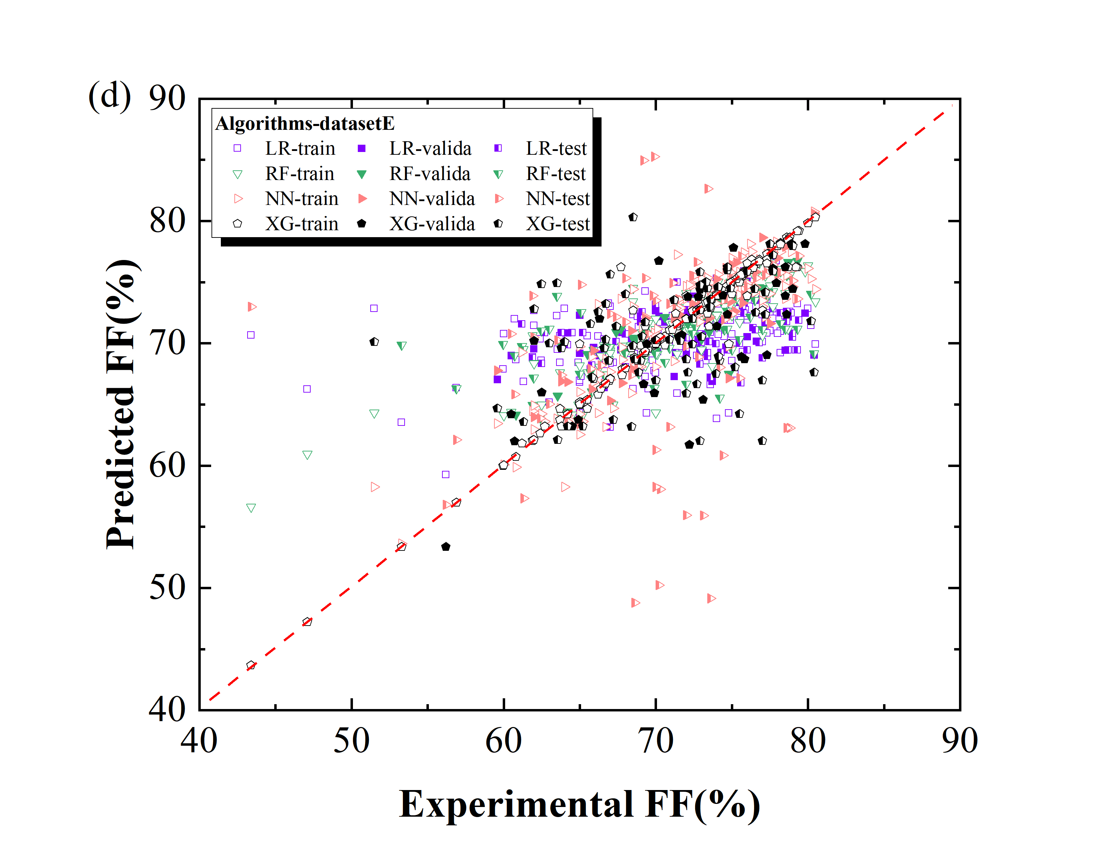

Fig. S3 Comparison of the experimental FF values and the predicted values by different algorithms. The red dash line presents the condition in which the predicted value equals to the experimental value.

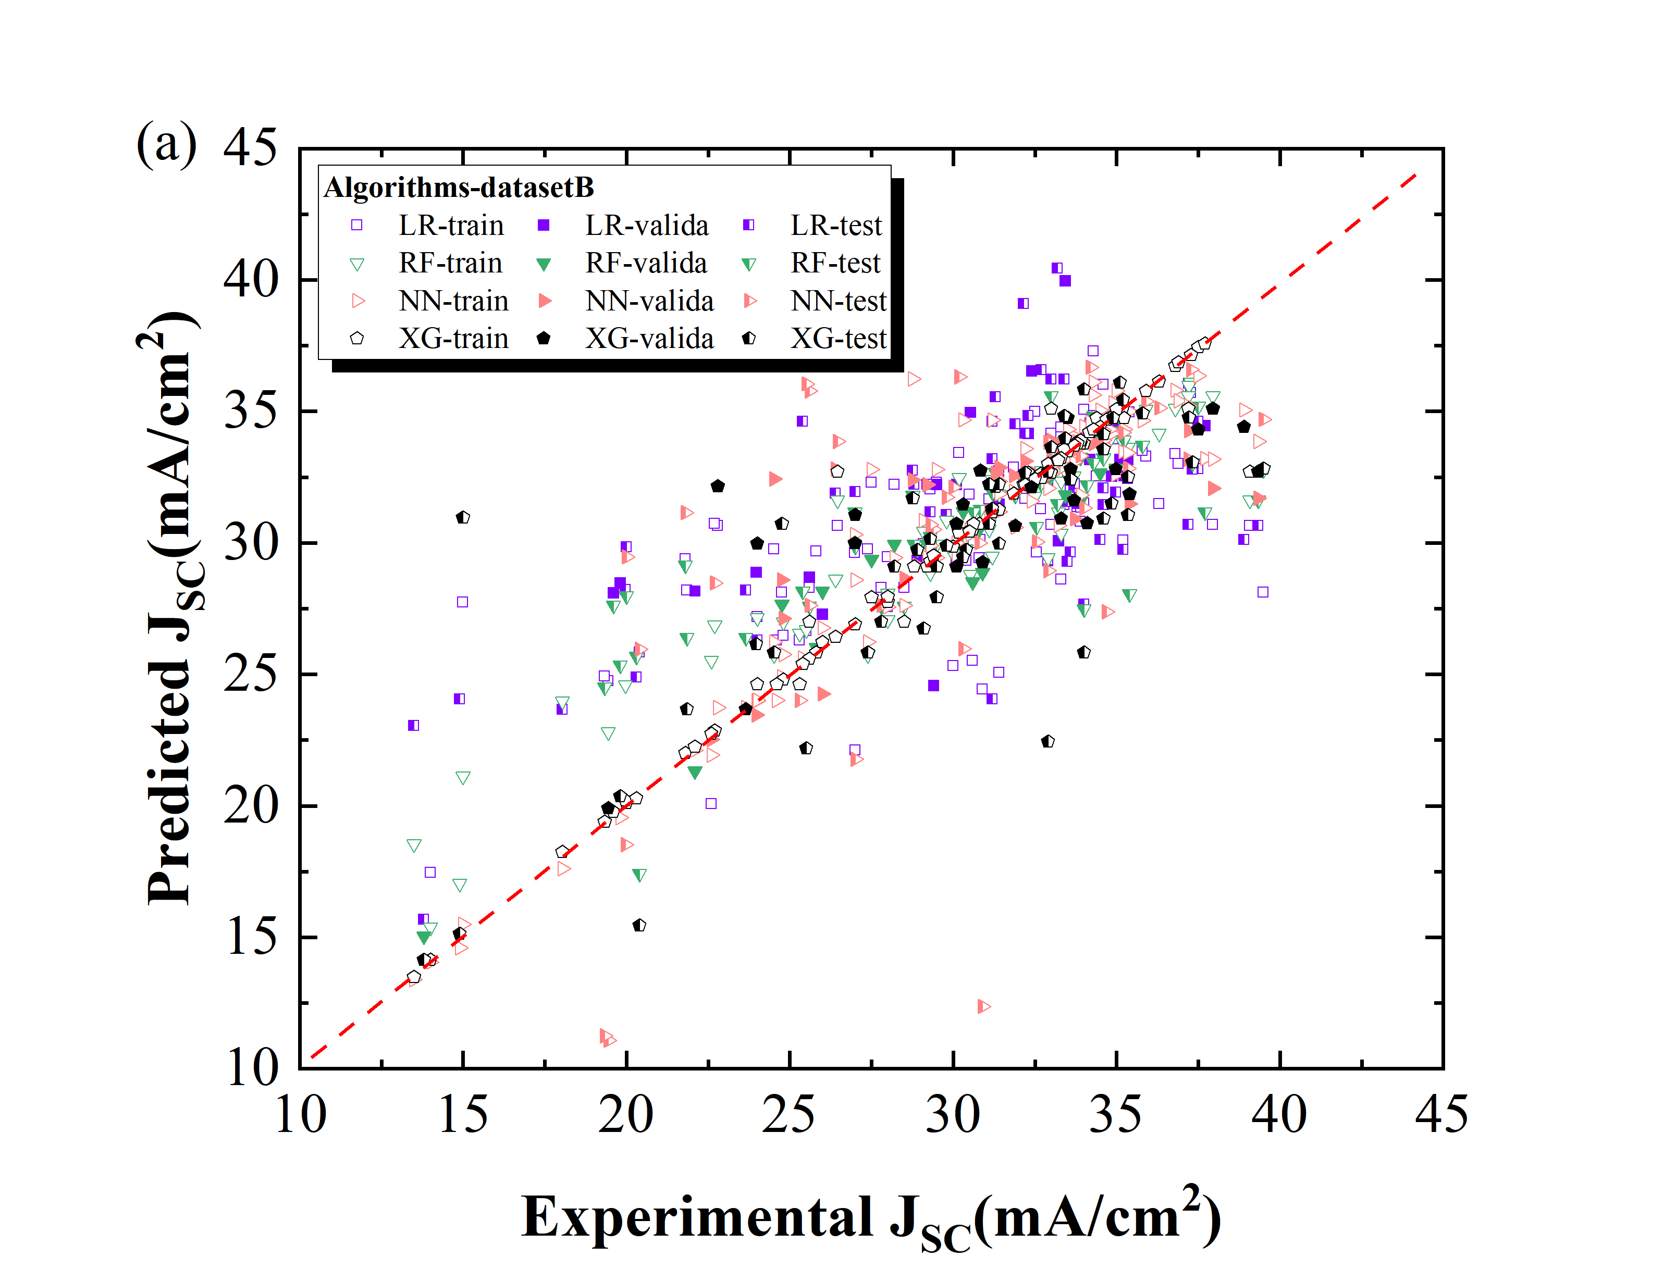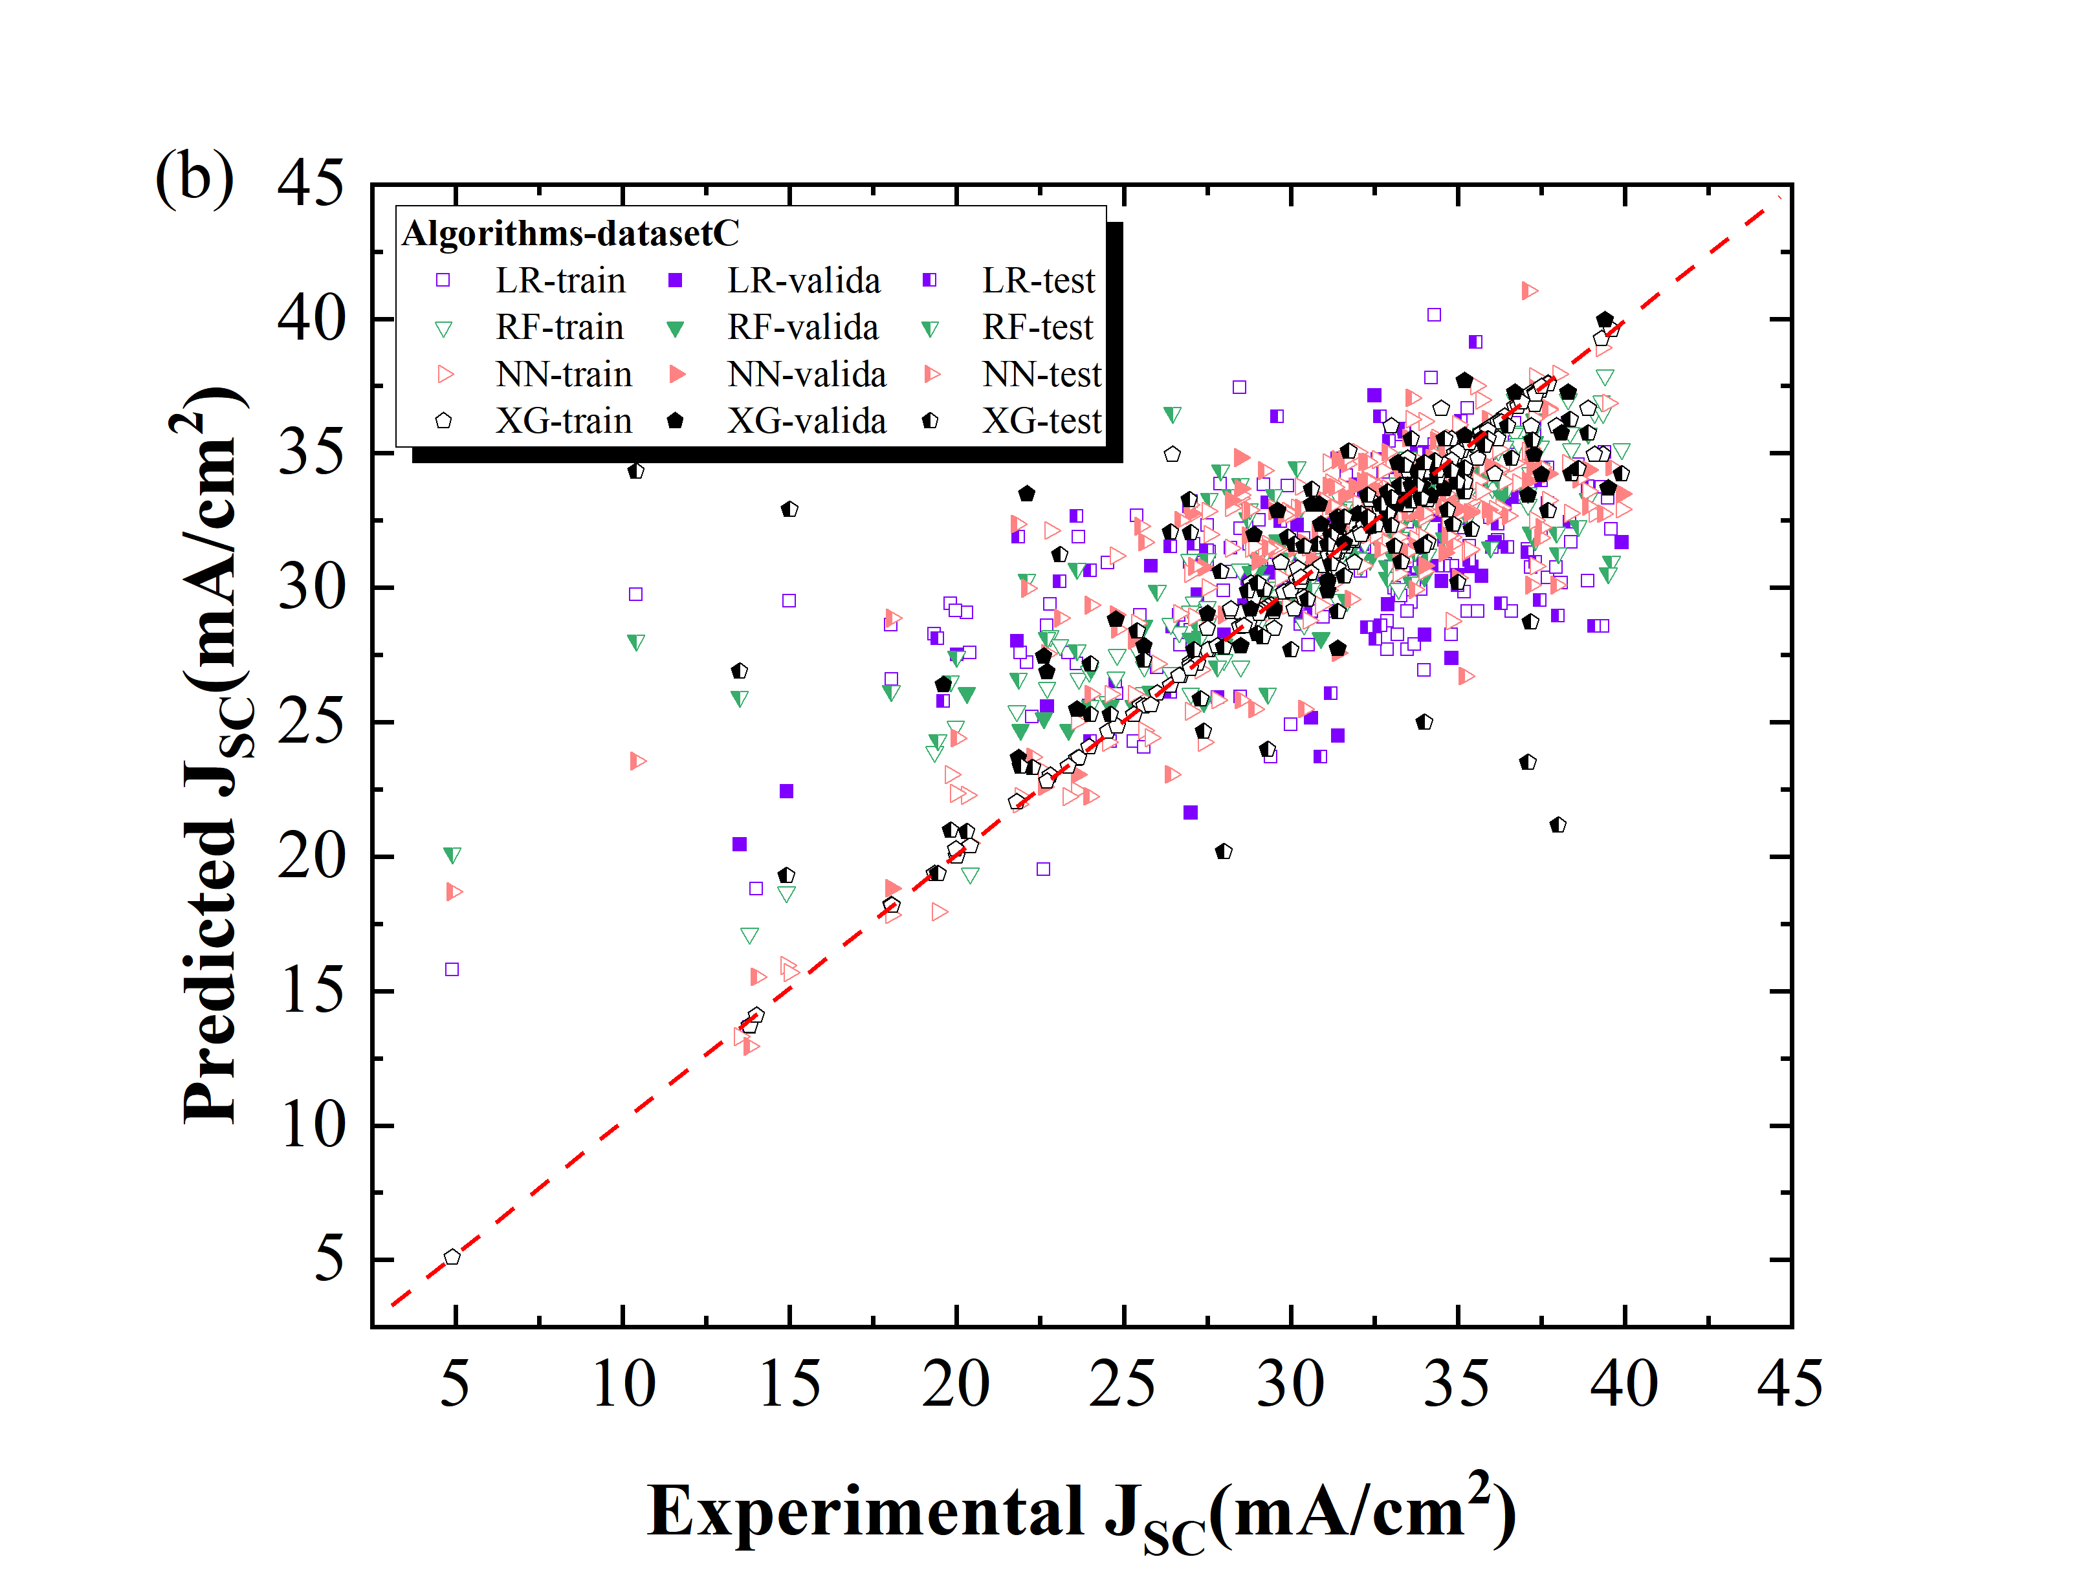

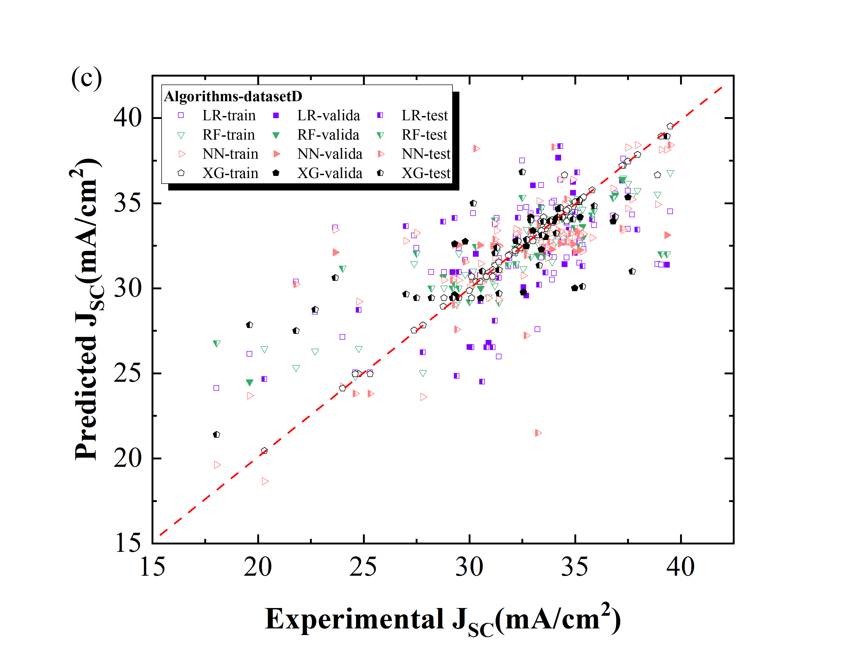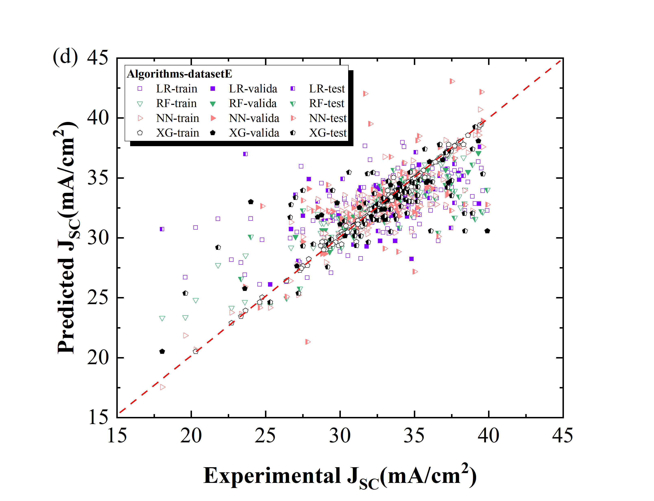

Fig. S4 Comparison of the experimental JSC values and the predicted values by different algorithms. The red dash line presents the condition in which the predicted value equals to the experimental value.

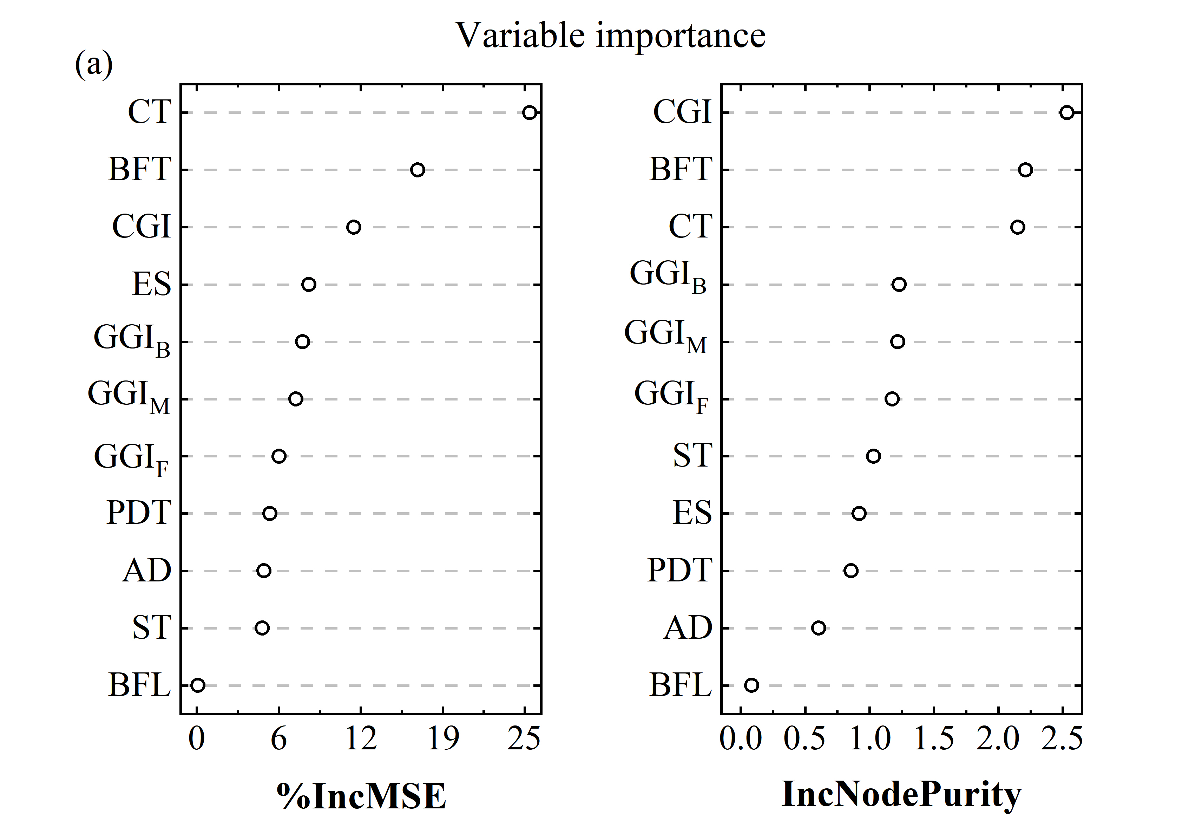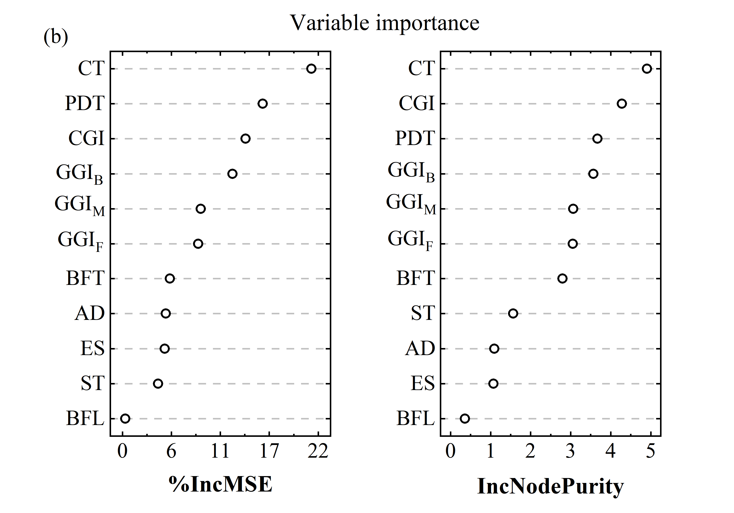

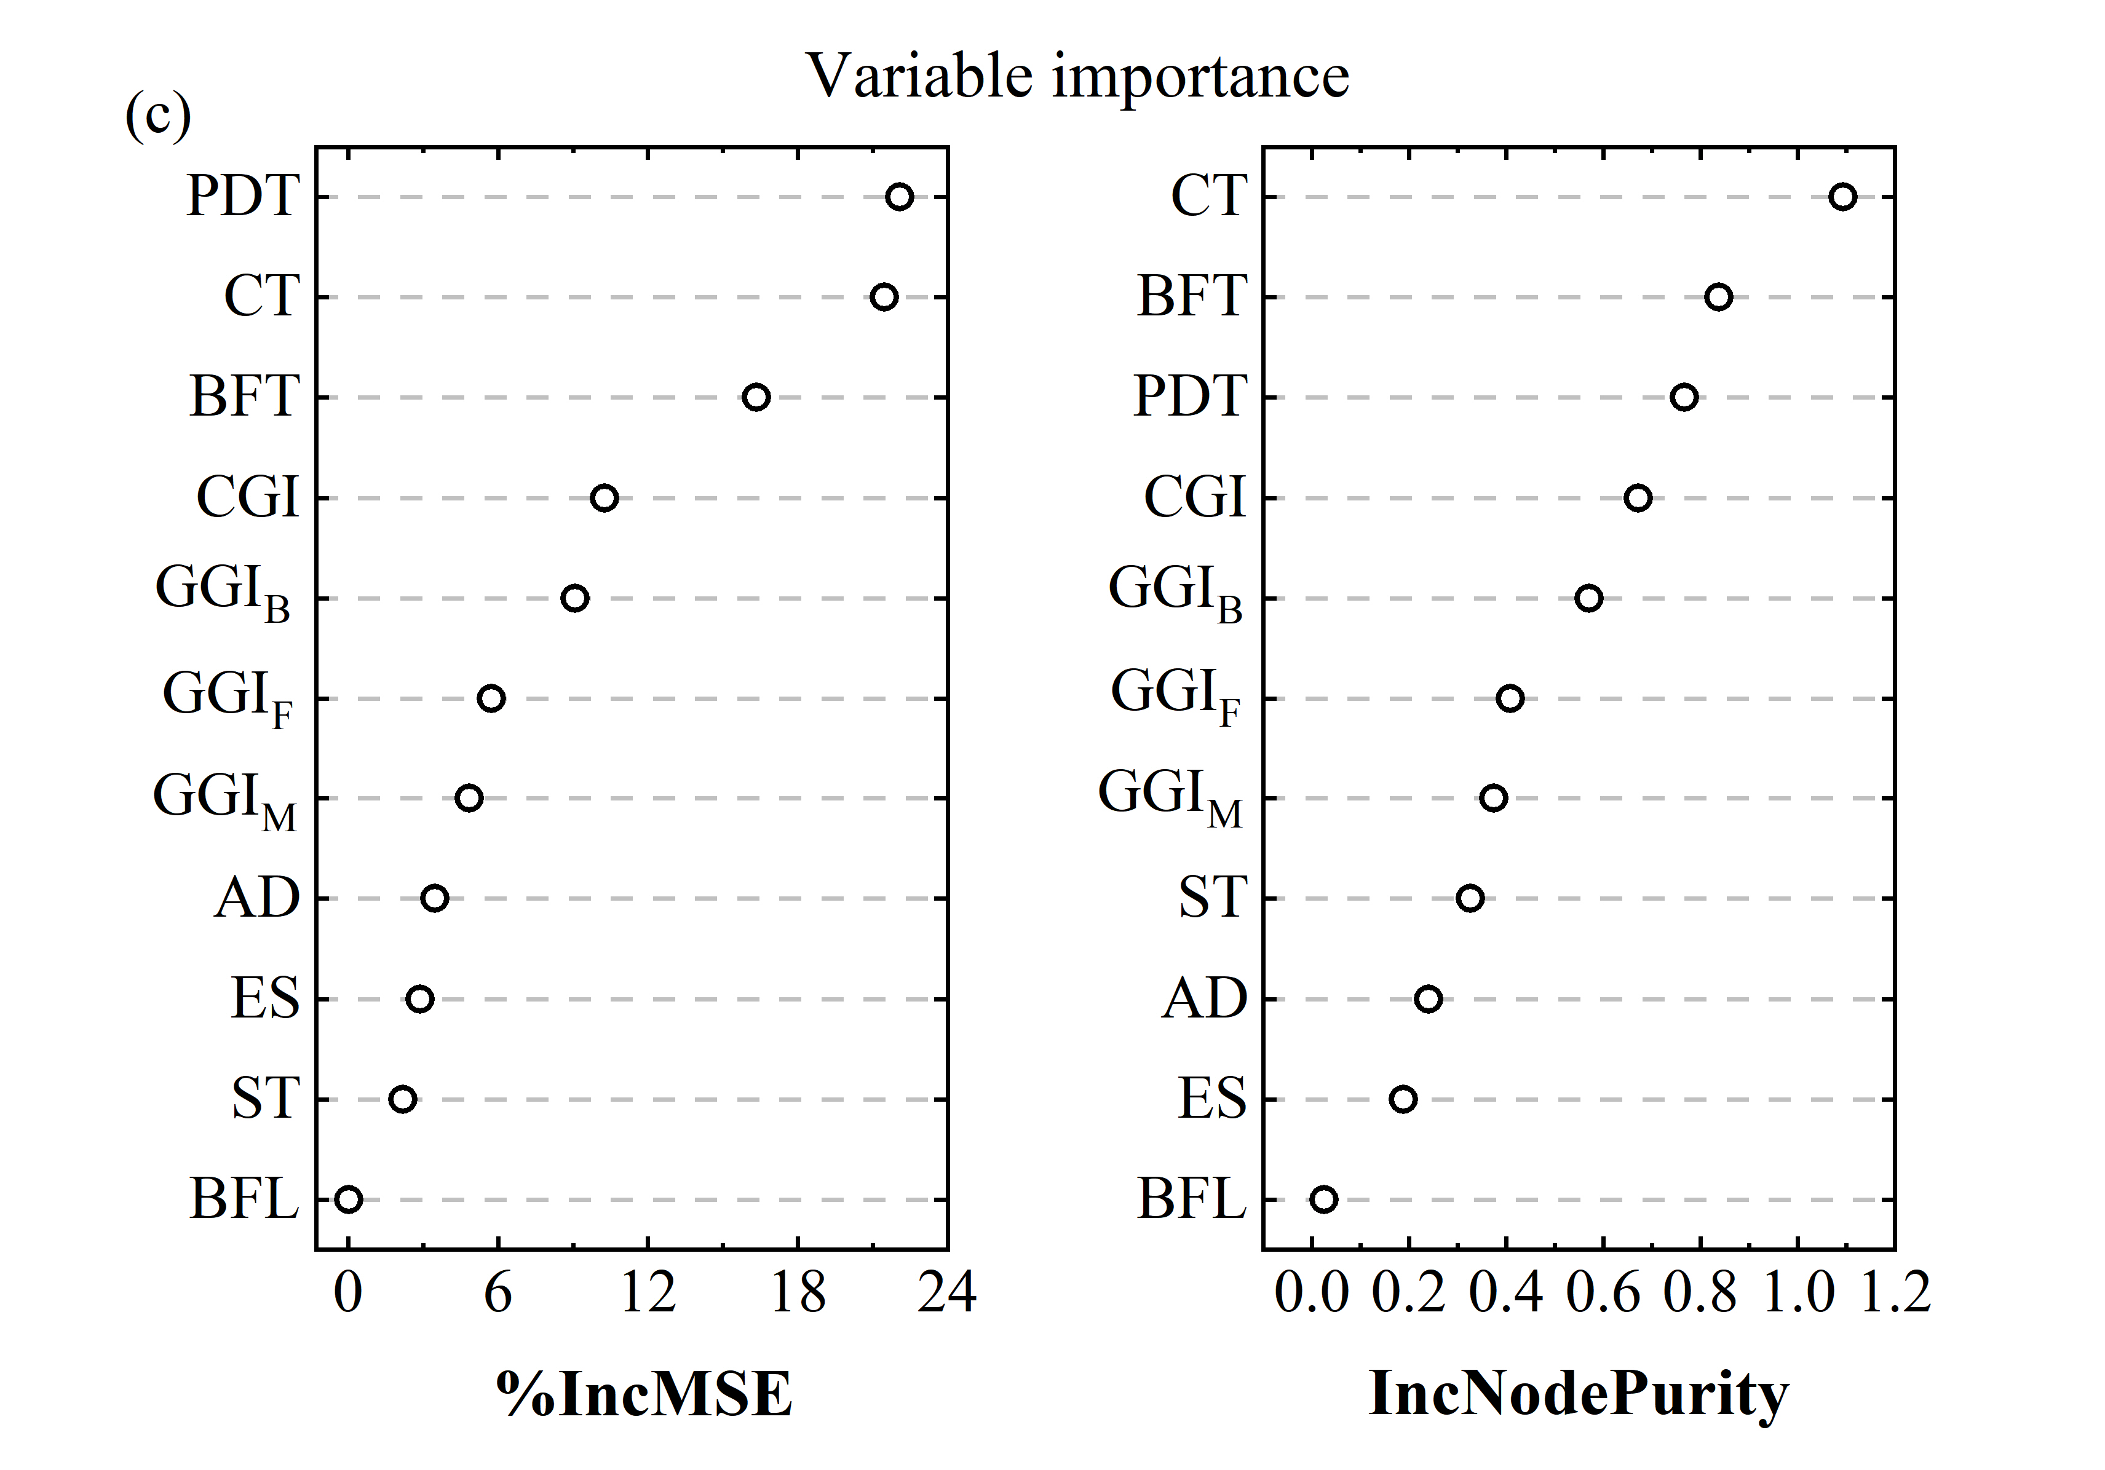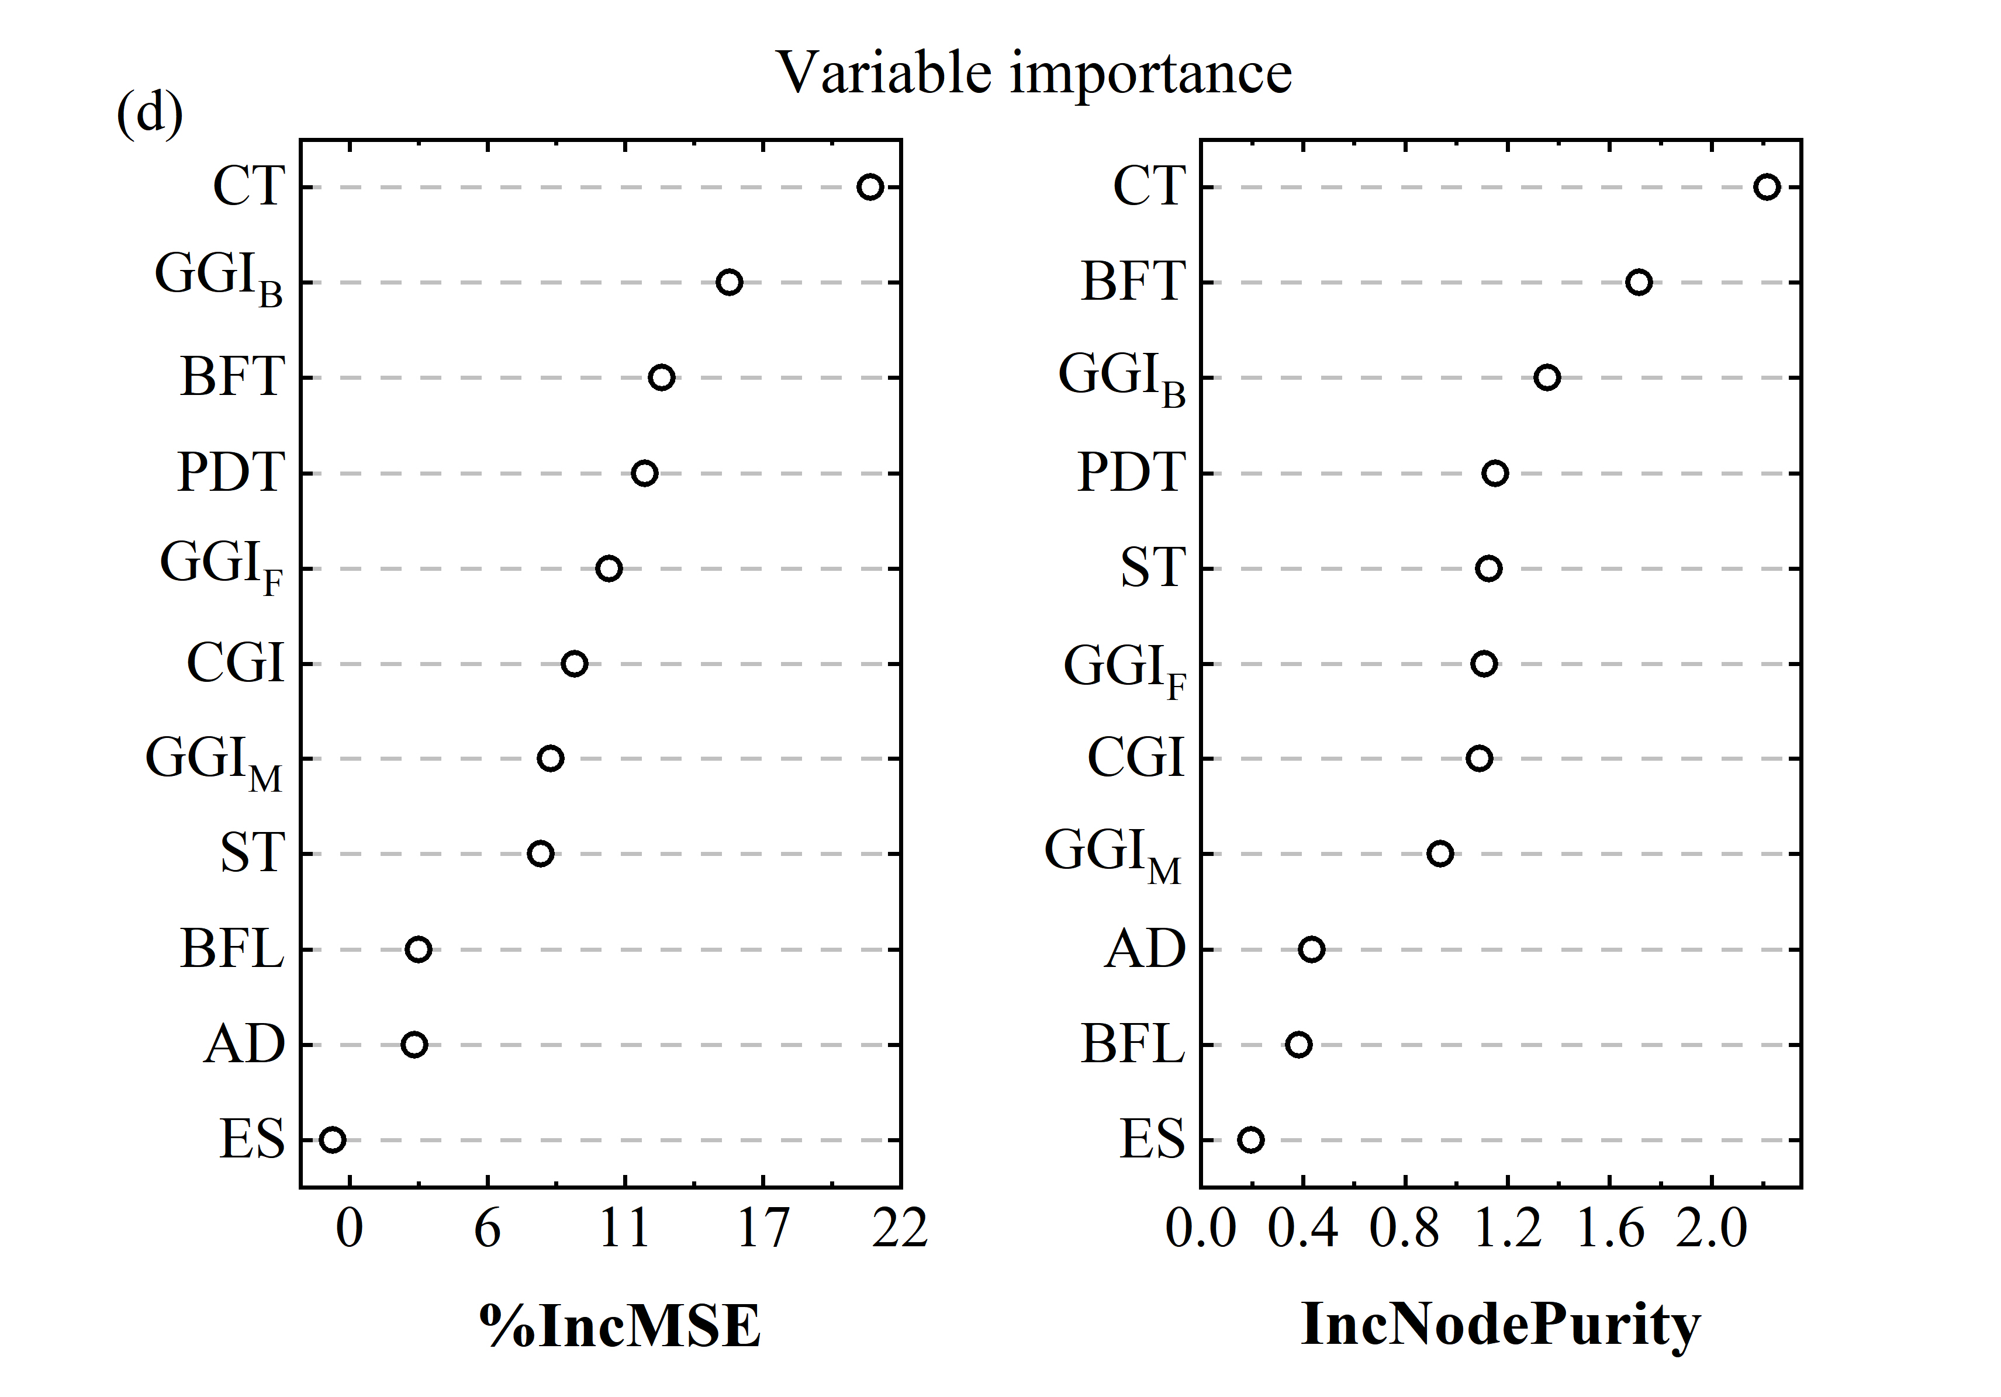

Fig. S5 Importance of the input features on PCE evaluated by RF algorithm from different datasets: (a) Dataset B, (b) Dataset C, (c) Dataset D, and (d) Dataset E.

Table S8 The photovoltaic characteristic parameter of CIGS solar cells with efficiency beyond 20%.

|  |  |  |  |  |  |  |  |  |
| --- | --- | --- | --- | --- | --- | --- | --- | --- |
| Lab. | Date of public. | **PCE**  **(%)** | **Voc**  **(mV)** | **Jsc**  **(mA/cm2)** | **FF**  **(%)** | **CGI** | **GGI** | Ref. |
| ATRL | 08/2019 | 23.35 | 734 | 39.6 | 80.4 | 0.93 | 0.3 | [88] |
| Sol. Front | 11/2018 | 22.92 | 746 | 38.5 | 79.7 | / | / | [125] |
| ZSW | 07/2016 | 22.6 | 741 | 37.8 | 80.6 | 0.88-0.92 | 0.3-0.33 | [126] |
| Sol. Front | 07/2017 | 22.3 | 722 | 39.4 | 78.2 | / | / | [127] |
| ZSW | 12/2014 | 21.7 | 748 | 36.5 | 79.4 | 0.90 | 0.32 | [128] |
| AIST | 03/2018 | 21.18 | 760 | 35.28 | 79.0 | 0.95 | 0.4 | [76] |
| ZSW | 07/2016 | 21.0 | 717 | 37.2 | 78.6 | 0.85-0.95 | 0.30-0.35 | [110] |
| ZSW | 09/2015 | 21.0 | 717 | 37.2 | 78.6 | 0.87 | 0.31 | [129] |
| Solibro | 06/2014 | 21.0 | 757 | 35.7 | 77.6 | / | / | [130] |
| Sol. Front | 04/2014 | 20.92 | 686 | 39.9 | 76.4 | / | / | [131] |
| ZSW | 02/2014 | 20.8 | 757 | 34.8 | 79.1 | 0.91 | 0.32 | [132] |
| EMPA | 11/2013 | 20.4 | 736 | 35.1 | 78.9 | 0.78–0.82 | 0.33-0.38 | [133] |
| ZSW | 01/2011 | 20.3 | 740 | 35.4 | 77.5 | 0.88 | 0.34 | [134] |

Table S9 Settings for the fabrication procedures and the device structure factors of the assuming CIGS solar cells

|  |  |  |  |  |  |  |
| --- | --- | --- | --- | --- | --- | --- |
|  | **CGI** | **GGIF** | **GGIM** | **GGIB** | **AD** | **PDT** |
| Primitive settings | 0.87-1.01, step 0.02 | 0.2-0.45, step 0.05 | 0.2-0.45, step 0.05 | 0.3-0.8, step 0.1, ≥GGIF | Yes | Yes |
| Narrowed settings | 0.87-0.95, step 0.01 | 0.30-0.40, step 0.01 | 0.24-0.40, step 0.01 | 0.30-0.80, step 0.01 | Yes | Yes |
|  | **CT (μm)** | **ES** | **ST (℃)** | **BFL** | **BFT (nm)** |  |
| Primitive settings | 1.8-2.4, step 0.1 | Co-evaporation | 450-600, step 30 | CdS or Zn(O,S)x | 10-50, step 10 |  |
| Narrowed settings | 2.0 | Co-evaporation | 550 | CdS | 50 |  |

References

[1] W.M. Li, X. Yan, W.L. Xu, J.D. Long, A.G. Aberle, S. Venkataraj, Efficiency improvement of CIGS solar cells by a modified rear contact, Solar Energy, 157 (2017) 486-495.

[2] W.M. Li, S.D. Xu, Y. Dai, P.C. Ma, Y. Feng, W.J. Li, H.L. Luo, C.L. Yang, Improvement of the crystallinity and efficiency of wide-gap CIGS thin film solar cells with reduced thickness, Materials Letters, 244 (2019) 43-46.

[3] J. Chantana, S. Hirai, M. Inoue, T. Masuda, T. Minemoto, Flexible Cu(In,Ga)Se-2 solar cell with superstrate-type configuration fabricated by a lift-off process, Thin Solid Films, 662 (2018) 110-115.

[4] J.Y. Chen, H.L. Shen, Z.H. Zhai, Y.F. Li, S.B. Li, Cd-free Cu(InGa)Se-2 solar cells with eco-friendly a-Si buffer layers, Applied Surface Science, 512 (2020) 145729.

[5] X.L. He, J. Liu, Q.Y. Ye, K. Luo, Y.D. Jiang, C. Liao, L.Q. Ouyang, D.M. Zhuang, J. Mei, W. Lau, The role of Na incorporation in the low-temperature processed CIGS thin film solar cells using post deposition treatment, Journal of Alloys and Compounds, 658 (2016) 12-18.

[6] K. Kim, I. Jeong, Y. Cho, D. Shin, S. Song, S.K. Ahn, Y.J. Eo, A. Cho, C. Jung, W. Jo, J.H. Kim, P.P. Choi, J. Gwak, J.H. Yun, Mechanisms of extrinsic alkali incorporation in GIGS solar cells on flexible polyimide elucidated by nanoscale and quantitative analyses, Nano Energy, 67 (2020) 104201.

[7] H. Li, F. Qu, H.T. Luo, X.N. Niu, J.W. Chen, Y. Zhang, H.J. Yao, X.J. Jia, H.W. Gu, W.J. Wang, Engineering CIGS grains qualities to achieve high efficiency in ultrathin Cu(InxGa1-x)Se-2 solar cells with a single-gradient band gap profile, Results in Physics, 12 (2019) 704-711.

[8] M.J. Shin, J.H. Jo, A. Cho, J. Gwak, J.H. Yun, K. Kim, S.K. Ahn, J.H. Park, J. Yoo, I. Jeong, B.H. Choi, J.S. Cho, Semi-transparent photovoltaics using ultra-thin Cu(In,Ga)Se-2 absorber layers prepared by single-stage co-evaporation, Solar Energy, 181 (2019) 276-284.

[9] S. Teraji, J. Chantana, T. Watanabe, T. Minemoto, Development of flexible Cd-free Cu(In,Ga)Se-2 solar cell on stainless steel substrate through multi-layer precursor method, Journal of Alloys and Compounds, 756 (2018) 111-116.

[10] L. Zhang, D.M. Zhuang, M. Zhao, Q.M. Gong, L. Guo, L.Q. Ouyang, R.J. Sun, Y.W. Wei, S.L. Zhan, The effects of annealing temperature on CIGS solar cells by sputtering from quaternary target with Se-free post annealing, Applied Surface Science, 413 (2017) 175-180.

[11] C. Wang, D.M. Zhuang, M. Zhao, Y.W. Wei, X.Y. Lyu, G.A. Ren, Y.X. Wu, L. Hu, Y.X. Li, Q.M. Gong, J.Q. Wei, The effects of preheating temperature on CuInGaSe2/CdS interface and the device performances, Solar Energy, 194 (2019) 11-17.

[12] P. Schoppe, S. Schonherr, M. Chugh, H. Mirhosseini, P. Jackson, R. Wuerz, M. Ritzer, A. Johannes, G. Martinez-Criado, W. Wisniewski, T. Schwarz, C.T. Plass, M. Hafermann, T.D. Kuhne, C.S. Schnohr, C. Ronning, Revealing the origin of the beneficial effect of cesium in highly efficient Cu(In,Ga)Se-2 solar cells, Nano Energy, 71 (2020) 104622.

[13] J.C. Park, M. Al-Jassim, S.W. Shin, J.H. Kim, T.W. Kim, Comprehensive characterization of CIGS absorber layers grown by one-step sputtering process, Ceramics International, 45 (2019) 4424-4430.

[14] Y. Kawano, J. Chantana, T. Nishimura, A. Mavlonov, T. Minemoto, Manipulation of Ga /( Ga plus In ) profile in 1.4-mu m-thick Cu(In,Ga)Se-2 thin film on flexible stainless steel substrate for enhancing short-circuit current density and conversion efficiency of its solar cell, Solar Energy, 204 (2020) 231-237.

[15] S. Karki, P.K. Paul, G. Rajan, T. Ashrafee, K. Aryal, P. Pradhan, R.W. Collins, A. Rockett, T.J. Grassman, S.A. Ringel, A.R. Arehart, S. Marsillac, In Situ and Ex Situ Investigations of KF Postdeposition Treatment Effects on CIGS Solar Cells, IEEE Journal of Photovoltaics, 7 (2017) 665-669.

[16] S. Karki, P. Paul, G. Rajan, B. Belfore, D. Poudel, A. Rockett, E. Danilov, F. Castellano, A. Arehart, S. Marsillac, Analysis of Recombination Mechanisms in RbF-Treated CIGS Solar Cells, IEEE Journal of Photovoltaics, 9 (2019) 313-318.

[17] Y.Y. Jseng, C.J. Chao, H.H. Sung, T.C. Chen, CIGS thin film and device performance produced through a variation Ga concentration during three-stage growth process, Materials Science in Semiconductor Processing, 87 (2018) 162-166.

[18] P.M.P. Salome, J. Keller, T. Torndahl, J.P. Teixeira, N. Nicoara, R.R. Andrade, D.G. Stroppa, J.C. Gonzalez, M. Edoff, J.P. Leitao, S. Sadewasser, CdS and Zn1-xSnxOy buffer layers for CIGS solar cells, Solar Energy Materials and Solar Cells, 159 (2017) 272-281.

[19] W.J. Lee, D.H. Cho, J.H. Wi, W.S. Han, B.K. Kim, S.D. Choi, J.Y. Baek, Y.D. Chung, Characterization of bilayer AZO film grown by low-damage sputtering for Cu(In,Ga)Se-2 solar cell with a CBD-ZnS buffer layer, Materials Science in Semiconductor Processing, 81 (2018) 48-53.

[20] S. Karki, J.I. Deitz, G. Rajan, S. Soltanmohammad, D. Poudel, B. Belfore, G. Bhandari, T.J. Grassman, A. Rockett, S. Marsillac, Impact of Water Ingress on Molybdenum Thin Films and Its Effect on Cu(In,Ga)Se-2 Solar Cells, IEEE Journal of Photovoltaics, 10 (2020) 696-702.

[21] R.L. Garris, L.M. Mansfield, B. Egaas, K. Ramanathan, Low-Cd CIGS Solar Cells Made With a Hybrid CdS/Zn(O, S) Buffer Layer, IEEE Journal of Photovoltaics, 7 (2017) 281-285.

[22] J. Chantana, T. Watanabe, S. Teraji, T. Minemoto, Influence of minimum position in Ga /( Ga plus In ) profile of Cu(In,Ga) Se-2 on flexible stainless steel substrate on its photovoltaic performances, Solar Energy Materials and Solar Cells, 157 (2016) 750-756.

[23] D. Bae, A Comparative Study of (Cd,Zn)S Buffer Layers for Cu(In,Ga)Se-2 Solar Panels Fabricated by Chemical Bath and Surface Deposition Methods, Materials, 13 (2020) 1622.

[24] Y.X. Zhang, S.P. Lin, Z.J. Hu, S.Q. Cheng, Z.C. He, Z.Q. Zhou, S.L. Sun, W. Liu, Y. Sun, Towards an optimized gallium gradient for Cu(In,Ga)Se-2 thin film via an improved constant low-temperature deposition process, Solar Energy Materials and Solar Cells, 209 (2020) 110425.

[25] K.B. Kim, M. Kim, H.C. Lee, S.W. Park, C.W. Jeon, Copper indium gallium selenide (CIGS) solar cell devices on steel substrates coated with thick SiO2-based insulating material, Materials Research Bulletin, 85 (2017) 168-175.

[26] X. Peng, M. Zhao, D.M. Zhuang, L. Guo, L.Q. Ouyang, R.J. Sun, L. Zhang, Y.W. Wei, S.L. Zhan, X.Y. Lv, Y.X. Wu, G.A. Ren, Eliminating the excess CuxSe phase in Cu-rich Cu(In,Ga)Se-2 by In2Se3 treatment, Journal of Alloys and Compounds, 709 (2017) 31-35.

[27] K. Kim, J. Kim, M.G. Gang, S.H. Kim, S. Song, Y. Cho, D. Shin, Y.J. Eo, I. Jeong, S.K. Ahn, A. Cho, J. Kim, S. Yoon, P.P. Choi, W. Jo, J.H. Kim, J. Gwak, J.H. Yun, A simple and robust route toward flexible CIGS photovoltaic devices on polymer substrates: Atomic level microstructural analysis and local opto-electronic investigation, Solar Energy Materials and Solar Cells, 195 (2019) 280-290.

[28] J.P. Ao, R. Fu, M.J. Jeng, J.L. Bi, L.Y. Yao, S.S. Gao, G.Z. Sun, Q. He, Z.Q. Zhou, Y. Sun, L.B. Chang, Formation of Cl-Doped ZnO Thin Films by a Cathodic Electrodeposition for Use as a Window Layer in CIGS Solar Cells, Materials, 11 (2018) 953.

[29] L. Zortea, S. Nishiwaki, T.P. Weiss, S. Haass, J. Perrenoud, L. Greuter, T. Feurer, G. Palaniswamy, S. Buecheler, A.N. Tiwari, Cu(In,Ga)Se-2 solar cells on low cost mild steel substrates, Solar Energy, 175 (2018) 25-30.

[30] X. Peng, M. Zhao, D.M. Zhuang, L. Guo, L.Q. Ouyang, R.J. Sun, L. Zhang, Y.W. Wei, S.L. Zhan, X.Y. Lv, Y.X. Wu, G.A. Ren, Multi-layer strategy to enhance the grain size of CIGS thin film fabricating by single quaternary CIGS target, Journal of Alloys and Compounds, 710 (2017) 172-176.

[31] X. Liang, H. Zhu, J. Chen, D. Zhou, C. Zhang, Y. Guo, X. Niu, Z. Li, Y. Mai, Substrate temperature optimization for Cu(In, Ga)Se-2 solar cells on flexible stainless steels, Applied Surface Science, 368 (2016) 464-469.

[32] I. Khatri, H. Fukai, H. Yamaguchi, M. Sugiyama, T. Nakada, Effect of potassium fluoride post-deposition treatment on Cu(In,Ga)Se-2 thin films and solar cells fabricated onto sodalime glass substrates, Solar Energy Materials and Solar Cells, 155 (2016) 280-287.

[33] J.B. Gong, Y.F. Kong, J.M. Li, K.F. Wang, X.Q. Wang, Z.M. Zhang, Z.J. Ding, X.D. Xiao, Enhancing photocurrent of Cu(In,Ga)Se-2 solar cells with actively controlled Ga grading in the absorber layer, Nano Energy, 62 (2019) 205-211.

[34] S.M. Youn, M.J. Park, J.H. Kim, C. Jeong, Performance enhancement of CIGS thin-film solar cells with a functional-window NiO thin layer, Journal of Alloys and Compounds, 836 (2020) 154803.

[35] H. Yong, T. Minemoto, T. Takahashi, Photovoltage Decay Measurements by Photo-Assisted Kelvin Probe Force Microscopy on Cu(In,Ga)Se-2 Solar Cells, IEEE Journal of Photovoltaics, 9 (2019) 483-491.

[36] P. Xiao, M. Zhao, D.M. Zhuang, R.J. Sun, L. Zhang, Y.W. Wei, Y.X. Wu, G.A. Ren, 10.3%-efficient submicron-thick Cu( In,Ga)Se-2 solar cells with absorber fabricated by sputtering In2Se3, CuGaSe2 and Cu2Se targets, Applied Surface Science, 442 (2018) 308-312.

[37] J.C. Park, M. Al-Jassim, B.T. Lee, T.W. Kim, 10% efficiency Cu(In,Ga)Se-2 solar cell with strongly (220)/(204) oriented Cu-poor absorber layers sputtered using single quaternary target, Journal of Alloys and Compounds, 812 (2020) 152065.

[38] W.M. Li, L. Yao, K.L. Li, X. Li, B. Yang, S.D. Xu, S. Shi, C.H. Yi, M. Chen, Y. Feng, W.J. Li, Z.H. Lu, C.L. Yang, Enabling Low-Temperature Deposition of High-Efficiency CIGS Solar Cells with a Modified Three-Stage Co-Evaporation Process, Acs Applied Energy Materials, 3 (2020) 4201-4207.

[39] X.H. Ma, Y.P. Ma, S.H. Yang, C.L. Yang, T. Lin, K.D. Wang, X.D. Xiao, Pre-incorporation of Na into flexible Cu(In,Ga)Se-2 thin film solar cells, Solar Energy, 173 (2018) 1080-1086.

[40] S. Kim, T. Nagai, H. Tampo, S. Ishizuka, H. Shibata, Large open-circuit voltage boosting of pure sulfide chalcopyrite Cu(In,Ga)S-2 prepared using Cu-deficient metal precursors, Progress in Photovoltaics, 28 (2020) 816-822.

[41] L.M. Mansfield, A. Kanevce, S.P. Harvey, K. Bowers, C. Beall, S. Glynn, I.L. Repins, Efficiency increased to 15.2% for ultra-thin Cu(In,Ga)Se-2 solar cells, Progress in Photovoltaics, 26 (2018) 949-954.

[42] S.C. Chen, S.W. Wang, S.Y. Kuo, J.Y. Juang, P.T. Lee, C.W. Luo, K.H. Wu, H.C. Kuo, A Comprehensive Study of One-Step Selenization Process for Cu(In1-xGax) Se-2 Thin Film Solar Cells, Nanoscale Research Letters, 12 (2017) 208.

[43] I. Khatri, M. Sugiyama, T. Nakada, Effects of combined additional indium deposition and potassium fluoride post-deposition treatments on Cu(In,Ga)Se-2 thin film solar cells, Progress in Photovoltaics, 25 (2017) 871-877.

[44] X.L. Lin, H. Li, F. Qu, H.W. Gu, W.J. Wang, Cu(In,Ga)Se-2 solar cell with Zn(S,O) as the buffer layer fabricated by a chemical bath deposition method, Solar Energy, 171 (2018) 130-141.

[45] Y. Cho, I. Jeong, M.G. Gang, J.H. Kim, S. Song, Y.J. Eo, S.K. Ahn, D.H. Shin, J.S. Cho, J.H. Yun, J. Gwak, K. Kim, Alkali incorporation into Cu(In,Ga)Se-2 determined by crystal orientation of Mo back contact: Implications for highly efficient photovoltaic devices, Solar Energy Materials and Solar Cells, 188 (2018) 46-50.

[46] X. Niu, H. Zhu, X. Liang, Y. Guo, Z. Li, Y. Mai, Air-annealing of Cu(In, Ga)Se-2/CdS and performances of CIGS solar cells, Applied Surface Science, 426 (2017) 1213-1220.

[47] X. Zheng, C.C. Xie, W.M. Li, A.G. Aberle, S. Venkataraj, Investigations of potassium-induced surface treatment of Cu(In,Ga)Se-2 (CIGSe) thin film solar cells prepared by two-stage process using elemental selenium, Applied Surface Science, 525 (2020) 146368.

[48] P.P. Xin, J.K. Larsen, F. Deng, W.N. Shafarman, Development of Cu(In,Ga)Se-2 superstrate devices with alternative buffer layers, Solar Energy Materials and Solar Cells, 157 (2016) 85-92.

[49] T.Y. Lin, C.H. Chen, L.W. Wang, W.C. Huang, Y.W. Jheng, C.H. Lai, Engineering Na-transport to achieve high efficiency in ultrathin Cu(In, Ga) Se-2 solar cells with controlled preferred orientation, Nano Energy, 41 (2017) 697-705.

[50] J. Matsuura, I. Khatri, T.Y. Lin, M. Sugiyama, T. Nakada, Impact of heat-light soaking and heat-bias soaking on NaF-treated CIGS thin film solar cells, Progress in Photovoltaics, 27 (2019) 623-629.

[51] I. Khatri, J. Matsuura, M. Sugiyama, T. Nakada, Effect of heat-bias soaking on cesium fluoride-treated CIGS thin film solar cells, Progress in Photovoltaics, 27 (2019) 22-29.

[52] I. Khatri, K. Shudo, J. Matsuura, M. Sugiyama, T. Nakada, Impact of heat-light soaking on potassium fluoride treated CIGS solar cells with CdS buffer layer, Progress in Photovoltaics, 26 (2018) 171-178.

[53] T.T. Wu, C.H. Chang, C.H. Hsu, W.C. Tsai, H.S. Tsai, Y.T. Yen, C.H. Shen, J.M. Shieh, Y.L. Chueh, 30 x 40 cm(2) flexible Cu(In,Ga)Se-2 solar panel by low temperature plasma enhanced selenization process, Nano Energy, 24 (2016) 45-55.

[54] B. Noikaew, S. Chatraphorn, Effects of substrate temperatures in the three-stage growth of CuIn (1-x) GaxSe2 thin films and their photovoltaic performances, Surface & Coatings Technology, 307 (2016) 547-553.

[55] J.M. Raguse, C.P. Muzzillo, J.R. Sites, L. Mansfield, Effects of Sodium and Potassium on the Photovoltaic Performance of CIGS Solar Cells, IEEE Journal of Photovoltaics, 7 (2017) 303-306.

[56] M. Acciarri, A. Le Donne, S. Marchionna, M. Meschia, J. Parravicini, A. Gasparotto, S. Binetti, CIGS thin films grown by hybrid sputtering-evaporation method: Properties and PV performance, Solar Energy, 175 (2018) 16-24.

[57] A. Sadono, M. Hino, K. Nakada, A. Yamada, Effect of an additional Cu-deficient layer deposition on alkali treated Cu(In, Ga)Se-2 solar cells deposited at low temperature, Solar Energy Materials and Solar Cells, 184 (2018) 67-72.

[58] C.S. Chiou, H.C. Peng, Influence of process parameters on the gallium composition of a CuIn1-xGaxSe2 solar cell on the efficiency of non-vacuum blade coating stacking, Solar Energy, 146 (2017) 436-442.

[59] J.K. Zhu, T.K. Lau, S.H. Yang, J.Q. Mai, Y.L. Lai, Y.J. Hsu, H.L. Luo, X.H. Lu, X.D. Xiao, New Route for Fabrication of High-Quality Zn(S,O) Buffer Layer at High Deposition Temperature on Cu(In,Ga)Se-2 Solar Cells, IEEE Journal of Photovoltaics, 7 (2017) 651-655.

[60] F. Larsson, O. Donzel-Gargand, J. Keller, M. Edoff, T. Torndahl, Atomic layer deposition of Zn(O,S) buffer layers for Cu(In,Ga)Se-2 solar cells with KF post-deposition treatment, Solar Energy Materials and Solar Cells, 183 (2018) 8-15.

[61] T.Y. Lin, C.H. Chen, W.C. Huang, W.H. Ho, Y.H. Wu, C.H. Lai, Direct probing Se spatial distribution in Cu(InxGa1-x)Se-2 solar cells: A key factor to achieve high efficiency performance, Nano Energy, 19 (2016) 269-278.

[62] I. Repins, S. Glynn, K. Bowers, B. Stevens, C.L. Perkins, L. Mansfield, Using hole injection layers for decreased metastability and higher performance in Cu(In,Ga)Se-2 devices, Solar Energy Materials and Solar Cells, 215 (2020) 110597.

[63] Y.C. Lin, Y.T. Hsieh, C.M. Lai, H.R. Hsu, Impact of Mo barrier layer on the formation of MoSe2 in Cu(In, Ga)Se-2 solar cells, Journal of Alloys and Compounds, 661 (2016) 168-175.

[64] Y.C. Lin, D.H. Hong, Y.T. Hsieh, L.C. Wang, H.R. Hsu, Role of Mo:Na layer on the formation of MoSe2 phase in Cu(In,Ga)Se-2 thin film solar cells, Solar Energy Materials and Solar Cells, 155 (2016) 226-233.

[65] J.Y. Chen, H.L. Shen, Z.H. Zhai, F. Liu, Z.P. Zhu, M.H. Luo, Performance and stability enhancement of Cu(InGa)Se-2 solar cells on ultrathin glass by potassium incorporation, Materials Letters, 271 (2020) 127749.

[66] D. Shin, J. Kim, T. Gershon, R. Mankad, M. Hopstaken, S. Guha, B.T. Ahn, B. Shin, Effects of the incorporation of alkali elements on Cu(In,Ga)Se-2 thin film solar cells, Solar Energy Materials and Solar Cells, 157 (2016) 695-702.

[67] C.P. Muzzillo, S. Glynn, P. Hacke, H.R. Moutinho, M.R. Young, G. Teeter, I.L. Repins, L.M. Mansfield, Potential-Induced Degradation of Cu(In,Ga)Se-2 Solar Cells: Alkali Metal Drift and Diffusion Effects, IEEE Journal of Photovoltaics, 8 (2018) 1337-1342.

[68] J.S. Ho, S.C. Chang, J.J. Ho, W.T. Hsu, C.C. Chiang, S.Y. Tsai, S.S. Wang, C.K. Lin, C.C. Chou, C.H. Yeh, K.L. Wang, Improving the performance of solar cells with novel buffer structure by the chemical bath deposition technique, Materials Science in Semiconductor Processing, 59 (2017) 29-34.

[69] L. Gouillart, W.C. Chen, A. Cattoni, J. Goffard, L. Riekehr, J. Keller, M. Jubault, N. Naghavi, M. Edoff, S. Collin, Reflective Back Contacts for Ultrathin Cu(In,Ga)Se-2-Based Solar Cells, IEEE Journal of Photovoltaics, 10 (2020) 250-254.

[70] K. Cheng, Y.Q. Huang, J.J. Liu, M. Xue, Z.C. Kuang, Z.B. Lu, S.X. Wu, Z.L. Du, Chalcogenide solar cells fabricated by co-sputtering of quaternary CuIn0.75Ga0.25Se2 and In targets: Another promising sputtering route for mass production, Journal of Alloys and Compounds, 684 (2016) 237-244.

[71] T. Kodalle, T. Bertram, R. Schlatmann, C.A. Kaufmann, Effectiveness of an RbF Post Deposition Treatment of CIGS Solar Cells in Dependence on the Cu Content of the Absorber Layer, IEEE Journal of Photovoltaics, 9 (2019) 1839-1845.

[72] J. Chantana, D. Hironiwa, T. Watanabe, S. Teraji, T. Minemoto, Flexible Cu(In,Ga)Se-2 solar cell on stainless steel substrate deposited by multi-layer precursor method: its photovoltaic performance and deep-level defects, Progress in Photovoltaics, 24 (2016) 990-1000.

[73] T. Koida, J. Nishinaga, Y. Ueno, H. Higuchi, H. Takahashi, M. Iioka, Y. Kamikawa, H. Shibata, S. Niki, Improved efficiency of Cu(In,Ga)Se-2 mini-module via high-mobility In2O3:W,H transparent conducting oxide layer, Progress in Photovoltaics, 27 (2019) 491-500.

[74] O. Donzel-Gargand, T. Thersleff, J. Keller, T. Torndahl, F. Larsson, E. Wallin, L. Stolt, M. Edoff, Deep surface Cu depletion induced by K in high-efficiency Cu(In,Ga)Se-2 solar cell absorbers, Progress in Photovoltaics, 26 (2018) 730-739.

[75] J. Lockinger, S. Nishiwaki, C. Andres, R. Erni, M.D. Rossell, Y.E. Romanyuk, S. Buecheler, A.N. Tiwari, ALD-ZnxTiyO as Window Layer in Cu(In,Ga)Se-2 Solar Cells, Acs Applied Materials & Interfaces, 10 (2018) 43603-43609.

[76] T. Koida, J. Nishinaga, Y. Ueno, H. Higuchi, H. Takahashi, M. Iioka, H. Shibata, S. Niki, Impact of front contact layers on performance of Cu(In,Ga)Se-2 solar cells in relaxed and metastable states, Progress in Photovoltaics, 26 (2018) 789-799.

[77] J. Keller, W.C. Chen, L. Riekehr, T. Kubart, T. Torndahl, M. Edoff, Bifacial Cu(In,Ga)Se-2 solar cells using hydrogen-doped In2O3 films as a transparent back contact, Progress in Photovoltaics, 26 (2018) 846-858.

[78] S.T. Kim, L. Larina, J.H. Yun, B. Shin, B.T. Ahn, Surface passivation and point defect control in Cu(In,Ga)Se-2 films with a Na2S post deposition treatment for higher than 19% CIGS cell performance, Sustainable Energy & Fuels, 3 (2019) 709-716.

[79] J.Y. Chen, H.L. Shen, Z.H. Zhai, J.Z. Li, W. Wang, H.R. Shang, Y.F. Li, Effect of substrate temperature and post-annealing on the properties of CIGS thin films deposited using e-beam evaporation, Journal of Physics D-Applied Physics, 49 (2016) 495601.

[80] W.J. Lee, D.H. Cho, J.H. Wi, H.J. Yu, W.S. Han, J.M. Bae, J. Park, Y.D. Chung, Ultrafast Photocarrier Dynamics at the p-n Junction in Cu(In,Ga)Se-2 Solar Cell with Various Zn(O,S) Buffer Layers Measured by Optical Pump-Terahertz Probe Spectroscopy, Acs Applied Energy Materials, 1 (2018) 522-530.

[81] C.H. Hsu, W.H. Ho, S.Y. Wei, C.H. Lai, Over 14% Efficiency of Directly Sputtered Cu(In,Ga)Se-2 Absorbers without Postselenization by Post-Treatment of Alkali Metals, Advanced Energy Materials, 7 (2017) 1602571.

[82] G. Kim, W.M. Kim, J.K. Park, D. Kim, H. Yu, J.H. Jeong, Thin Ag Precursor Layer-Assisted Co-Evaporation Process for Low-Temperature Growth of Cu(In,Ga)Se-2 Thin Film, Acs Applied Materials & Interfaces, 11 (2019) 31923-31933.

[83] Y.F. Kong, J.M. Li, Z.Y. Ma, Z. Chi, X.D. Xiao, Formation of Ga double grading in submicron Cu(In,Ga)Se-2 solar cells by pre-depositing a CuGaSe2 layer, Journal of Materials Chemistry A, 8 (2020) 9760-9767.

[84] E. Avancini, R. Carron, T.P. Weiss, C. Andres, M. Burki, C. Schreiner, R. Figi, Y.E. Romanyuk, S. Buecheler, A.N. Tiwari, Effects of Rubidium Fluoride and Potassium Fluoride Postdeposition Treatments on Cu(ln,Ga)Se-2 Thin Films and Solar Cell Performance, Chemistry of Materials, 29 (2017) 9695-9704.

[85] S. Kim, H. Yoo, T.R. Rana, T. Enkhbat, G. Han, J. Kim, S. Song, K. Kim, J. Gwak, Y.J. Eo, J.H. Yun, Effect of Crystal Orientation and Conduction Band Grading of Absorber on Efficiency of Cu(In,Ga)Se-2 Solar Cells Grown on Flexible Polyimide Foil at Low Temperature, Advanced Energy Materials, 8 (2018) 1801501.

[86] J. Nishinaga, T. Koida, S. Ishizuka, Y. Kamikawa, H. Takahashi, M. Iioka, H. Higuchi, Y. Ueno, H. Shibata, S. Niki, Effects of long-term heat-light soaking on Cu(In,Ga) Se-2 solar cells with KF postdeposition treatment, Applied Physics Express, 10 (2017) 092301.

[87] T. Kato, A. Handa, T. Yagioka, T. Matsuura, K. Yamamoto, S. Higashi, J.L. Wu, K.F. Tai, H. Hiroi, T. Yoshiyama, T. Sakai, H. Sugimoto, Enhanced Efficiency of Cd-Free Cu(In,Ga)(Se,S)(2) Minimodule Via (Zn,Mg)O Second Buffer Layer and Alkali Metal Post-Treatment, IEEE Journal of Photovoltaics, 7 (2017) 1773-1780.

[88] M. Nakamura, K. Yamaguchi, Y. Kimoto, Y. Yasaki, T. Kato, H. Sugimoto, Cd-Free Cu(In,Ga)(Se,S)(2) Thin-Film Solar Cell With Record Efficiency of 23.35%, IEEE Journal of Photovoltaics, 9 (2019) 1863-1867.

[89] J.L. Liu, L.F. Guo, X.S. Liu, S. Li, X.L. Liu, X.F. Shen, S.F. Chang, K. Cheng, Z.L. Du, Protection-Free Ag Nanowires as a Transparent Conductive Electrode for Improved Cu(In1-x, Ga-x)Se-2 (CIGS)-Based Photovoltaic Performances, Acs Applied Energy Materials, 1 (2018) 783-789.

[90] M.Y. Cho, I.S. Kim, C. Park, H. Sohn, D. Lee, S.M. Koo, W.J. Cho, Y.N. Kim, D.W. Lee, J.M. Oh, Multistage Degradation Mechanisms in Cu(In, Ga)Se-2 Photovoltaic Modules Prepared by Co-Evaporation: Toward High Performances and Enhanced Stability, Acs Applied Energy Materials, 2 (2019) 7171-7182.

[91] X.F. Zhang, M. Kobayashi, A. Yamada, Comparison of Ag(ln,Ga)Se-2/Mo and Cu(In,Ga)Se-2/Mo Interfaces in Solar Cells, Acs Applied Materials & Interfaces, 9 (2017) 16215-16220.

[92] M. Singh, T.R. Rana, S. Kim, K. Kim, J.H. Yun, J. Kim, Silver Nanowires Binding with Sputtered ZnO to Fabricate Highly Conductive and Thermally Stable Transparent Electrode for Solar Cell Applications, Acs Applied Materials & Interfaces, 8 (2016) 12764-12771.

[93] A. Loubat, C. Eypert, F. Mollica, M. Bouttemy, N. Naghavi, D. Lincot, A. Etcheberry, Optical properties of ultrathin CIGS films studied by spectroscopic ellipsometry assisted by chemical engineering, Applied Surface Science, 421 (2017) 643-650.

[94] C.W. Chen, H.W. Tsai, Y.C. Wang, Y.C. Shih, T.Y. Su, C.H. Yang, W.S. Lin, C.H. Shen, J.M. Shieh, Y.L. Chueh, Rear-Passivated Ultrathin Cu(In,Ga)Se-2 Films by Al2O3 Nanostructures Using Glancing Angle Deposition Toward Photovoltaic Devices with Enhanced Efficiency, Advanced Functional Materials, 29 (2019) 1905040.

[95] D.H. Cho, W.J. Lee, M.E. Kim, B. Shin, Y.D. Chung, Color tuning in Cu(In,Ga)Se-2 thin-film solar cells by controlling optical interference in transparent front layers, Progress in Photovoltaics, 28 (2020) 798-807.

[96] F. Tsin, D. Hariskos, D. Lincot, J. Rousset, Photo-assisted electrodeposition of a ZnO front contact on a p/n junction, Electrochimica Acta, 220 (2016) 176-183.

[97] S. Gallanti, E. Chassaing, N. Loones, M. Bouttemy, A. Etcheberry, D. Lincot, N. Naghavi, Ammonia-free, room temperature, and reusable photochemical bath for the deposition of Zn(S,O) buffer layers in Cu(In,Ga)Se-2 thin-film solar cells, Progress in Photovoltaics, 26 (2018) 332-341.

[98] P. Gecys, E. Markauskas, S. Nishiwaki, S. Buecheler, R. De Loor, A. Burn, V. Romano, G. Raciukaitis, CIGS thin-film solar module processing: case of high-speed laser scribing, Scientific Reports, 7 (2017) 40502.

[99] S. Gedi, Q. Sun, C.W. Jeon, Remarkable enhancement of the efficiency of Cu(In,Ga)Se-2 solar cells by annealing the (In,Ga)(2)Se-3 precursor layer, Journal of Alloys and Compounds, 659 (2016) 255-261.

[100] Y.I. Kim, K.J. Yang, S.Y. Kim, J.K. Kang, J. Kim, W. Jo, H. Yoo, J. Kim, D.H. Kim, The characteristics of Cu(In, Ga)Se-2 thin-film solar cells by bandgap grading, Journal of Industrial and Engineering Chemistry, 76 (2019) 437-442.

[101] W.C. Tsai, S.R. Thomas, C.H. Hsu, Y.C. Huang, J.Y. Tseng, T.T. Wu, C.H. Chang, Z.M.M. Wang, J.M. Shieh, C.H. Shen, Y.L. Chueh, Flexible high performance hybrid AZO/Ag-nanowire/AZO sandwich structured transparent conductors for flexible Cu(In, Ga)Se-2 solar cell applications, Journal of Materials Chemistry A, 4 (2016) 6980-6988.

[102] M. Saifullah, D. Kim, J.S. Cho, S. Ahn, S. Ahn, J.H. Yun, H.S. Lee, J.H. Park, The role of NaF post-deposition treatment on the photovoltaic characteristics of semitransparent ultrathin Cu(In,Ga)Se-2 solar cells prepared on indium-tin-oxide back contacts: a comparative study, Journal of Materials Chemistry A, 7 (2019) 21843-21853.

[103] J. Keller, F. Chalvet, J. Joel, A. Aijaz, T. Kubart, L. Riekehr, M. Edoff, L. Stolt, T. Torndahl, Effect of KF absorber treatment on the functionality of different transparent conductive oxide layers in CIGSe solar cells, Progress in Photovoltaics, 26 (2018) 13-23.

[104] J. Keller, O.V. Bilousov, J. Neerken, E. Wallin, N.M. Martin, L. Riekehr, M. Edoff, C. Platzer-Bjorkman, Heavy Alkali Treatment of Post-Sulfurized Cu(In,Ga)Se(2)Layers: Effect on Absorber Properties and Solar Cell Performance, SOLAR RRL, 4 (2020) 2000248.

[105] F. Larsson, N.S. Nilsson, J. Keller, C. Frisk, V. Kosyak, M. Edoff, T. Torndahl, Record 1.0 V open-circuit voltage in wide band gap chalcopyrite solar cells, Progress in Photovoltaics, 25 (2017) 755-763.

[106] J.X. Hu, K. Cheng, K.K. Han, Z.C. Kuang, J.L. Liu, B.B. Hu, Q.W. Tian, S.X. Wu, Z.L. Du, 10.3% efficient Cu(In, Ga)Se-2 solar cells fabricated by selenization of Cu-In-Ga precursors, Materials Letters, 174 (2016) 114-117.

[107] L.Q. Ouyang, D.M. Zhuang, M. Zhao, Q.M. Gong, L. Guo, R.J. Sun, L. Zhang, Cu(In,Ga)Se-2 solar cells fabricated by sputtering from copper-poor and selenium-rich ceramic target with selenium-free post treatment, Materials Letters, 184 (2016) 69-72.

[108] H.H. Sung, D.C. Tsai, Z.C. Chang, T.J. Chung, S.C. Liang, E.C. Chen, F.S. Shieu, The structural evolution of Cu(In,Ga)Se-2 thin film and device performance prepared through a three-stage process, Materials Science in Semiconductor Processing, 41 (2016) 519-528.

[109] Y.K. Liao, Y.T. Liu, D.H. Hsieh, T.L. Shen, M.Y. Hsieh, A.J. Tzou, S.C. Chen, Y.L. Tsai, W.S. Lin, S.W. Chan, Y.P. Shen, S.J. Cheng, C.H. Chen, K.H. Wu, H.M. Chen, S.Y. Kuo, M.D.B. Charlton, T.P. Hsieh, H.C. Kuo, Breakthrough to Non-Vacuum Deposition of Single-Crystal, Ultra-Thin, Homogeneous Nanoparticle Layers: A Better Alternative to Chemical Bath Deposition and Atomic Layer Deposition, Nanomaterials, 7 (2017) 78.

[110] D. Hariskos, P. Jackson, W. Hempel, S. Paetel, S. Spiering, R. Menner, W. Wischmann, M. Powalla, Method for a High-Rate Solution Deposition of Zn(O,S) Buffer Layer for High-Efficiency Cu(In,Ga)Se-2-Based Solar Cells, IEEE Journal of Photovoltaics, 6 (2016) 1321-1326.

[111] C. Hones, J. Hackenberg, R. Keller, S. Zweigart, A. Fuchs, S. Siebentritt, A Novel Fast Process for Zn(O,S) Buffer Layers, Doped With Al and B and Deposited on CIGSSe Solar Cells, IEEE Journal of Photovoltaics, 7 (2017) 864-869.

[112] M. Balestrieri, V. Achard, T. Hildebrandt, L. Lombez, M. Jubault, S. Bechu, M. Bouttemy, A. Etcheberry, D. Lincot, F. Donsanti, Improving V-oc With Indium and Alkali Fluorides in Cu(In,Ga)Se-2 Solar Cells Deposited at Low Temperature on Polyimide, IEEE Journal of Photovoltaics, 8 (2018) 1343-1348.

[113] H. Guthrey, J. Moseley, J. Nishinaga, H. Shibata, H. Takahashi, M. Al-Jassim, Spatially Resolved Recombination Analysis of CuInxGa1-xSe2 Absorbers With Alkali Postdeposition Treatments, IEEE Journal of Photovoltaics, 8 (2018) 1833-1840.

[114] J. de Wild, T. Kohl, D.G. Buldu, G. Birant, D.M. Parragh, G. Brammertz, M. Meuris, J. Poortmans, B. Vermang, KF Postdeposition Treatment in N-2 of Single-Stage Thin Cu(In,Ga)Se-2 Absorber Layers, IEEE Journal of Photovoltaics, 10 (2020) 255-258.

[115] T. Nishimura, H. Sugiura, K. Nakada, A. Yamada, Accurate control and characterization of Cu depletion layer for highly efficient Cu(In,Ga)Se-2 solar cells, Progress in Photovoltaics, 27 (2019) 171-178.

[116] S.S. Schmidt, C. Wolf, H. Rodriguez-Alvarez, J.P. Backer, C.A. Kaufmann, S. Merdes, F. Ziem, M. Hartig, S. Cinque, I. Dorbandt, C. Koble, D. Abou-Ras, R. Mainz, R. Schlatmann, Adjusting the Ga grading during fast atmospheric processing of Cu(In,Ga)Se-2 solar cell absorber layers using elemental selenium vapor, Progress in Photovoltaics, 25 (2017) 341-357.

[117] W.Q. Shi, M. Theelen, A. Illiberi, N. Barreau, S.J. van der Sar, M. Butterling, H. Schut, W. Egger, M. Dickmann, C. Hugenschmidt, M. Zeman, E. Bruck, S.W.H. Eijt, Evolution and role of vacancy clusters at grain boundaries of ZnO:Al during accelerated degradation of Cu(In, Ga)Se-2 solar cells revealed by positron annihilation, Physical Review Materials, 2 (2018) 105403.

[118] S.P. Lin, W. Liu, Y.X. Zhang, S.Q. Cheng, Y. Fan, Z.Q. Zhou, Y. Zhang, Y. Sun, Adjustment of alkali element incorporations in Cu(In,Ga)Se-2 thin films with wet chemistry Mo oxide as a hosting reservoir, Solar Energy Materials and Solar Cells, 174 (2018) 16-24.

[119] J.J. Li, B.F. Deng, H.B. Zhu, F. Guo, X.C. You, K. Shen, M.X. Wan, Y.H. Mai, Rear interface modification for efficient Cu(In,Ga)Se-2 solar cells processed with metallic precursors and low-cost Se vapor, Solar Energy Materials and Solar Cells, 186 (2018) 243-253.

[120] T. Kodalle, L. Choubrac, L. Arzel, R. Schlatmann, N. Barreau, C.A. Kaufmann, Effects of KF and RbF post deposition treatments on the growth of the CdS buffer layer on CIGS thin films - a comparative study, Solar Energy Materials and Solar Cells, 200 (2019) 109997.

[121] Y.S. Son, H. Yu, J.K. Park, W.M. Kim, S.Y. Ahn, W. Choi, D. Kim, J.H. Jeong, Control of Structural and Electrical Properties of Indium Tin Oxide (ITO)/Cu(ln,Ga)Se-2 Interface for Transparent Back-Contact Applications, Journal of Physical Chemistry C, 123 (2019) 1635-1644.

[122] S. Ishizuka, N. Taguchi, P.J. Fons, Similarities and Critical Differences in Heavy Alkali-Metal Rubidium and Cesium Effects on Chalcopyrite Cu(In,Ga)Se-2 Thin-Film Solar Cells, Journal of Physical Chemistry C, 123 (2019) 17757-17764.

[123] E. Avancini, R. Carron, B. Bissig, P. Reinhard, R. Menozzi, G. Sozzi, S. Di Napoli, T. Feurer, S. Nishiwaki, S. Buecheler, A.N. Tiwari, Impact of compositional grading and overall Cu deficiency on the near-infrared response in Cu(In, Ga)Se2 solar cells, Progress in Photovoltaics, 25 (2017) 233-241.

[124] C.P. Muzzillo, M.O. Reese, L.M. Mansfield, Macroscopic Nonuniformities in Metal Grids Formed by Cracked Film Lithography Result in 19.3% Efficient Solar Cells, Acs Applied Materials & Interfaces, 12 (2020) 25895-25902.

[125] T. Kato, J.-L. Wu, Y. Hirai, H. Sugimoto, V. Bermudez, Record Efficiency for Thin-Film Polycrystalline Solar Cells Up to 22.9% Achieved by Cs-Treated Cu(In,Ga)(Se,S)(2), IEEE Journal of Photovoltaics, 9 (2019) 325-330.

[126] P. Jackson, R. Wuerz, D. Hariskos, E. Lotter, W. Witte, M. Powalla, Effects of heavy alkali elementsin Cu(In,Ga)Se-2 solar cells with efficiencies up to 22.6%, Physica Status Solidi-Rapid Research Letters, 10 (2016) 583-586.

[127] K.F. Tai, R. Kamada, T. Yagioka, T. Kato, H. Sugimoto, From 20.9 to 22.3% Cu(In, Ga)(S, Se)(2) solar cell: Reduced recombination rate at the heterojunction and the depletion region due to K-treatment, Japanese Journal of Applied Physics, 56 (2017) 08MC03.

[128] P. Jackson, D. Hariskos, R. Wuerz, O. Kiowski, A. Bauer, T.M. Friedlmeier, M. Powalla, Properties of Cu(In,Ga)Se-2 solar cells with new record efficiencies up to 21.7%, Physica Status Solidi-Rapid Research Letters, 9 (2015) 28-31.

[129] T.M. Friedlmeier, P. Jackson, A. Bauer, D. Hariskos, O. Kiowski, R. Wuerz, M. Powalla, Improved Photocurrent in Cu(In, Ga)Se-2 Solar Cells: From 20.8% to 21.7% Efficiency with CdS Buffer and 21.0% Cd-Free, IEEE Journal of Photovoltaics, 5 (2015) 1487-1491.

[130] D. Herrmann, P. Kratzert, S. Weeke, M. Zimmer, J. Djordjevic-Reiss, R. Hunger, P. Lindberg, E. Wallin, O. Lundberg, L. Stolt, IEEE, CIGS Module Manufacturing with High Deposition Rates and Efficiencies, IEEE 40th Photovoltaic Specialist Conference, (2014) 2775-2777.

[131] M. Nakamura, N. Yoneyama, K. Horiguchi, Y. Iwata, K. Yamaguchi, H. Sugimoto, T. Kato, IEEE, Recent R&D Progress in Solar Frontier's Small-sized Cu(InGa)(SeS)(2) Solar Cells, IEEE 40th Photovoltaic Specialist Conference,(2014) 205-208.

[132] P. Jackson, D. Hariskos, R. Wuerz, W. Wischmann, M. Powalla, Compositional investigation of potassium doped Cu(In,Ga)Se-2 solar cells with efficiencies up to 20.8%, Physica Status Solidi-Rapid Research Letters, 8 (2014) 219-222.

[133] A. Chirila, P. Reinhard, F. Pianezzi, P. Bloesch, A.R. Uhl, C. Fella, L. Kranz, D. Keller, C. Gretener, H. Hagendorfer, D. Jaeger, R. Erni, S. Nishiwaki, S. Buecheler, A.N. Tiwari, Potassium-induced surface modification of Cu(In,Ga)Se-2 thin films for high-efficiency solar cells, Nature Materials, 12 (2013) 1107-1111.

[134] P. Jackson, D. Hariskos, E. Lotter, S. Paetel, R. Wuerz, R. Menner, W. Wischmann, M. Powalla, New world record efficiency for Cu(In,Ga)Se-2 thin-film solar cells beyond 20%, Progress in Photovoltaics, 19 (2011) 894-897.